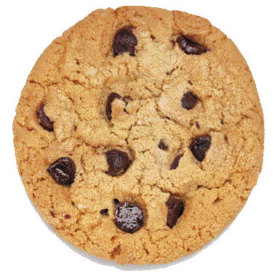
One Cookie

Cookie. (n.d.). https://1.bp.blogspot.com/-94XK-zMZLFI/Tk5ekLtwDgI/AAAAAAAADs4/dEjtNbQsvXc/s400/Cookie.gif

