FOOD PICTURES FOR THE EQUALLY AND UNEQUALLY SPLIT T-CHART
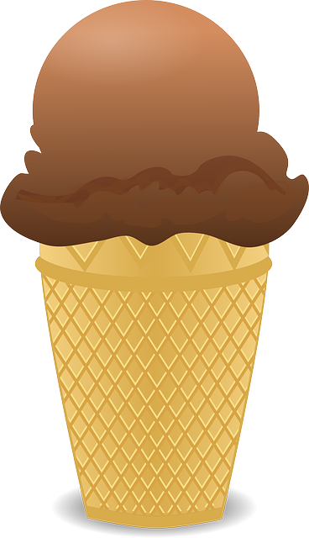
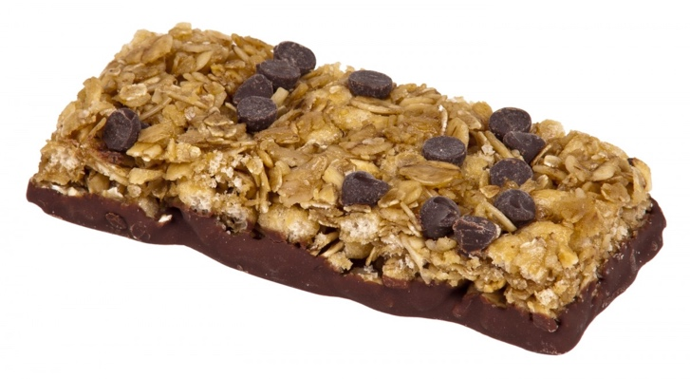
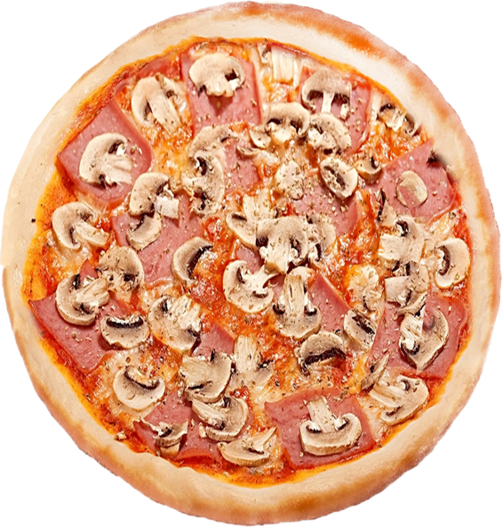
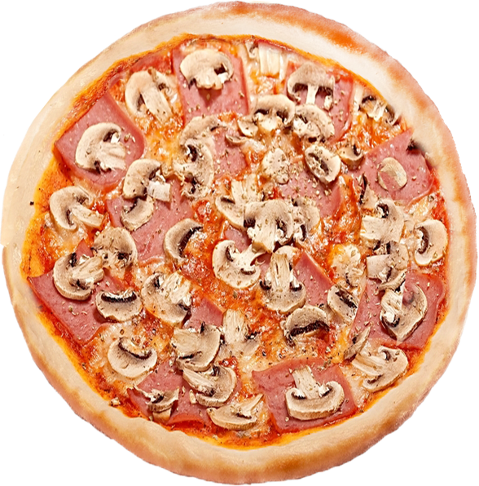
Cut out the shapes ahead of time. Wait to cut the splits until students are present or, alternatively, leave the shapes uncut with the lines left on to represent the splits.

Granola Bar. (n.d.). https://c.pxhere.com/photos/0f/93/food_eat_diet_chewy_granola_bar-1387004.jpg!d
Ice Cream. (n.d.). https://pixabay.com/static/uploads/photo/2013/07/13/01/23/cone-155671_640.png
Pizza. (n.d.). https://pngimg.com/uploads/pizza/pizza_PNG44068.png

