¿son partes iguales?
1.  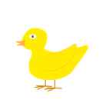  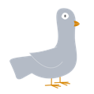  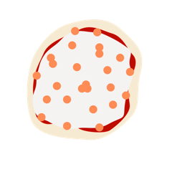  ¿Son partes iguales? | 2.  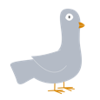  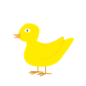  ¿Son partes iguales?
3.  ¿Son partes iguales?  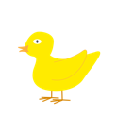  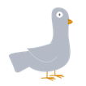  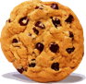  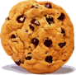 | 4.  ¿Son partes iguales?  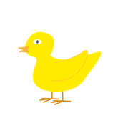  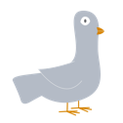
5.  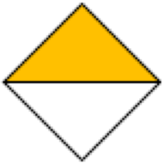  ¿Son partes iguales? | 6.  ¿Son partes iguales?
7.  ¿Son partes iguales? | 8.  ¿Son partes iguales?  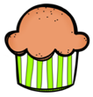  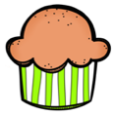  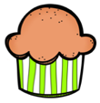

9.  ¿Son partes iguales?  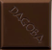  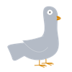  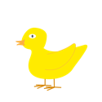  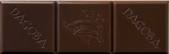 | 10.  ¿Son partes iguales?  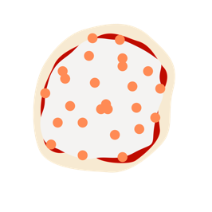  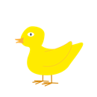  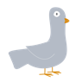  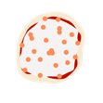
11.  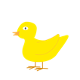  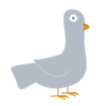  ¿Son partes iguales? | 12.  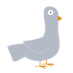  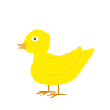  ¿Son partes iguales?
13.  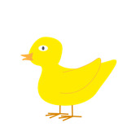  ¿Son partes iguales? | 14.  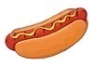  ¿Son partes iguales?  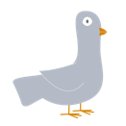  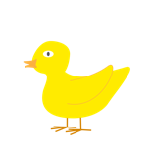
17.  ¿Son partes iguales?  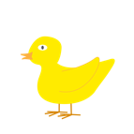 | 18.  ¿Son partes iguales?  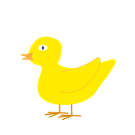  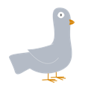

Chocolate Bar. (s.f.). https://i.stack.imgur.com/1mZPB.jpg

Cookie. (s.f.). https://1.bp.blogspot.com/-94XK-zMZLFI/Tk5ekLtwDgI/AAAAAAAADs4/dEjtNbQsvXc/s400/Cookie.gif

Duck. (s.f.). https://pixabay.com/vectors/duck-bird-duckling-yellow-cute-4525218/

Hot Dog. (s.f.). https://as1.ftcdn.net/jpg/02/65/57/58/220_F_265575805_ivE7dEFyoVAaUdVDUi2phiqp6WGqzfAX.jpg

Pizza. (s.f.) https://pngimg.com/uploads/pizza/pizza_PNG43974.png
Puppy. (s.f.). https://i.stack.imgur.com/aMUMt.jpg?s=328&g=1
Willems, M. (2012). The Duckling Gets a Cookie!?. Hyperion Books for Children.

