Is this a fair share?
1.  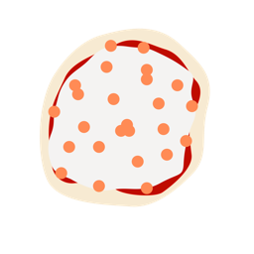  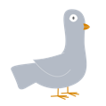  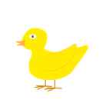  Is this a fair share? | 2.  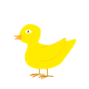  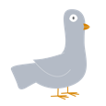  Is this a fair share?
3.  Is this a fair share?  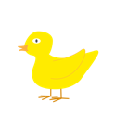  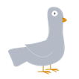  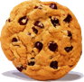  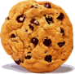 | 4.  Is this a fair share?  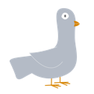  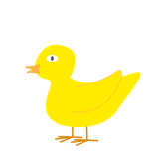
5.  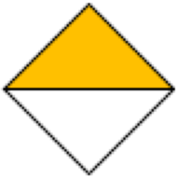  Is this a fair share? | 6.  Is this a fair share?
7.  Is this a fair share? | 8.  Is this a fair share?  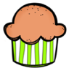  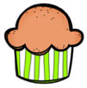  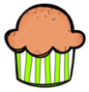

9.  Is this a fair share?  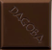  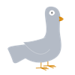  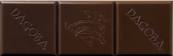  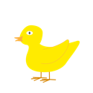 | 10.  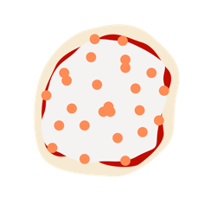  Is this a fair share?  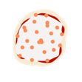  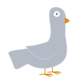  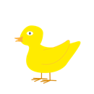
11.  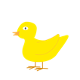  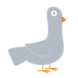  Is this a fair share? | 12.  Is this a fair share?  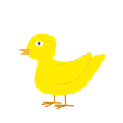  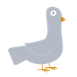
13.  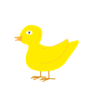  Is this a fair share? | 14.  Is this a fair share?  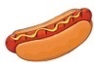  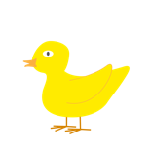  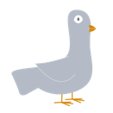
17.  Is this a fair share?  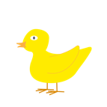 | 18.  Is this a fair share?  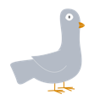  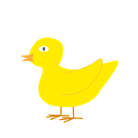  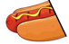

Chocolate Bar. (n.d.). https://i.stack.imgur.com/1mZPB.jpg

Cookie. (n.d.). https://1.bp.blogspot.com/-94XK-zMZLFI/Tk5ekLtwDgI/AAAAAAAADs4/dEjtNbQsvXc/s400/Cookie.gif

Duck. (n.d.). https://pixabay.com/vectors/duck-bird-duckling-yellow-cute-4525218/

Hot Dog. (n.d.). https://as1.ftcdn.net/jpg/02/65/57/58/220_F_265575805_ivE7dEFyoVAaUdVDUi2phiqp6WGqzfAX.jpg

Pizza. (n.d.) https://pngimg.com/uploads/pizza/pizza_PNG43974.png
Puppy. (n.d.). https://i.stack.imgur.com/aMUMt.jpg?s=328&g=1
Willems, M. (2012). The Duckling Gets a Cookie!?. Hyperion Books for Children.

