Joseph Stalin’s name meant "man of steel." He supervised the war machine that helped defeat Nazism. He became the supreme ruler of the Soviet Union for a quarter of a century. He caused the death and suffering of tens of millions of people. He ruled the Soviet Union with an iron hand and transformed it into a major world power.

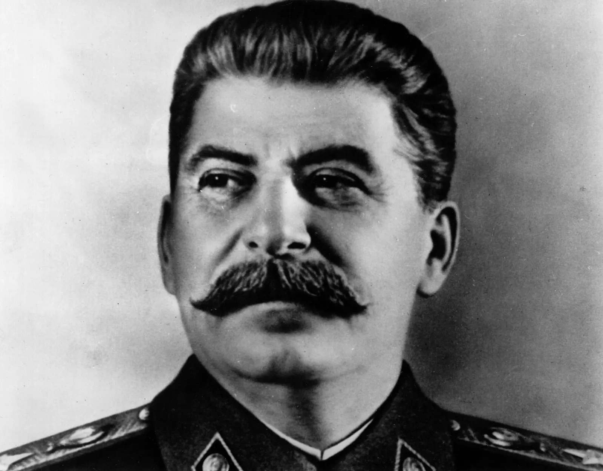
Conditions Under Which Stalin Came to Power
Stalin was born on December 18, 1879, in Gori, Georgia. He was named Iosif (Joseph) Vissarionovich Dzhugashvili. He was born into extreme poverty. His mother was a washerwoman. His father was a cobbler. Like many children born into poverty, his childhood was a struggle. He caught smallpox at the age of seven. He was left with pockmarks on his face. And later, he was involved in a hit and run carriage accident that left him with a deformed left arm. He was bullied by the other children and regularly beaten by his alcoholic father.

In August 1894, when he was fifteen, Stalin was sent to study for the priesthood. He was an outstanding student. He joined 600 trainee priests who boarded there. However, Stalin quickly lost interest in his priestly studies. He was punished often for his behavior, and he gave up on becoming a priest and declared himself an atheist. He joined a local socialist group and devoted his time to overthrowing the wealthy class.

After leaving the seminary, Stalin carried on with his revolutionary activities. He organized strikes and protests. His activities became known to the Tsarist secret police. He was forced to go into hiding to avoid being arrested. He joined the Bolshevik party. He conducted guerrilla warfare in the 1905 Russian Revolution. In 1907, he stole 250,000 rubles (approximately $3.4m in US dollars) in a bank robbery to fund his revolutionary inclinations. After the bank robbery, Stalin and his family escaped Tsarist forces by traveling to Azerbaijan. In 1907, his wife died of typhus. Stalin left his son with his wife’s parents. He threw himself into his revolutionary work. At this time, he adopted the name Stalin. He was arrested on a number of occasions and sent to Siberia in 1910. Stalin spent several years in exile. Russia entered the First World War in 1914 to support the Serbs and their French and British allies. In 1916, Stalin was drafted into the Russian army. Because of his crippled arm, he was rejected.

Use of the Military
In 1917, Stalin became a hero when he helped Vladimir Lenin escape the Tsar Nicholas’ army into Finland. At their first meeting, he impressed Lenin by what he called a ‘ruthless underground operator.’ At this time, Stalin was appointed to an important position in the Bolshevik party. The Tsar was soon overthrown, and the country erupted into civil war. Lenin took power in November 1917. He appointed Stalin as General Secretary of the Communist Party. The violent revolution marked the end of the Romanov family and centuries of imperial rule. Stalin gained new skills working for officials in the party. To prove himself to them, Stalin ordered the public execution of deserters. People who did not support their point of view were also executed.

After the Bolshevik revolution, Civil War erupted between two armies. The Red Army fought for Lenin’s Bolshevik government. The White Army was a loosely organized Allied force. The White Army supported democratic socialism. The Civil War ended in 1923 with Lenin’s Red Army claiming victory.

The winning side established what we know today as the Soviet Union. Many in the party expected Red Army leader Leon Trotsky to become Lenin’s natural successor. Trotsky’s goals were too idealistic for the majority of the Communist Party. Stalin developed his own nationalistic brand of Marxism – "Socialism in One Country.” His brand concentrated on strengthening the Soviet Union rather than taking over the world. Trotsky criticized his plans, so Stalin had him exiled. Stalin’s ideas were popular with the party. After Lenin died in 1924, Stalin promoted himself as the leader.

Methods Used to Acquire Territory and Power
Lenin appointed Stalin as General Secretary. He was given a free hand in making appointments. He locked in his supporters. When Kamenev and Zinoviev opposed Stalin, they were removed from the Central Committee and were exiled in 1929. Stalin was recognized as the party’s supreme leader. He believed that if the Soviet Union did not modernize, then Communism would fail. He thought that the country would be destroyed by its capitalist neighbors. He managed huge increases in coal, oil, and steel productivity. The country saw massive economic growth. He enforced his own plans for growth. He gave factories high production targets. He knew they would be impossible to fulfill. Those who failed to meet their quota were accused of being unfaithful and were sent to prison or executed. Stalin became increasingly paranoid. He killed anyone who opposed him. Ninety three of the 139 Central Committee members were killed. Eighty one of the 103 generals and admirals were executed. The secret police strictly enforced Stalinism. People were encouraged to inform on one another. Three million people were accused of opposing Communism. These people were sent to the gulag, which was a system of labor camps in Siberia. Around 750,000 people were killed.

Methods Used to Maintain Control
During World War II, Stalin emerged as the most successful of the supreme leaders. In 1939, he came to an agreement with Hitler. He encouraged the German dictator to attack Poland and begin World War II. Stalin claimed eastern Poland, Estonia, Latvia, Lithuania, and parts of Romania for Russia. In 1941, Stalin appointed himself chairman of the Council of People’s Commissars. In the winter of 1942, he organized a successful Soviet defense of the city of Stalingrad. The defense stopped the German advance into the Soviet Union. It turned the tide of war in favor of the Allies.
After the war, Stalin imposed extreme control on eastern Europe. He attempted to control the United States and Great Britain, too. Imposing a Marxist way of life, Stalin became increasingly suspicious and paranoid. Stalin ordered the arrests of Kremlin doctors on charges of medically murdering various Soviet leaders. When he died on March 5, he was acknowledged as a strict dictator. He was remembered as a man who increased the Soviet Union’s overall industrial output, surpassed only by the United States.
Stalin imposed severe living conditions on most Russian citizens. The Soviet Union was able to play a major part in defeating Hitler and maintained its position as the most powerful industrial and military complexes in the world.
In 1947, the Cold War began. Soviet forces took over most of Eastern Europe and East Berlin. Stalin blocked entry to allied-occupied West Berlin. In August 1949, the Soviet Union under Stalin tested its first atomic bomb in Kazakhstan. The success of this experiment delighted Stalin and other Russian officials. It sent a message to the western world that Russia was not to be underestimated.
Stalin’s iron-fisted rule over the Soviet Union ended on Sunday, March 5, 1953. He died alone in his bedroom after suffering a stroke. His funeral was performed with military honors. It was attended by hundreds of thousands of citizens paying their respects. His body was buried in Lenin’s Mausoleum.

