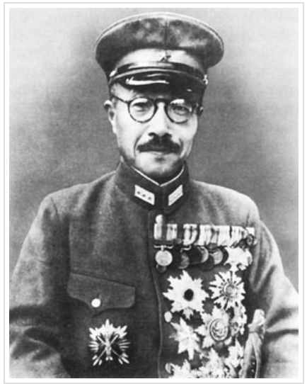
Hideki Tojo was head of Japan’s government during most of World War II. He was both general of the Imperial Japanese Army and Prime Minister of Japan. Historians refer to him as the ‘Military Leader’ of Japan during World War II. During this period, Emperor Hirohito was the supreme leader. The Emperor was viewed as a living god by his people. He was not held accountable for the terrible things done in his name. Instead, the General of the Army, Hideki Tojo, took responsibility for one of the most horrific events of World War II – the Japanese bombing of Pearl Harbor.

​Conditions Under Which Tojo Came to Power
Tojo was born into a low-ranking samurai family. Tojo worked his way up in the Imperial Japanese Army. As a boy, Tojo was known for his stubbornness. He lacked any sense of humor, and he frequently got into fights with other boys.

Tojo began his career in the Army in 1902 as a minor officer in the infantry. Between 1919-1922, he served as the Japanese military coordinator to Germany. The Japanese Army had been trained by the German military in the 19th century. The two countries stayed connected with one another. So it was natural for Germany’s hatred of America to influence Japanese military leaders. It was not difficult for the Japanese to dislike Americans. In 1924, Tojo was greatly angered when the American Congress passed the Immigration Control Act. This law banned all Asian immigration into the United States. Tojo was angered by American attitudes. He believed they would never accept Asians as equals. In his words, the immigration law showed how “the strong will always put their own interests first. Japan, too, has to be strong to survive in the world.”

In 1928, Tojo took a stronger interest in politics. He disliked Western cultural influence on Japan. He believed that American influence was bad for traditional Japanese families. Traditional Japanese values were needed to maintain the “essence of Japanese culture.” He directed his anger at any country that did not appreciate Japanese culture. In 1934, he was promoted to the position of major general. This promotion put him in command of the 24th Infantry Brigade of the Imperial Japanese Army. Tojo was a strong supporter of all things Japanese. He believed that Japan could obtain its goals and expand its territories by taking over surrounding countries. Tojo continued his rise to power in 1935. He was given command over the Kwantung Army in Manchuria, a region in northeastern China. He returned to Japan in 1938. There he continued to gain power in the Japanese military.

Use of the Military
​In July of 1940, Tojo was appointed as Army Minister by Japanese Prime Minister Fumimaro Konoe. This appointment gave him even greater influence in the Japanese government. Tojo had been chosen because he was a strong-minded commander. Tojo was in line with Prime Minister Konoe’s own personal views. Tojo and Konoe believed in an extreme form of nationalism that promoted total loyalty to the nation. This meant promoting hatred and violence against others who did not share their point of view.

​Alliance with Germany and Italy would put him in direct conflict with America. Under Tojo’s guidance as Army Minister, Japan was set to join Nazi Germany and Fascist Italy. The three countries agreed to a military alliance in September of 1940. This group was referred to as the Tripartite Pact. At the same time, Tojo was asked to make peace with the Allied Powers of World War II and the United States. However, the growing tensions from the start of World War II made this unlikely. Prime Minister Konoe was criticized because of the growing possibility of a war with the Allied Powers. As a result, Konoe resigned as Prime Minister in October of 1940. He was replaced by Tojo.

Methods Used to Acquire Territory and Power
Tojo ruled Japan as a military dictator. Tojo’s leadership over Japan was based on several key principles. First, Tojo demanded extreme loyalty to Emperor Hirohito. The Japanese believed the Emperor was a living god. He deserved the utmost respect. Tojo expected his soldiers to die before being captured. Tojo and other government officials promoted this belief to Japanese soldiers through powerful propaganda. To prove their loyalty to the Japanese government, Tojo supported the long-held Japanese belief of bushido. Originating with the Samurai, ‘Bushido’ translates to ‘the way of the warrior.’ This practice intended Japanese soldiers to willingly die – even by suicide – before dishonoring their Emperor.

In 1937, Japan started a war with China. Tojo expanded Japan’s military presence in China to force the Chinese to support Japan. After joining forces with Nazi Germany and Fascist Italy, on December 8, 1941, Tojo announced on Japanese radio that Japan was at war with the United States, the British Empire, and the Netherlands. In May 1942, Tojo presented a host of “non-negotiable” demands to the Allies. The demands gave Japan control of eight British Crown colonies, including Australia and New Zealand, three American states (Washington, Alaska, and Hawaii), and most of Latin America.

Methods Used to Maintain Control
Tojo was eager to engage the United States in war. He described a note written by American Secretary of State, Cordell Hull, as an ultimatum, demanding that Japan remove its troops from China. Tojo met with the Japanese cabinet on November 27, 1941. He reported this ultimatum. Toyo was given permission to start the war. Tojo maintained his position as army commissioner. The Japanese continued on to victory after victory. The Japanese leaders and Tojo were convinced that Japan was invincible. They felt sure they would win the war.

As the war continued, the Japanese navy and air force were destroyed. Intensive bombing of Japanese cities devastated the country. Japanese propaganda portrayed American soldiers as arrogant and bullying white supremacists. So, the Japanese code of honor prevented surrender. Instead of surrendering, Japanese soldiers voluntarily killed themselves. Soldiers charged at American defensive lines even though they had no weapons. American soldiers shot and killed them. Japanese soldiers were also known to kill themselves by ritual suicide. Seppuku was an act which involved stabbing a sword into their own stomachs. Some soldiers killed themselves by pulling the pin of a grenade and holding it until it exploded. This extreme loyalty was typical of the Japanese soldiers. They were expressing loyalty to their Emperor and their nation.

After Japan’s unconditional surrender in 1945, U. S. General Douglas MacArthur ordered Tojo’s arrest for war crimes. American troops surrounded his house on September 11. Tojo attempted to kill himself by shooting himself in the heart, but he was saved from dying. He was tried by the International Military Tribunal for the Far East on a number of charges. Fourteen million civilians and prisoners of war died through massacre, human experimentation, starvation, and forced labor. Tojo was sentenced to death on November 12, 1948. He was executed by hanging on December 23, 1948.

