Molly Burkhart, a full-blooded Osage woman with 3 sisters and mother

SOLO Hexagons

Unistructural LO - single hexagon.
Multistructural LO - several separate hexagons.
Relational LO - connected hexagons (explain the cause for connecting two edges).
Extended abstract - tessellated hexagons (generalise about the vertex where three hexagons meet).

Nathan Hale, King of the Osage Hills

It took an Osage Tribal Council request in 1923, along with payments of $20,000 to the Department of Justice, to persuade the U.S. to investigate.

SOLO Hexagons

Unistructural LO - single hexagon.
Multistructural LO - several separate hexagons.
Relational LO - connected hexagons (explain the cause for connecting two edges).
Extended abstract - tessellated hexagons (generalise about the vertex where three hexagons meet).

Anna Brown, a full-blooded Osage woman, older sister to Molly Burkhart

Again and again, the hand of death struck, quickly and effectively. None of the victims attacked was ever left alive, crippled or maimed, to tell the story.

SOLO Hexagons

Unistructural LO - single hexagon.
Multistructural LO - several separate hexagons.
Relational LO - connected hexagons (explain the cause for connecting two edges).
Extended abstract - tessellated hexagons (generalise about the vertex where three hexagons meet).

J. Edgar Hoover, Director of the US Bureau of Investigation

Guardianship - the position of protecting or defending something or someone

SOLO Hexagons

Unistructural LO - single hexagon.
Multistructural LO - several separate hexagons.
Relational LO - connected hexagons (explain the cause for connecting two edges).
Extended abstract - tessellated hexagons (generalise about the vertex where three hexagons meet).

Incompetence - not having the necessary mental skills to do something successfully

Million Dollar Elm
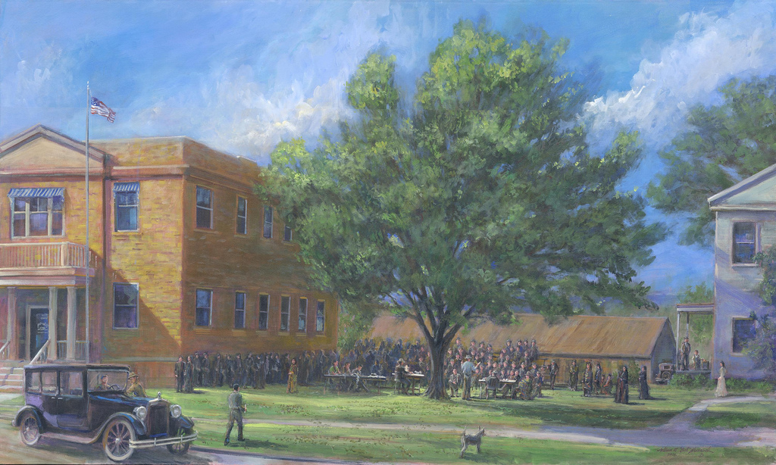

SOLO Hexagons

Unistructural LO - single hexagon.
Multistructural LO - several separate hexagons.
Relational LO - connected hexagons (explain the cause for connecting two edges).
Extended abstract - tessellated hexagons (generalise about the vertex where three hexagons meet).

In 1871, the Osage were displaced again and forced to move to Oklahoma. However, unlike other tribes, the Osage sold their land in Kansas and bought their land in OK.

In 1887, Congress passed the General Allotment Act, also known as the Dawes Act, which divided communal tribe lands into individual plots.

SOLO Hexagons

Unistructural LO - single hexagon.
Multistructural LO - several separate hexagons.
Relational LO - connected hexagons (explain the cause for connecting two edges).
Extended abstract - tessellated hexagons (generalise about the vertex where three hexagons meet).

People received payments worth over $100,000 a year in inflation-adjusted terms. They bought fancy clothes, big houses, and nice cars.

