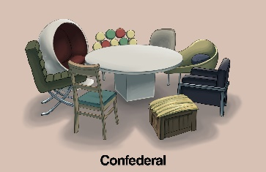 | 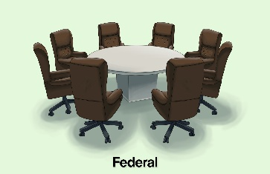 |  | The central government could be slow to respond to local issues. | Services can be offered at multiple levels of government.
Laws are the same throughout the country. | Local problems might take longer to be addressed by the central government. | There might be disputes between states and the federal government. | Each state has their independence but cooperates loosely with other states for a specific purpose. | The power of the government is at the local level.
There is a sense of national unity, but local areas can make laws that best suit their needs. | The central government might be too weak to be considered effective. | Decisions can be made fast and efficiently for the entire country. | Power is concentrated in one central area. | Laws are different from state to state.

Systems Card Sort

