# H-Chart

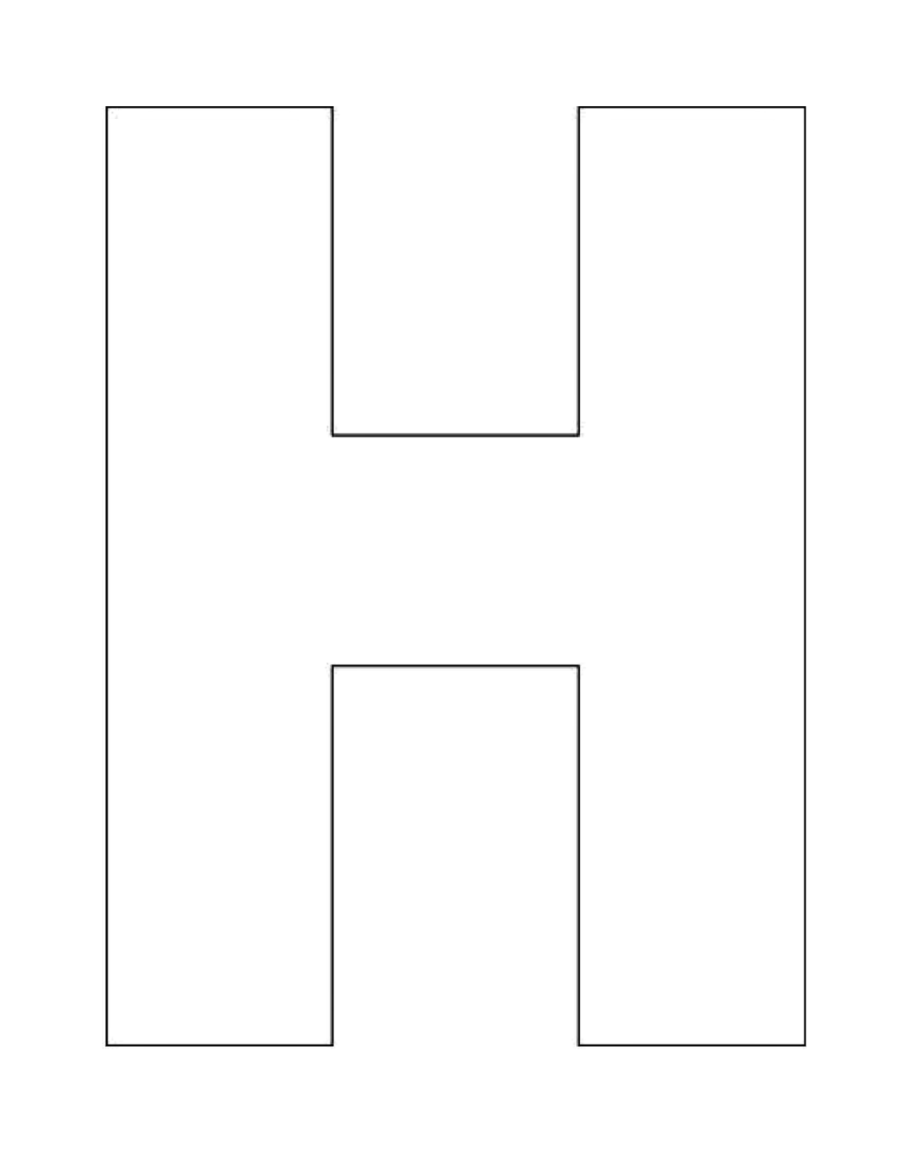

Texts Together

Separate Text

Separate Text