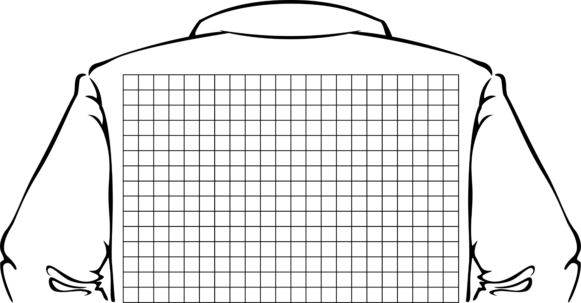
Translating Me

1) Write the algebraic rule that represents the translation from the preimage to image 1. | 2) Write the translation from the preimage to image 2 using vector notation.
3) Caption:

