Exploring Ribbonwork (Part A)

Completing the Pattern
Below is part of an Osage ribbonwork pattern. Part of the arrow pattern is the unshaded preimage (image 1) and two new images: image 2 and image 4, each in their respective quadrants. Use image 2 or image 4 to complete the pattern in Quadrant III. Label this new image as image 3.

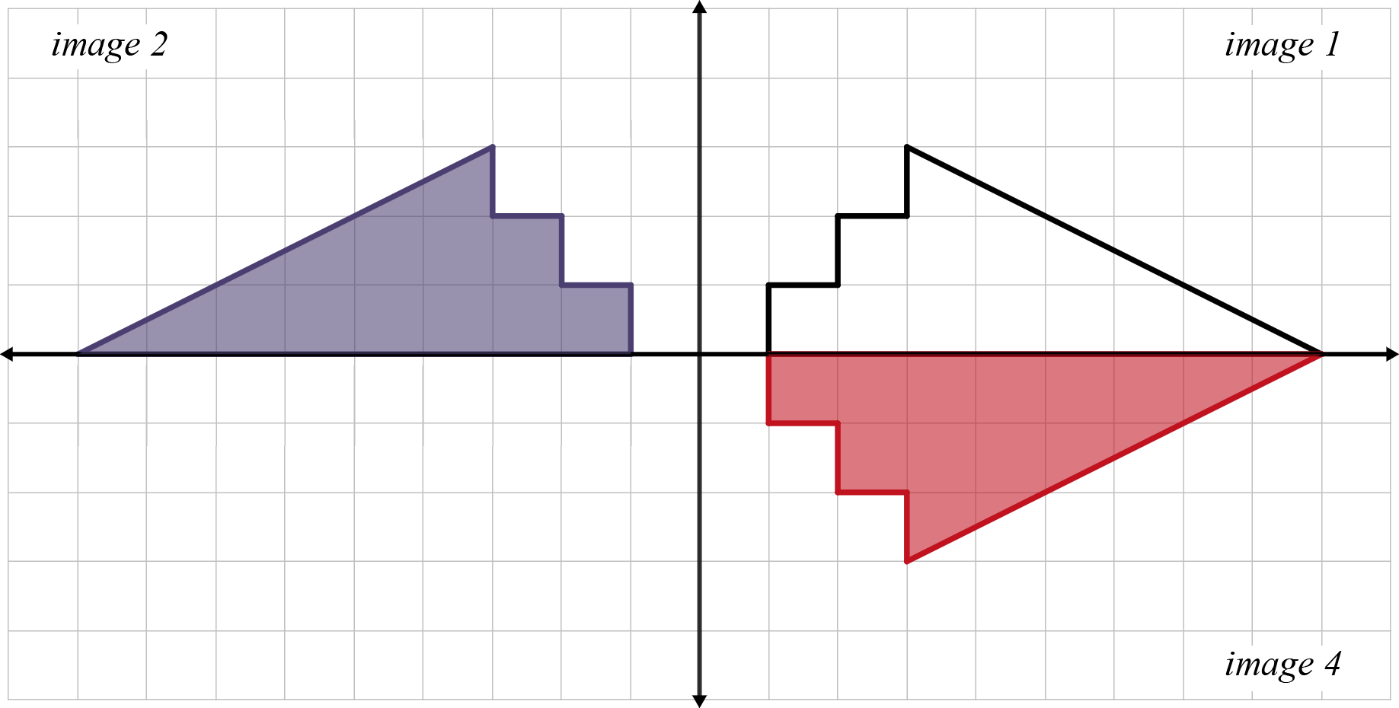
1) How did you complete the pattern?

2) Do your best to describe how the preimage transformed into image 2.

3) Do your best to describe how the preimage transformed into image 4.

