Perfecting Patterns
Student A: _______________  Create your own polygon design (preimage) in Quadrant II, using the space provided below:  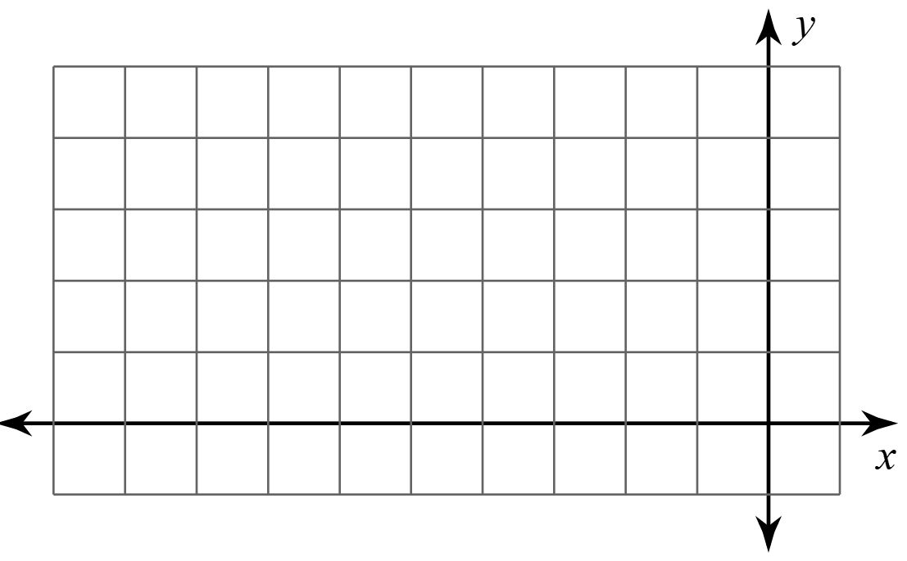 | Student B: _______________  Label the vertices of Student A’s design. This design is the preimage. Then create a table for the corresponding vertices of the image created by reflecting the preimage over the x-axis.
Student C: _______________  Check Student B’s work. Then create a table for the corresponding vertices of the image created by reflecting the preimage over the y-axis. | Student A: _______________  Copy your preimage onto a piece of graph paper. Then plot the points from Student B’s and Student C’s tables.  Are there any points that need to be corrected? If so, work together to adjust the point(s).

