Seeing Symmetry
- A line of symmetry cuts a figure into two mirror images.
Write equation(s) of the line(s) of symmetry for each of the following ribbonwork designs.
1) | 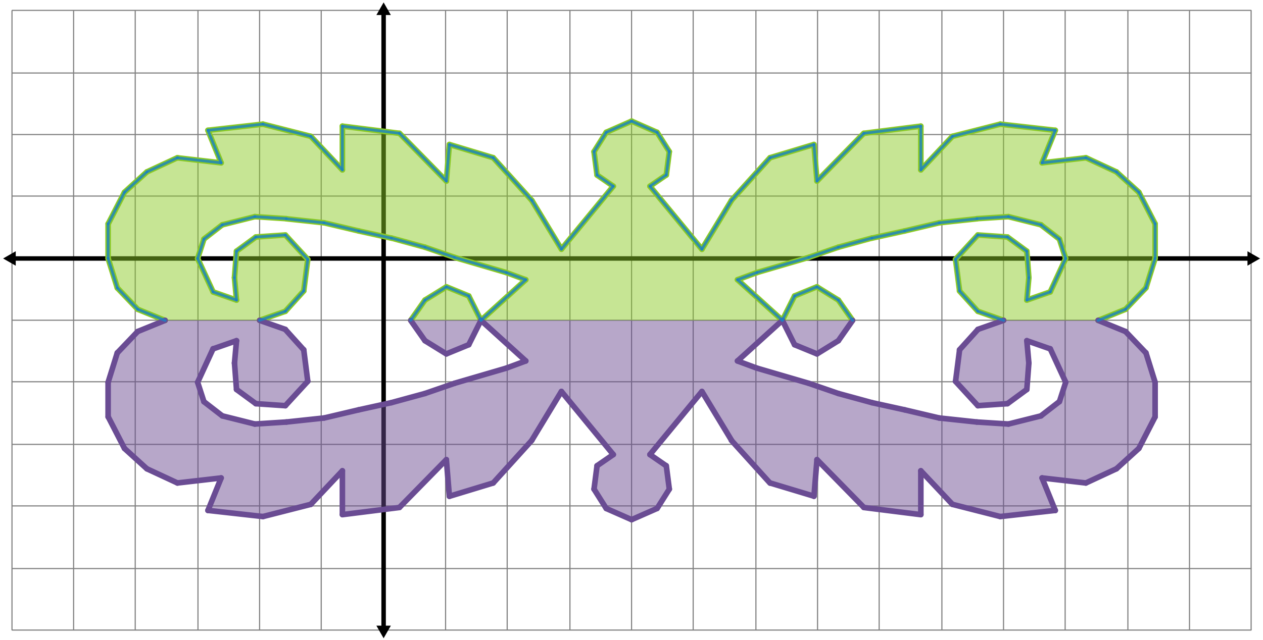
2) | 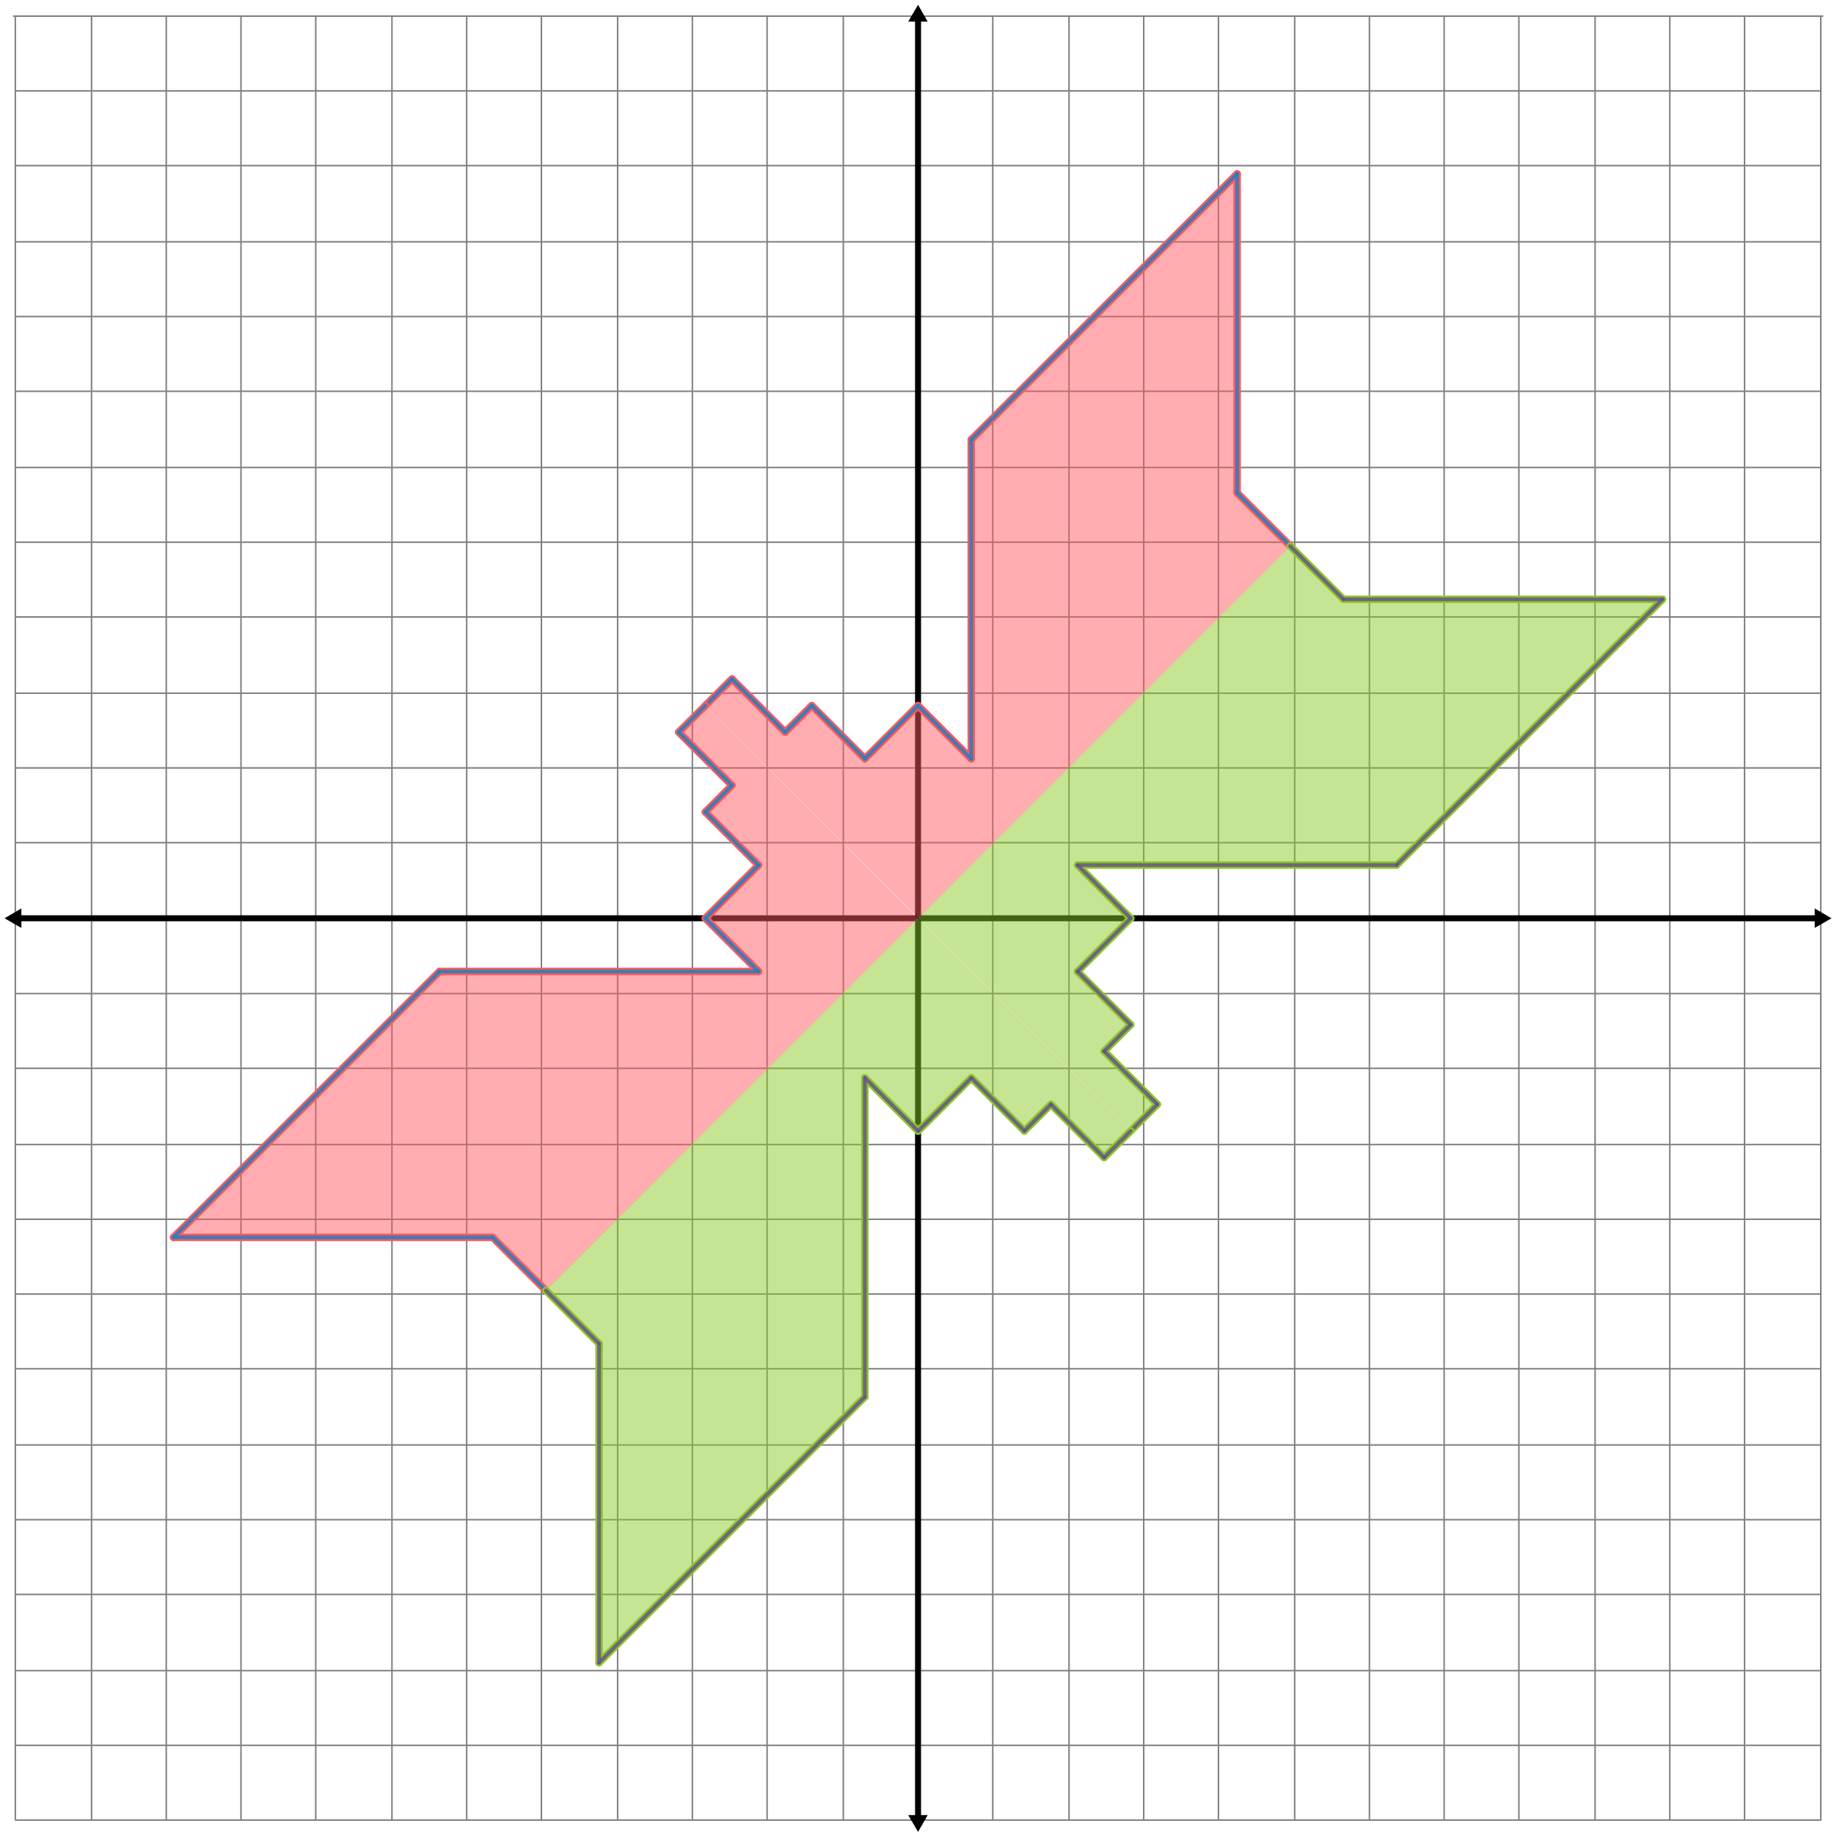
3) | 