Guided Notes (Model Notes)

# Vocabulary

* **Rotation**:a type of transformation where a preimage is spun by a certain angle measure around a fixed point that is the center of rotation.
* **Angle of rotation:** the number of degrees by which the preimage is rotated.

|  |  |  |  |
| --- | --- | --- | --- |
|  | * **Clockwise (CW):** the direction in which the hands on a clock move |  | * **Counterclockwise (CCW):** the opposite direction in which the hands on a clock move |

*Assume rotations to be counterclockwise unless stated otherwise.*

Is a rotation an example of rigid motion? Write your answer below.

*Yes, because the preimage and image are congruent.*

# Special Rotations: Algebraic Rules

Fill in the blanks below.

|  | Rotate about the origin … | Algebraic Rule |
| --- | --- | --- |
| … 90° CCW |  |
| … 180° CCW |  |
| … 270° CCW |  |

* Rotating a figure 90° CCW is the same as rotating that figure 270° CW.
* Rotating a figure 180° CCW is the same as rotating that figure 180° CW.
* Rotating a figure 90° CW is the same as rotating that figure –90° CCW.

# Applying Algebraic Rules

**1)** On the table below, draw the rotated image on the graph based on the provided preimage. Then, write a verbal description of the transformation.

| Graph | Verbal Description | Algebraic Rule |
| --- | --- | --- |
|  | *Rotate the preimage 180° about the origin.* |  |

# Other Rotations

**2)** What if we rotate a figure around a point that is not the origin? Rotate the following preimage 270°   
about the point **.

**3)** How should we transform a preimage that is not on a coordinate plane? Rotate the primage below 120° about the given center of rotation, *R*. Draw the rotated image and mark its vertices.

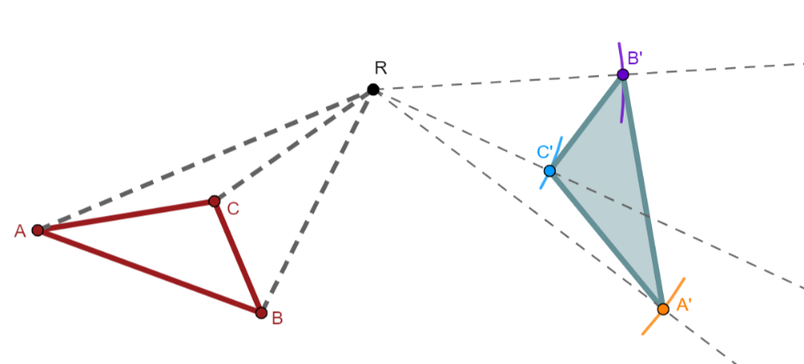

Guided Notes (Teacher Guide)

# Example 3

Constructing a rotation with a compass and protractor.

| Construction | Instruction |
| --- | --- |
|  | **Step 1:** Use the protractor to draw a line from  to . |
|  | **Step 2:** Use the protractor to measure 120° clockwise around . Leave a mark at 120°. |
|  | **Step 3:** Draw a light line from  through the mark. |
|  | **Step 4:** Use the compass to measure the distance from  to . |
|  | **Step 5:** Use the compass measurement as the radius to construct an arc that intersects the 120° line. Label the intersection point . |
|  | **Step 6:** Repeat steps 1–5 for to draw *B* ' and *C* '.  *. This will also be the case for  and .* |
|  | **Step 7:** Use the protractor to draw lines that connect *A* ', *B* ', and *C* '. |