Guided Notes (Model Notes)

# Vocabulary

* **Dilation:** a type of transformation where a preimage is resized with respect to a fixed point and a certain ratio; the preimage is **enlarged or reduced** by a *scale factor, k*
* **Scale Factor:** *k*; the ratio of corresponding side lengths of the preimage to image
* **Center of Dilation:** the fixed (unchanging) point, which is the origin unless stated otherwise, that the image dilates from

Is a dilation an example of rigid motion?

*No, because the preimage and image are similar, not congruent*

# Scale Factors (*k*-Values):

| Graph |  |  |  |
| --- | --- | --- | --- |
| *k*-values | *k > 1* | ***0 < k < 1*** | *k < 0* |
| Verbal | *enlargement,*  *magnification,*  *scale up, zoom in,*  *increase the size* | *reduction,*  *shrinkage,*  *scale down, zoom out,*  *decrease the size* | *resized and rotated 180°* |

# Algebraic

* When the center of the dilation is at the origin, then the ***algebraic rule*** is **.
* If , then the scale factor: .

# Applying Algebraic Rules

**1)** Draw the image and complete the table below for the unshaded preimage.

| Graph | Verbal Description | Algebraic Rule |
| --- | --- | --- |
|  | The image is a dilation   centered at the origin  with a scale factor of . |  |

# Other Centers of Dilation

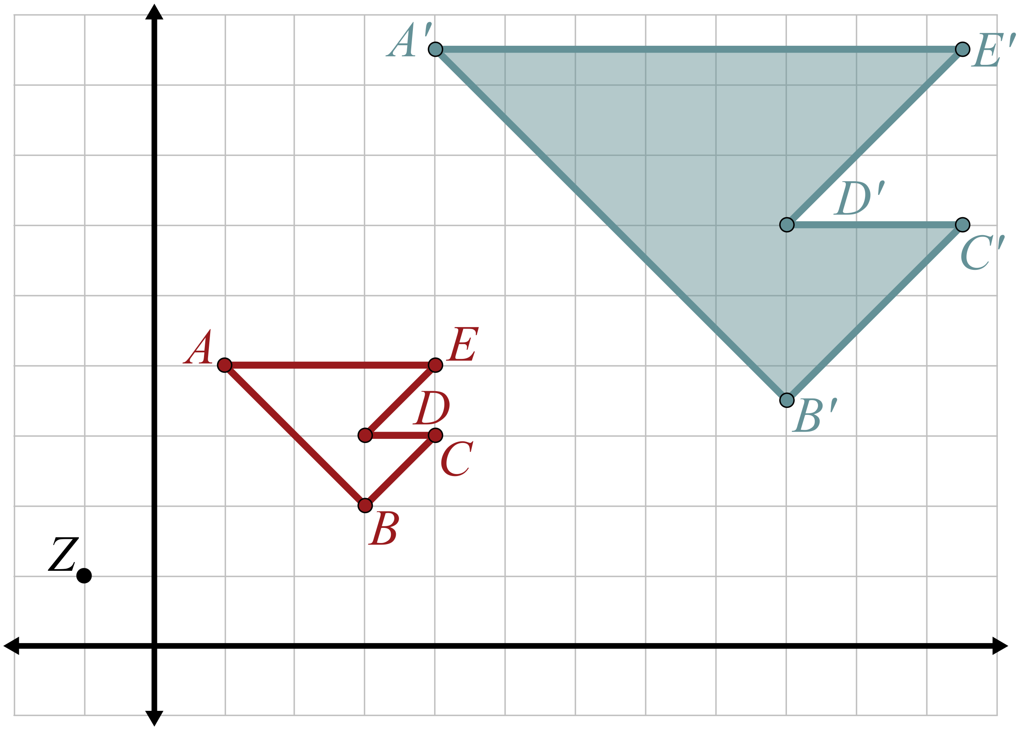**2)** What if we dilate a figure with respect to a   
point other than the origin? Dilate the following   
preimage with a center of dilation at   
point  and a scale factor of 2.5.

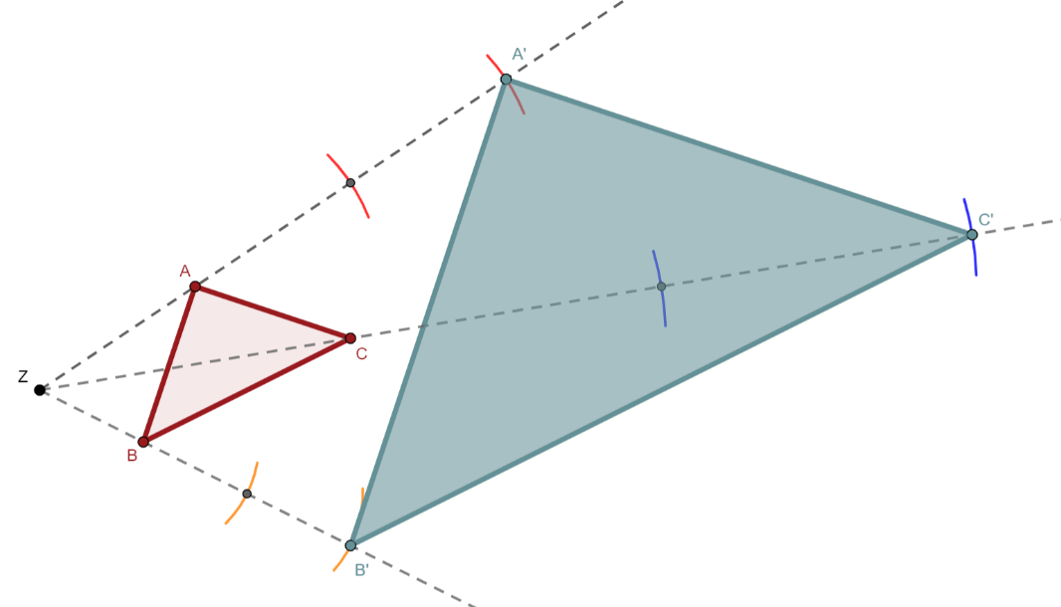**3)** What if the preimage was not on the coordinate plane? How would we construct the image? Construct the image given the following preimage and the given center of dilation, *Z*, dilating it using .

Guided Notes (Teacher Guide)

# Example 3

How to construct a dilation with a compass and straightedge.

| Construction | Instruction |
| --- | --- |
|  | **Step 1:** Use the straightedge to draw a ray from the center of dilation, , through . |
|  | **Step 2:** Use the compass to measure the distance from  to . |
|  | **Step 3:** Use this measurement to construct an arc with a center at  along the line from Step 1. |
|  | **Step 4:** Repeat Step 3 but now with the center at the intersection of the arc and line from Steps 2. Label that point of intersection .  *Notice the length of  is three times the length of .* |
|  | **Step 5:** Repeat Steps 1-4 for the remaining points. |
|  | **Step 6:** Use the straightedge to create the polygon (image). |