Dilations: Guided Notes

# Vocabulary

* **_____________:** a type of transformation where a preimage is resized with respect to a fixed point and a certain ratio; the preimage is **enlarged or reduced** by a *scale factor, k*
* **_______________:** *k*; the ratio of corresponding side lengths of the preimage to image
* **________________:** the fixed (unchanging) point, which is the origin unless stated otherwise, that the image dilates from

Is a dilation an example of rigid motion?

# Scale Factors (*k*-Values):

| Graph |  |  |  |
| --- | --- | --- | --- |
| *k*-values | *k > 1* | ***0 < k < 1*** | *k < 0* |
| Verbal |  |  |  |

# Algebraic

* When the center of the dilation is at the origin, then the ***algebraic rule*** is **
* If , then the scale factor: 

# Applying Algebraic Rules

**1)** Draw the image and complete the table below for the unshaded preimage.

| Graph | Verbal Description | Algebraic Rule |
| --- | --- | --- |
|  | The image is a dilation   centered at the origin  with a scale factor of . |  |

# Other Centers of Dilation

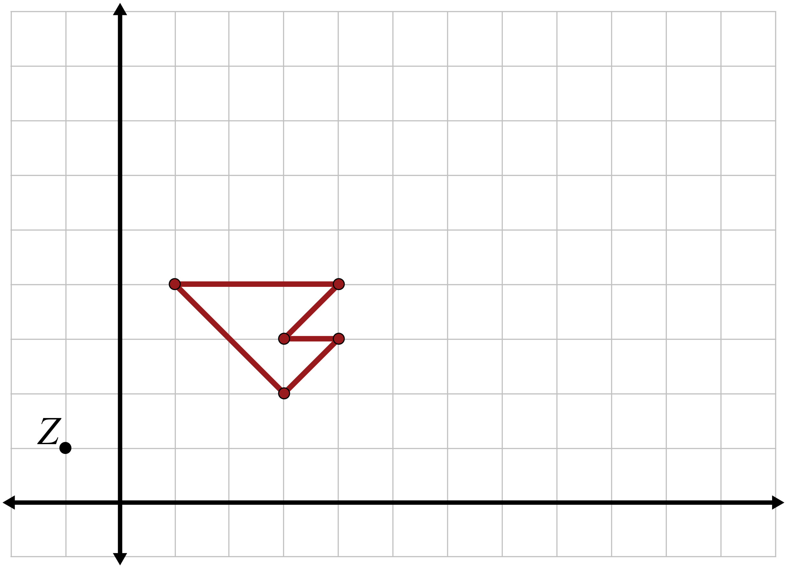**2)** What if we dilate a figure with respect to a   
point other than the origin? Dilate the following   
preimage with a center of dilation at   
point  and a scale factor of 2.5.

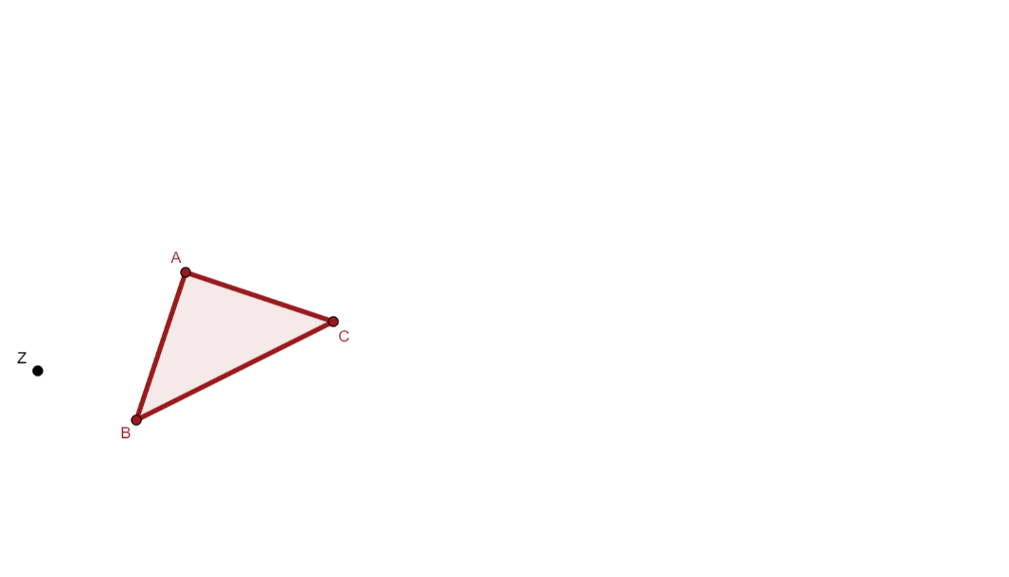**3)** What if the preimage was not on the coordinate plane? How would we construct the image? Construct the image given the following preimage and the given center of dilation, *Z*, dilating it using .