Composition Exit Ticket

Use the unshaded preimage and shaded image below to determine the unknown transformation.

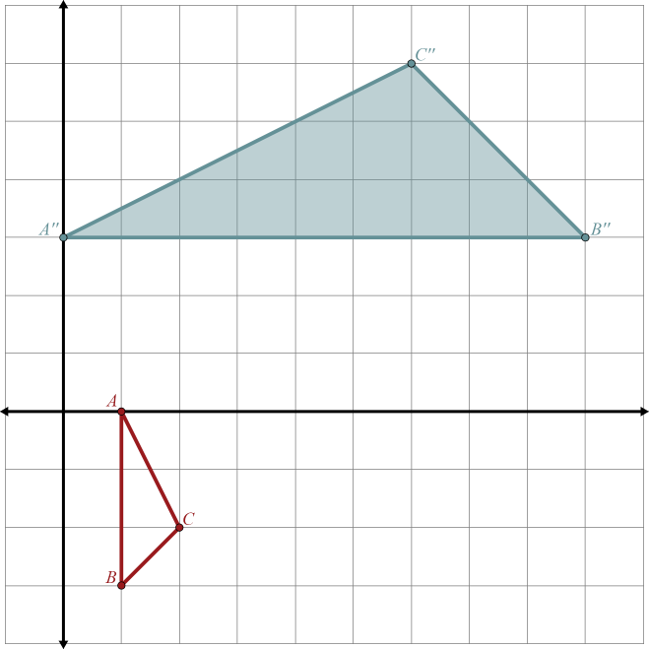

**First Transformation:**



**Second Transformation:**

Rotate 90° about the origin



Traditional Transformations, Part 5

Composition Exit Ticket

Use the unshaded preimage and shaded image below to determine the unknown transformation.



**First Transformation:**



**Second Transformation:**

Rotate 90° about the origin