Multiple Transformations
In certain cases, a composition of transformations can be represented by a single transformation. Describe two different ways to transform the preimage into the image.

Example 1
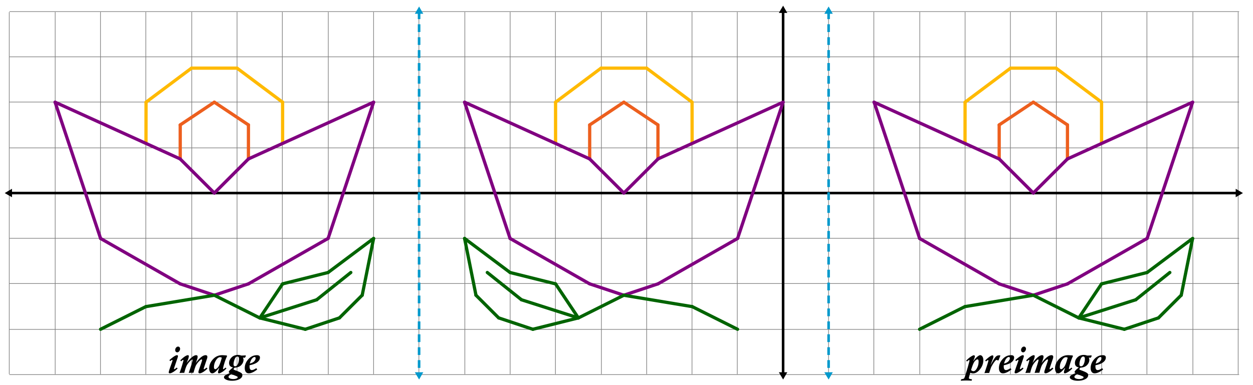

Example 2

