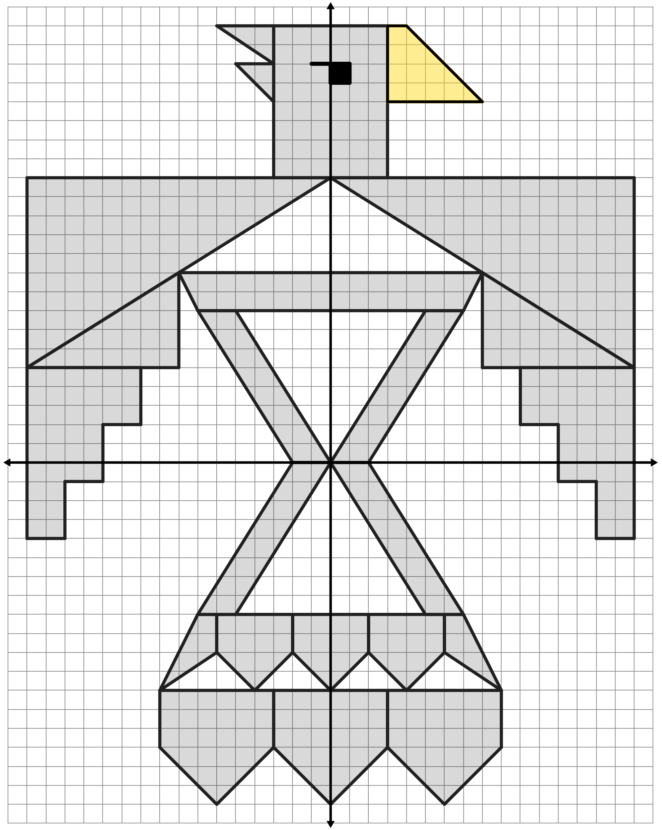
Transformation Puzzle: Graph (Key)

