Transformation Puzzle: Student A

Perform the following transformations for each given preimage.

|  |  |
| --- | --- |
|  | **1)** **Dilation:** *k* = 2  **Translation:**  **2)** **Dilation:** *k* = 2  **Translation:**  **3)** **Dilation:** *k* = 2  **Translation:** |
|  | **4)** **Translation:**  **5)** **Reflection:** over the *y*-axis  **Translation:**  **6)** **Reflection:** over the *x*-axis  **Translation:**  **7)** **Translation:**  **Rotation:** 180° |

Transformation Puzzle: Student A

Perform the following transformations for each given preimage.

|  |  |
| --- | --- |
|  | **8)** **Translation:** left 6 units and down 8 units  **9)** **Reflection:** over the *y* -axis  **Translation:** |
|  | **10)** **Translation:** |
|  | **11)** **Translation:**  **12)** **Translation:**  **Reflection:** over the *y*-axis |

Transformation Puzzle: Student B

Perform the following transformations for each given preimage.

|  |  |
| --- | --- |
|  | **1)** **Dilation:** *k* = 3  **Translation:**  **2)** **Dilation:** *k* = 3  **Translation:**  **3)** **Dilation:** *k* = 3  **Translation:** |
|  | **4)** **Translation:** right 4 units and up 19 units |
|  | **5)** **Reflection:** over the *y*-axis  **Translation:**  **6)** **Translation:** |

Transformation Puzzle: Student B

Perform the following transformations for each given preimage.

|  |  |
| --- | --- |
|  | **7)** **Translation:**  **8)** **Reflection:** over the *y*-axis  **Translation:**  **9)** **Dilation:** *k* = 2  **Rotation:** 180°  **Translation:**  **10)** **Dilation:** *k* = 2  **Rotation:** 180°  **Translation:**  **Reflection:** over the *y* -axis |
|  | **11)** **Rotation:** 270°  **Translation:** |
|  | **12)** **Dilation:**  **Rotation:** 90°  **Translation:** |

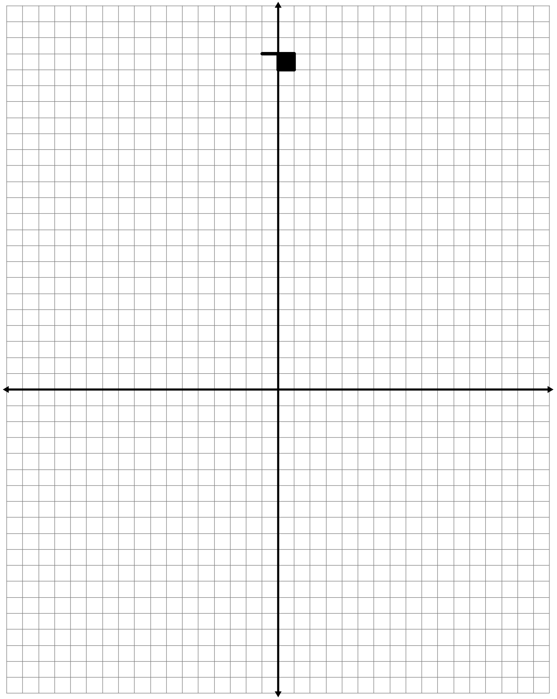 Transformation Puzzle: Graph