Carbon Is Not the Enemy

By William McDonough

Design with the natural cycle in mind to ensure that carbon ends up in the right places.
Carbon has a bad name. The 2015 Paris climate agreement calls for a balance between carbon dioxide emissions to the atmosphere and to earthbound carbon sinks. Climate Neutral Now, a United Nations initiative, encourages businesses and individuals to voluntarily measure, reduce and offset their greenhouse-gas emissions by 2050. The American Institute of Architects has challenged the architecture community worldwide to become carbon neutral by 2030. The Carbon Neutral Cities Alliance, an international network of urban-sustainability directors, aims to slash its cities' greenhouse-gas emissions by 80% by 2050.
‘Low carbon’, ‘zero carbon’, ‘decarbonization’, ‘negative carbon’, ‘neutral carbon’, even ‘a war on carbon’ — all are part of the discourse. If we can reduce our carbon emissions, and shrink our carbon footprint, the thinking goes, we can bring down the carbon enemy. It’s no wonder that businesses, institutions and policymakers struggle to respond.
But carbon — the element — is not the enemy. Climate change is the result of breakdowns in the carbon cycle caused by us: it is a design failure. Anthropogenic greenhouse gases in the atmosphere make airborne carbon a material in the wrong place, at the wrong dose and for the wrong duration. It is we who have made carbon toxic — like lead in our drinking water or nitrates in our rivers. In the right place, carbon is a resource and a tool.
Carbon dioxide is the currency of photosynthesis, a source of Earth’s capacity for regeneration. Soil carbon is the guarantor of healthy ecosystems and food and water security. Carbon atoms are the building blocks of life. Wool, cotton and silk are carbon compounds, as are many industrial polymers and pure ‘supercarbons’ such as diamonds and graphene.
After 30 years of designing sustainable buildings and landscapes that manage carbon, I believe it is time to breathe new life into the carbon conversation. Rather than declare war on carbon emissions, we can work with carbon in all its forms. To enable a new relationship with carbon, I propose a new language — living, durable and fugitive — to define ways in which carbon can be used safely, productively and profitably. Aspirational and clear, it signals positive intentions, enjoining us to do more good rather than simply be less bad.

Words Drive Actions
It is easy to lose one’s way in the climate conversation. Few of the terms are clearly defined or understood. Take ‘carbon neutral’. The European Union considers electricity generated by burning wood as carbon neutral — as if it releases no CO₂ at all. Their carbon neutrality relies problematically on the growth and replacement of forests that will demand decades to centuries of committed management. Another strategy is to offset fossil-fuel use by renewable-energy credits — this still means an increase in the global concentration of atmospheric CO₂.
Even more confusing is the term ‘carbon negative’. This is sometimes used to refer to the removal of CO₂ from the atmosphere. For example, Bhutan’s prime minister has indicated that his country is carbon negative because its existing forests sequester more CO₂ than the country emits and Bhutan exports hydroelectric power (see go.nature.com/2es9lgt). But aren’t trees having a positive effect on atmospheric carbon, and hydroelectric power a neutral one?
Carbon sequestration is a long-sought goal. It requires two elements: a way to capture carbon from the atmosphere or a chimney and a way to store it safely and permanently. But some so-called carbon-storage methods are paradoxical. For example, in enhanced oil recovery, CO₂ is injected into rock formations to flush out remnant crude oil, which is eventually burned.
At the same time, enterprises are starting to announce their hopes to be ‘carbon positive’ by, for example, producing more renewable energy than their operations require, or by sequestering carbon through planting trees.
Such terms highlight a confusion about the qualities and value of CO₂. In the United States, the gas is classified as a commodity by the Bureau of Land Management, a pollutant by the Environmental Protection Agency and as a financial instrument by the Chicago Climate Exchange.
A new language of carbon recognizes the material and quality of carbon so that we can imagine and implement new ways forward (see ‘The new language of carbon’). It identifies three categories of carbon — living, durable and fugitive — and a characteristic of a subset of the three, called working carbon. It also identifies three strategies related to carbon management and climate change — carbon positive, carbon neutral and carbon negative.

“To enable a new relationship with carbon, I propose a new language.”

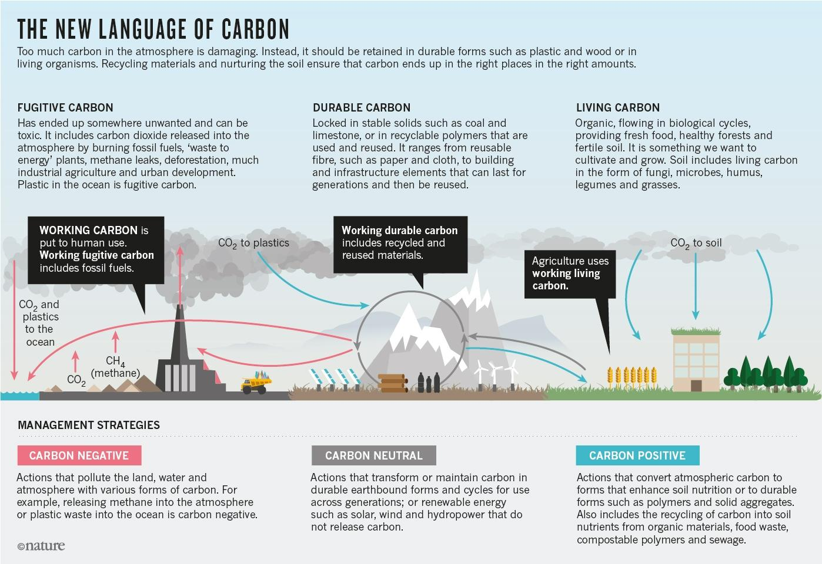
Source: McDonough Innovation.

Start With the Soil
How do we work with the carbon cycle to preserve and enhance the benefits it naturally provides? From the soil up.
Carbon is at the heart of soil health. In healthy ecosystems, when plants convert CO₂ into carbon-based sugars — liquid carbon — some flows to shoots, leaves and flowers. The rest nourishes the soil food web, flowing from the roots of plants to communities of soil microbes. In exchange, the microbes share minerals and micronutrients that are essential to plants’ health. Drawn into the leaves of plants, micronutrients increase the rate of photosynthesis, driving new growth, which yields more liquid carbon for the microbes and more micronutrients for the fungi and the plants. Below ground, liquid carbon moves through the food web, where it is transformed into soil carbon — rich, stable and life-giving. This organic matter also gives soil a sponge-like structure, which improves its fertility and its ability to hold and filter water.
This is how a healthy carbon cycle supports life. This flow kept carbon in the right place in the right concentration, tempered the global climate, fuelled growth and nourished the evolution of human societies for 10,000 years.
Many soil researchers believe it could do so again. Ecologist and soil scientist Christine Jones, founder of the Amazing Carbon Project, describes the “photosynthetic bridge” between atmospheric carbon and liquid carbon, and the “microbial bridge” between plants and biologically active, carbon-rich soils as twin cornerstones of landscape health and climate restoration.
David Johnson at the New Mexico State University Institute for Energy and the Environment in Las Cruces has studied the carbon–microbial bridge. He found that the most important factor for promoting plant growth and cultivating soil carbon was not added nitrogen or phosphorus but the carbon inputs from other plants.

Design for Living
Let’s keep those carbon bridges open on all landscapes — rural and urban. Let’s use carbon from the atmosphere to fuel biological processes, build soil carbon and reverse climate change. Let’s adopt regenerative farming and urban-design practices to increase photosynthetic capacity, enhance biological activity, build urban food systems, and cultivate closed loops of carbon nutrients. Let’s turn sewage-treatment plants into fertilizer factories. Let’s recognize carbon as an asset and the life-giving carbon cycle as a model for human designs.
All designs — from products to buildings, cities and farms — could be carbon positive. This may take a century, but that’s how long it took us to get into our current carbon calamity. The sooner we start, the better. By 2030, our exuberantly urbanizing planet is expected to convert more habitat and farmland into cities than all previous urban growth combined. More than 2 billion urbanites will live in homes, attend schools and work in factories that are not yet built. Despite these challenges, there are models of hope.
In 1989 my architecture firm designed a day-care facility in Frankfurt, Germany, based on ‘a building like a tree’ that could be operated by children, who would move solar shutters, open and close windows, grow food on roof terraces and irrigate the gardens with rainwater.
The idea of ‘buildings like trees’ and ‘cities like forests’ endured, and we started to approach our product, building and city designs as photosynthetic and biologically active, accruing solar energy, cycling nutrients, releasing oxygen, fixing nitrogen, purifying water, providing diverse habitats, building soil and changing with the seasons.
The Adam Joseph Lewis Center for Environmental Studies at Oberlin College in Ohio, which we designed, is a built example of this philosophy. It purifies its wastewater and sewage in an on-site system that produces carbon-rich organic compost. This year the project is producing solar energy at an annual rate of 40% more than it needs. The building still relies on the electrical grid when solar energy is unavailable. Soon, with new and affordable on-site thermal and electric battery storage systems, buildings like this can be both carbon and energy positive.
In the Netherlands, Park 20|20 near Amsterdam applies these carbon-positive design strategies at the campus scale. Next door, the Valley at Schiphol Trade Park, the country’s national hub for the circular economy, will scale these and many other innovations to create an urban ecology of work, supply chains and collaborative spaces. The development will be a network of integrated buildings, landscapes and technical systems operating as a connected whole. Each building is oriented to the path of the Sun to maximize exposure during winter and shade during summer. Photovoltaic arrays and green roofs are the system’s leaves and roots, harvesting renewable energy, absorbing and filtering water, producing food and providing habitat for other living things in a vibrant, sustainable business community.
The energy sector, too, can be generously carbon positive. SunPower, based in San Jose, California, and other solar providers are developing ‘solar orchards’ — power plants that perform as working farms. Rotating arrays of elevated solar panels shade the earth and provide habitat for grassland, which captures water, nitrogen and carbon to build soil health, can include legumes to fix nitrogen, and can provide food for grazing animals, in turn providing protein and wool. By design, the power plant generates an abundance of benefits: renewable energy, biodiversity, food, soil restoration, nutrient cycling, carbon sequestration, water conservation, fibre products, and agricultural and manufacturing jobs. Thus, working durable carbon creates and supports living carbon while reducing fugitive carbon, all in an economically robust and profitable model.
Such designs offer an inspiring model for climate action. It all starts with changing the way we talk about carbon. Our goal is simple and positive: a delightfully diverse, safe, healthy and just world — with clean air, soil, water and energy — economically, equitably, ecologically and elegantly enjoyed.

Source
McDonough, W. (2016). Carbon is not the enemy. Nature 539, 349–351. https://doi.org/10.1038/539349a

