NESSIE INFORMATIVE WRITING SAMPLE

Introduction
Cryptozoologists have spent years trying to determine the validity of animals and monsters around the world whose existence or survival is disputed or unsubstantiated. Some examples of such cryptids are the yeti, vampires, werewolves, and the famous Loch Ness monster. Legend has it that Nessie, the nickname given to the cryptid, can be spotted in the large body of water in the Scottish Highlands known as Loch Ness. Nessie is a mythological creature with a unique description, a storied past, and a host of modern searches and sightings.

Unique Description
On May 2, 1933, the Inverness Courier, a local newspaper, printed a story about a lake "monster." A couple had spotted "an enormous animal rolling and plunging on the surface" as it passed in front of their car in late April (History.com). They even compared it to a "dragon or prehistoric monster" (Britannica.com). Later in 1934, an English physicist named Robert Kenneth Wilson photographed the creature. This famous photo became known as the "Surgeon's Photograph" (Britannica.com). After the photograph was shared around the world, many people speculated that the Loch Ness monster was actually a plesiosaur, a water-dwelling dinosaur that went extinct 65.5 million years ago!
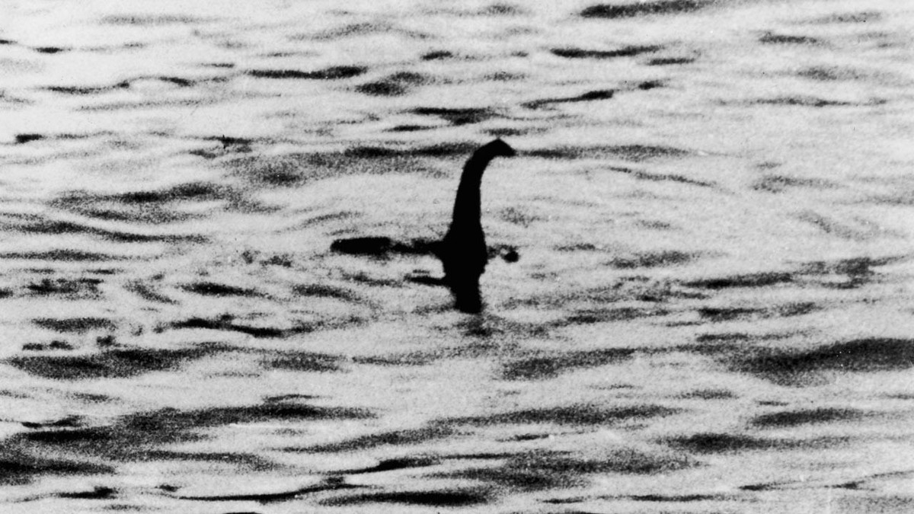
The Surgeon’s Photograph (Britannica.com)

Storied Past
With Nessie becoming a media sensation, Scotland offered a £20,000 reward to anyone who could capture the cryptid. In December 1933, a big-game hunter named Marmaduke Wetherell found large footprints around the lake's shores. However, it was soon discovered that the tracks were made with an umbrella stand that had a hippopotamus leg as a base (Britannica.com). Reports of a monster inhabiting the lake did not surface until 1933. In fact, local stone carvings from the Picts, local natives who date back as far as 300 A.D., show a beast with flippers. The first written account appears later in a 7th-century biography of a monk, St. Columba. Columba intervened after the creature bit a swimmer and ordered the beast to "go back." It obeyed, which is why many believe it only surfaces occasionally (Britannica.com).

Host of Modern Searches and Sightings
Many attempts have been made to find the monster over the last century. In the 1960s, British universities launched sonar operations, which did not yield any results. Later, in 1975, another expedition was launched, this time combining sonar and underwater photography. One photo resulted, which appears to show what vaguely looks like the giant flipper of an aquatic animal (History.com). Finally, in 1987, researchers sent 20 cruisers equipped with sonar equipment, once again, to sweep the Loch (Smithsonian). In 1994, however, it was revealed that the photograph taken by Wilson was, in fact, a hoax. This hoax was spearheaded by Wetherell and was actually a plastic and wooden head attached to a toy submarine (Britannica.com). Even so, cryptozoologists and enthusiasts alike were not dampened by this information and continued their search (History.com). In 2018, researchers actually went so far as to conduct a DNA survey of the lake to learn which organisms lived in the water. There was no sign that a plesiosaur inhabited the water; however, it did leave open the possibility of Nessie being an oversized eel (Britannica.com).

Conclusion
The modern legend of the Loch Ness Monster was born in 1933, but this was not the first time Nessie had been spotted, and it will not be the last. A quick internet search reveals that Scotland hosts a website that details exciting tourist attractions to visit, including Lake Loch Ness (Visit Scotland). This site breaks down what Nessie looks like, where you are most likely to spot her, and additional information on the local area. The United Kingdom even hosts a government-sponsored website dedicated to the Legend of the Loch Ness Monster. Whether she is real or not, it is clear that the legend of Nessie continues to live on.

Citations
A&E Television Networks. (n.d.). Legend of loch ness monster born. History.com. https://www.history.com/this-day-in-history/loch-ness-monster-sighted
AR, H. (2017, April 25). The Loch Ness Monster. https://www.highland.gov.uk/highlandar/TheLochNessMonster
Encyclopædia Britannica, inc. (2023, June 28). Loch Ness Monster. Encyclopædia Britannica. https://www.britannica.com/topic/Loch-Ness-monster-legendary-creature
Loch Ness. Smithsonian Institution. (n.d.). https://www.si.edu/encyclopedia_si/nmnh/lochness.htm
Nessie - is the Loch Ness Monster Real?. Visit Scotland. (n.d.). https://www.visitscotland.com/places-to-go/loch-ness/things-to-do/nessie

