Paired Text H-Chart

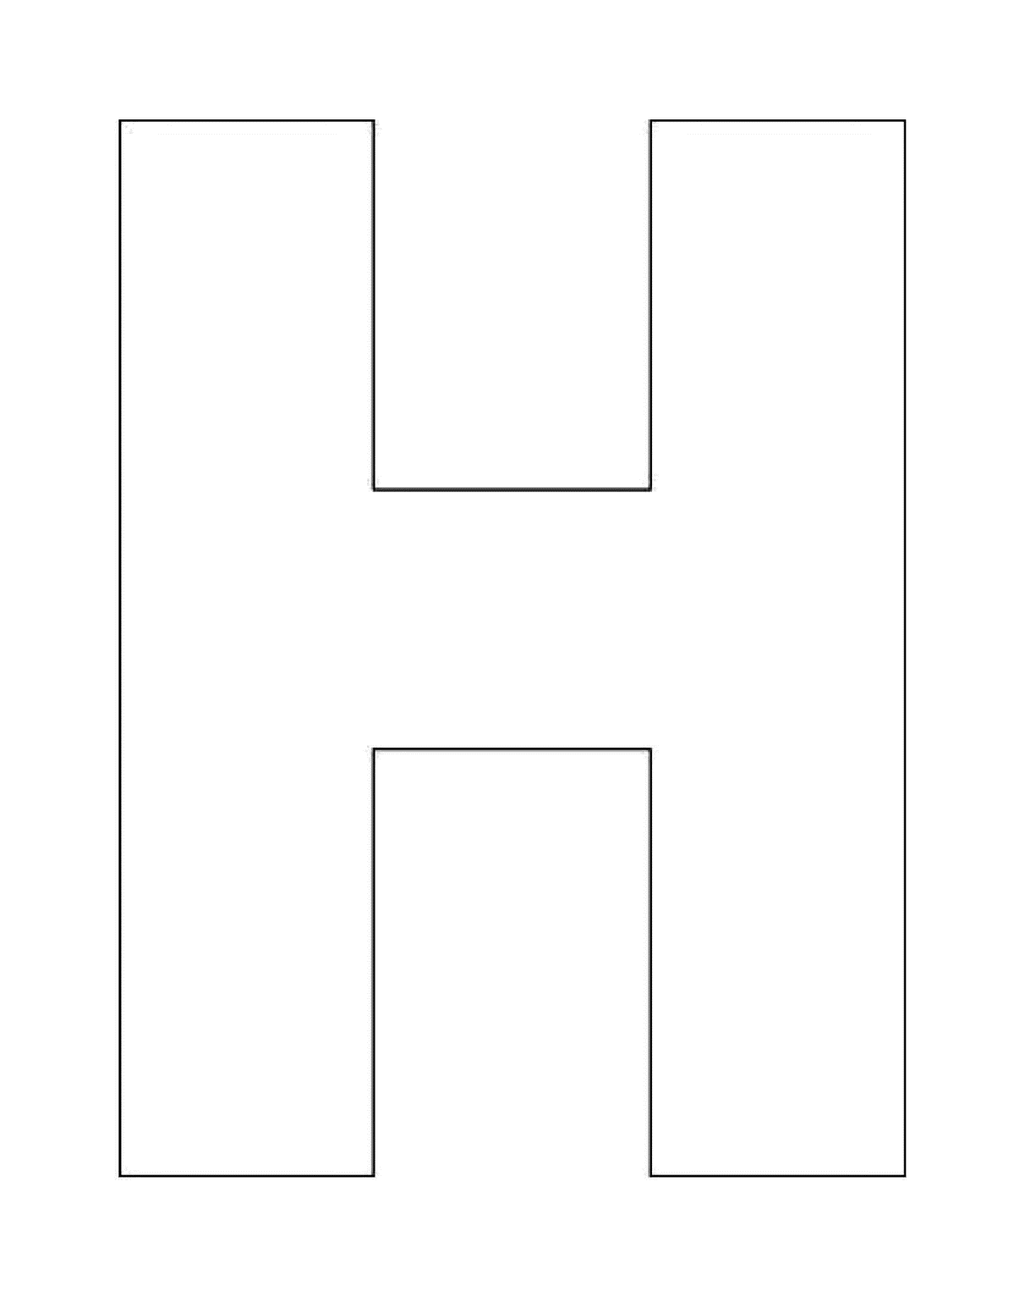

Ogopogo

Nessie

Texts Together