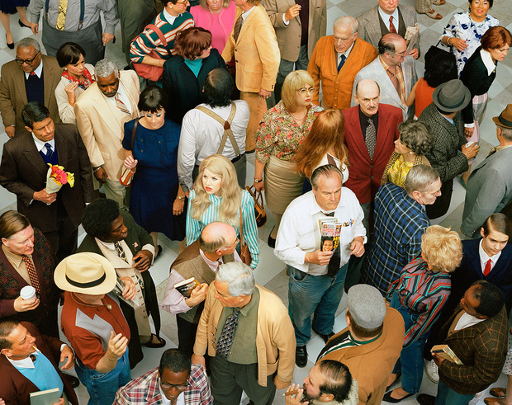
Face in the Crowd
Artist: Alex Prager 2013

