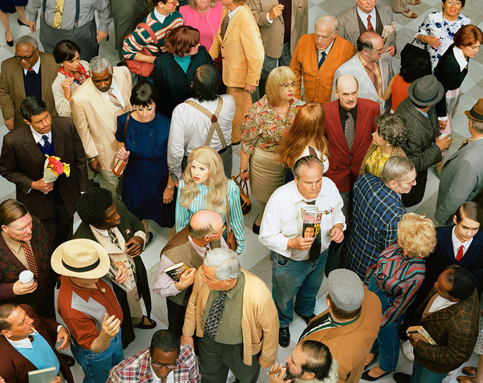

**Face in the Crowd**

Artist: Alex Prager 2013