IT’S OPTIC-AL GRAPHIC ORGANIZER
Image | It’s OPTIC-al
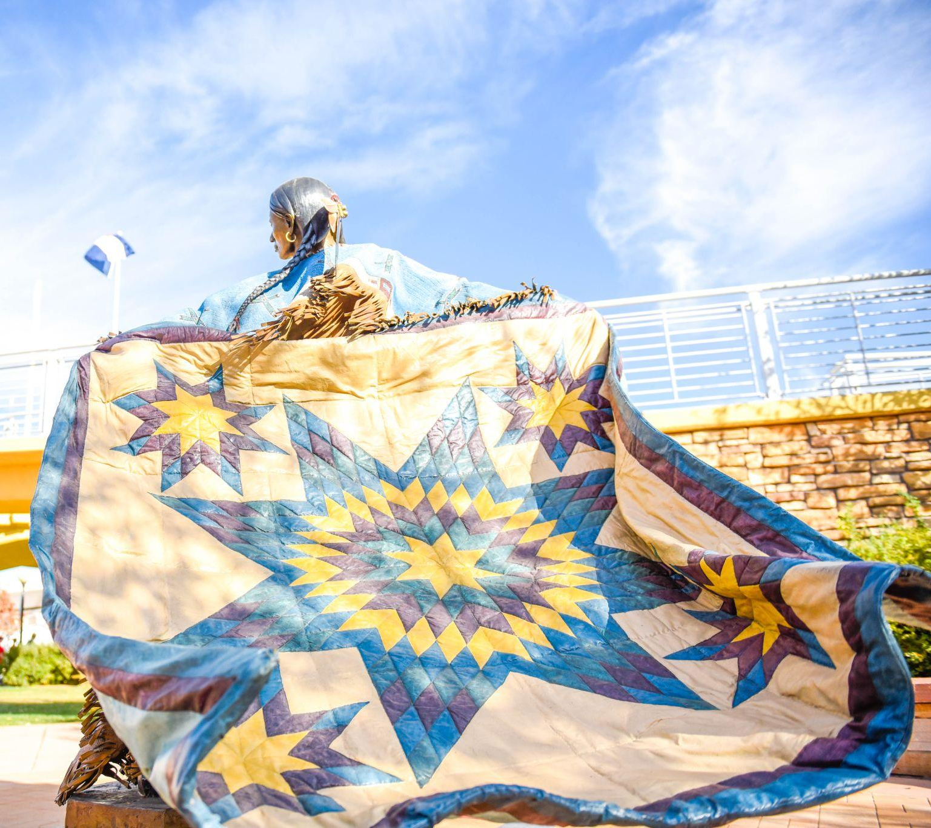  ACWA, P. (2018). Pueblo River Walk Sculpture of the Lakota Sioux Tribe. flickr. Retrieved July 6, 2023, from https://www.flickr.com/photos/acwa/45058507815. | O  Observations | What do you notice or observe in this piece of art?
 | P  Parts | What are the parts of this artwork? What are the details?
 | T  Title | What does the title tell you about the artwork? How does it relate to what you see?
 | I  Interrelationships | How do the parts of the painting work together to convey the artist’s message?
 | C  Conclusions | What does this artwork convey? What can you tell from the artwork (time period, artist, etc.)?

IT’S OPTIC-AL GRAPHIC ORGANIZER
Image | It’s OPTIC-al
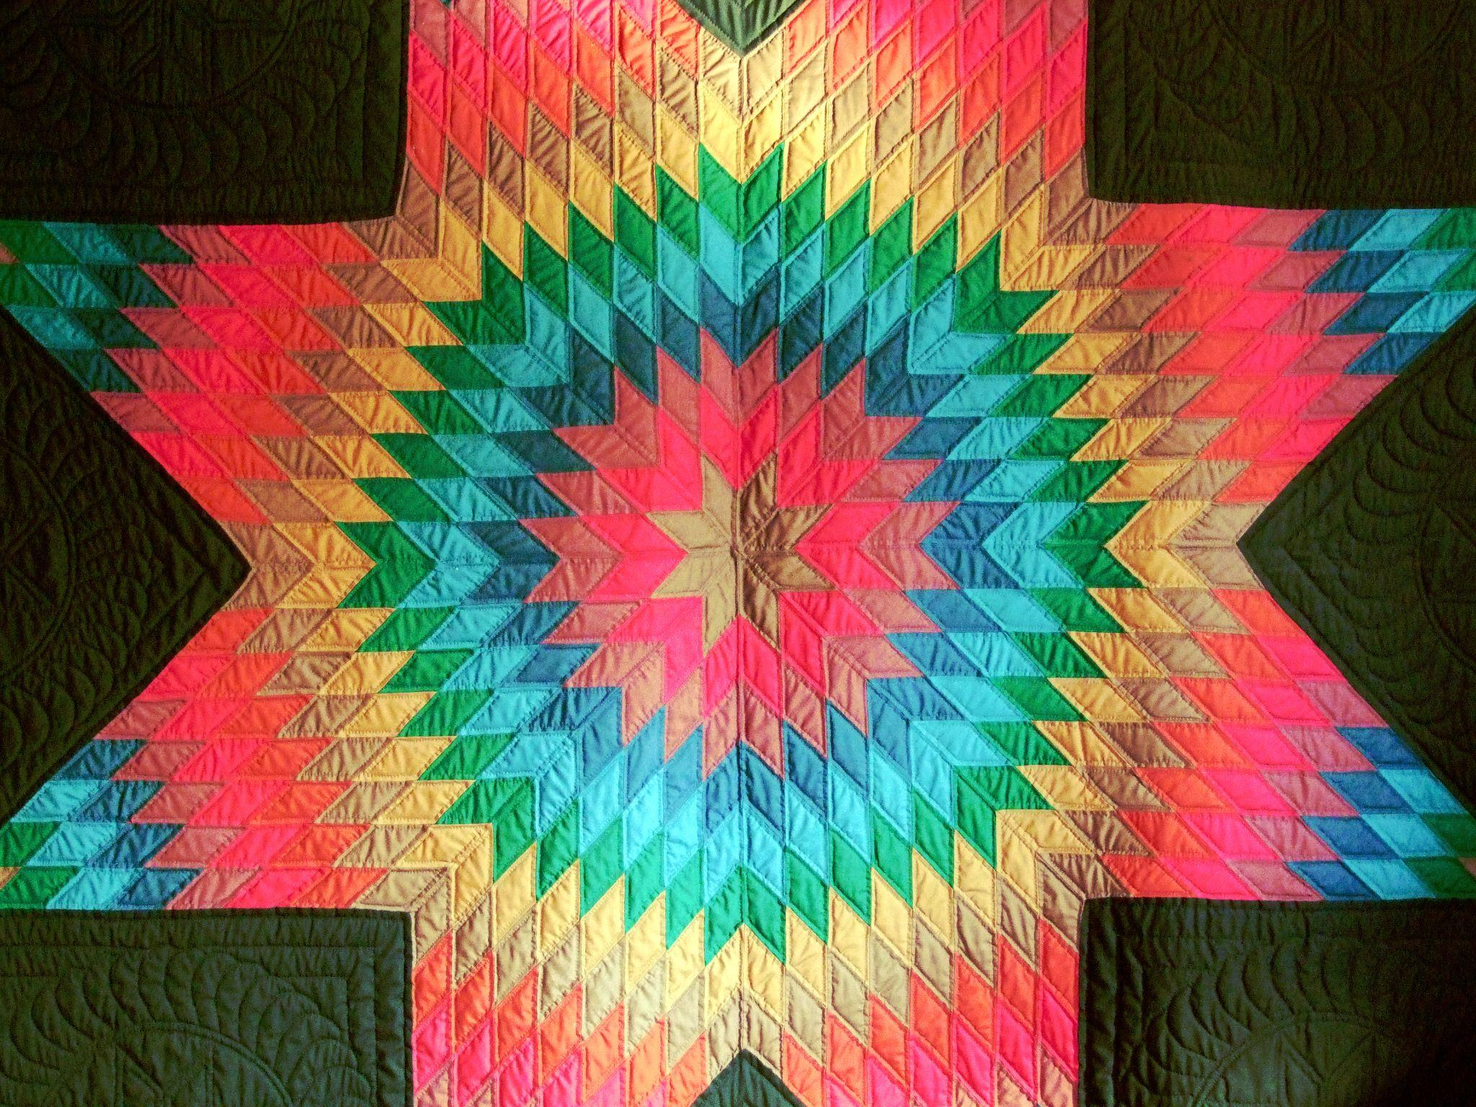  Elstef. (2020). Star shaped patch sewing. PXhere. Retrieved July 6, 2023, from https://pxhere.com/en/photo/1605062#google_vignette. | O  Observations | What do you notice or observe in this piece of art?
 | P  Parts | What are the parts of this artwork? What are the details?
 | T  Title | What does the title tell you about the artwork? How does it relate to what you see?
 | I  Interrelationships | How do the parts of the painting work together to convey the artist’s message?
 | C  Conclusions | What does this artwork convey? What can you tell from the artwork (time period, artist, etc.)?

IT’S OPTIC-AL GRAPHIC ORGANIZER
Image | It’s OPTIC-al
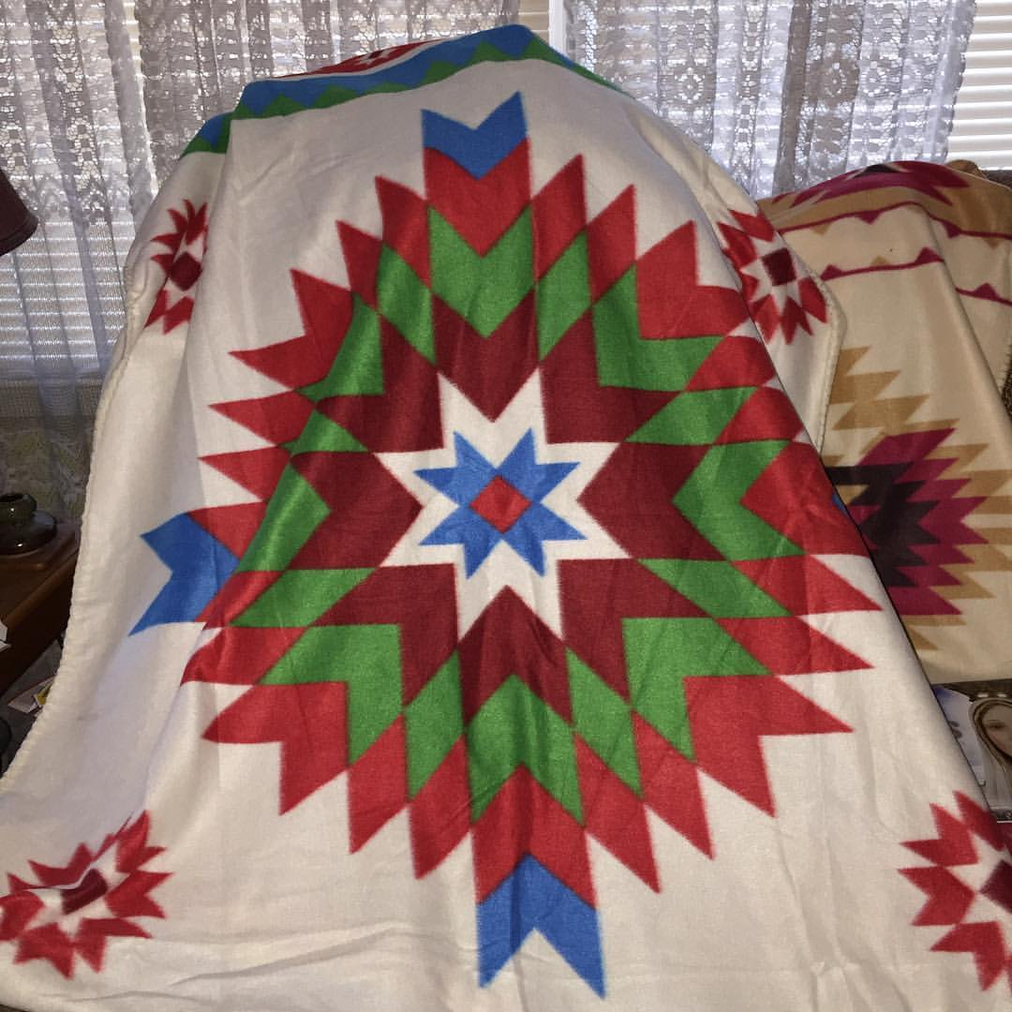  Alter, T. (2016). I got another blanket from the Northern Cheyenne and Crow Missions I support. flickr. Retrieved July 6, 2023, from https://www.flickr.com/photos/78428166@N00/30414560965. | O  Observations | What do you notice or observe in this piece of art?
 | P  Parts | What are the parts of this artwork? What are the details?
 | T  Title | What does the title tell you about the artwork? How does it relate to what you see?
 | I  Interrelationships | How do the parts of the painting work together to convey the artist’s message?
 | C  Conclusions | What does this artwork convey? What can you tell from the artwork (time period, artist, etc.)?

