**EXPLORING GRAPHS**

Use your graphing calculator to complete the following tasks:

**Part I**

Graph  on your calculator and sketch it here:

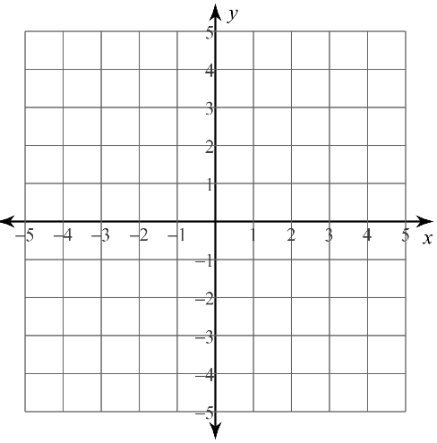

Now, consider the following equations:

|  |  |  |  |
| --- | --- | --- | --- |
|  |  |  |  |

First, predict how the changes to the equation  will change the graph:

Second, graph the equations and explain the changes in each graph compared to the parent graph.

Third, explain how the graph of  would compare to the parent graph.

**Part II**

Graph  on your calculator and sketch it here:



Now, consider the following equations:

|  |  |  |  |
| --- | --- | --- | --- |
|  |  |  |  |

First, predict how the changes to the equation  will change the graph:

Second, graph the equations and explain the changes in each graph compared to the parent graph.

Third, explain how the graph of  would compare to the parent graph.

**Part III**

Were there any similarities in transformations? Look back at your answers for Part I and II and see if you can find any patterns. List any observations you make here:

**Part IV**

Get with another group and compare your answers for Part III. Do you all agree about the pattern for transformations? Be prepared to participate in our class discussion about these transformations.