Leafhopper Migration
https://aeroecology.shinyapps.io/Birds_Bugs_and_Phenology/
Setting up the model for Lesson 1 Extend
- Show/hide Data
  - Have students toggle on the “Show State Abbreviations” button.
  - They can ignore the temperature data for now, so they should leave the temperature colors and numbers toggled off (this is the default setting already).
- Select states for first arrival plot
  - This shows students what day of the year leafhoppers were found in a state for every year there is data available. They can select more than one from the list.
- Display data for individual states or means
  - “Show States” is the default and most straightforward graph to interpret. It will create a line for arrival date (see previous section) for each state selected.
  - “Show Means” will show the average day leafhoppers were found across all the states students have selected. It is a little less obvious to interpret but will show overall trends of arrival over time across the entire range students have selected.
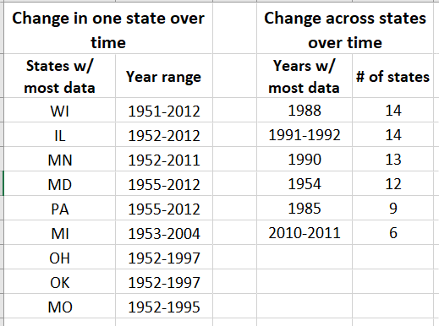
- Recommended data ranges

Troubleshooting tips for using the model
- If the model is refreshing slowly for students, have them work in groups of 2-3 per device to reduce the strain on the program.
- After moving a slider, wait until the map(s) update before making other changes to the variables.
- Avoid the play button (small triangle at the right end of the Day of Year sliders) if you have a large class and/or the model is refreshing slowly.

