TRANSPIRING TREES EXCEL INSTRUCTIONS
EXPLORE PART 2
Calculating Leaf Surface Area
Video Tutorial - https://drive.google.com/file/d/0B_pBNbQVSt6fcFlQdmZyYnJEWEU/view?usp=sharing
- Open a new excel spreadsheet document.
- Label column A: Leaf Length and column B: Leaf Surface Area
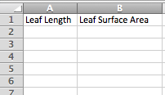
- Next enter the entire class data from part 2 of the explore phase, calculating leaf surface area, into the appropriate columns.
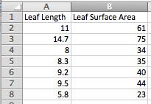
- Next highlight the data and the headings in both columns.
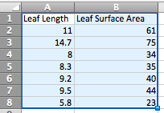
- Now click on the CHARTS tab. Then click on the SCATTER option. Click on the MARKED SCATTER option. This will create a scatter plot from the entered data.
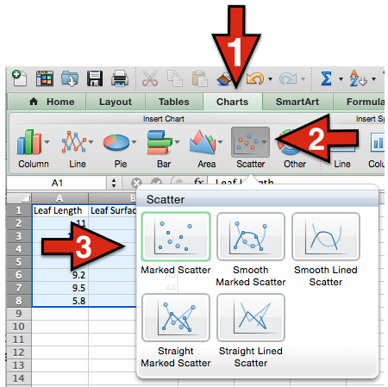

- Next, right click on any data point on the scatter plot graph. An option box will appear, click on ADD TRENDLINE. This will add a trendline to the scatter plot.
- Now, right click on the trendline and select FORMAT TRENDLINE. A format box will appear.
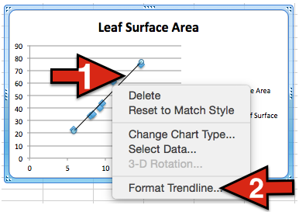
- Next, in the Format Trendline box click options and check the boxes labeled: Display equation on chart and Display R-squared value on chart. Now you will see an equation on the chart and an R² value.
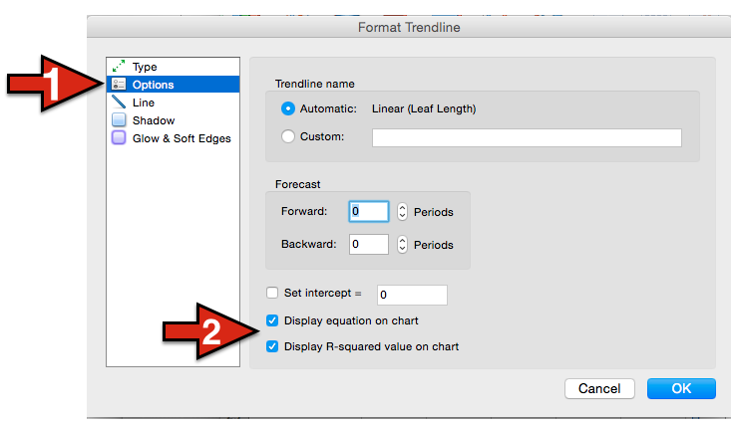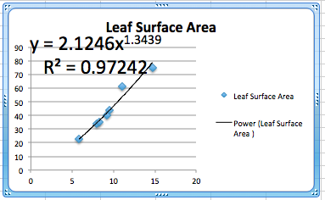
- Now, in the Format Trendline box, click on TYPE. In the middle you have 6 types of trendlines. When select different types it will change the R² value. Choose the type that gives you the LARGEST R² value (Generally the POWER option gives the highest R² value).
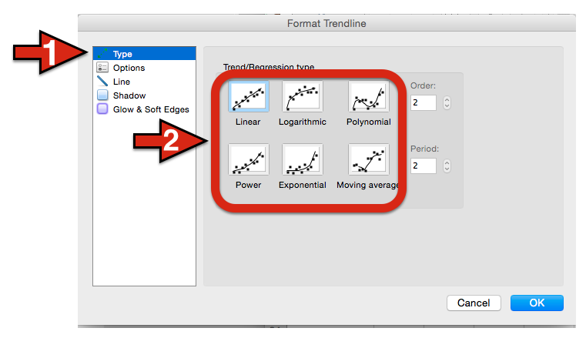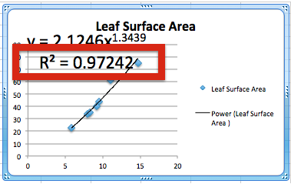

- Now you have the equation for your students to calculate the surface area of each leaf simply by measuring the leaf length.
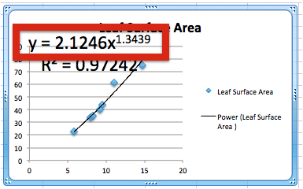
In this example the equation is: y = 2.1246x^{1.3439}
That means to find the surface area of a leaf you would take the length and plug it into the equation as X.
E.g. If I had a leaf with a length of 16.3cm.

y = 2.1246(16.3^{1.3439})

y = 2.1246(42.5656)

y = 90.4349cm³

So leaf surface area for a leaf of this specific sample species with length 16.3cm would be 90.4349 cm³

TRANSPIRING TREES EXCEL INSTRUCTIONS

EXPLORE PART 3
Calculating Total Leaf Surface Area (TLSA)
Video Tutorial - https://drive.google.com/file/d/0B_pBNbQVSt6fdDZFRnIxQ3NXbG8/view?usp=sharing

- Open a new excel spreadsheet document. Label the columns the same as in the previous spreadsheet. (Column A: Leaf Length and Column B: Leaf Surface Area)
- Right click in cell B2. Select INSERT FUNCTION from the selection box.
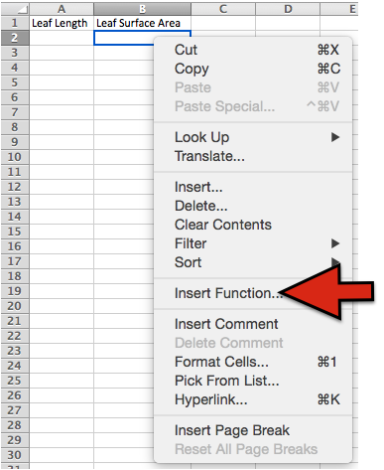
- A sliding menu will appear. Select the POWER function.
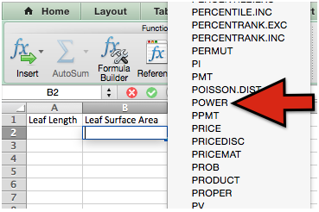
- The cell should have POWER() in it. Now, you will enter the leaf surface equation into the cell.
E.g. our equation was y = 2.1246x^{1.3439} , so in our cell we will enter:

2.1246*POWER(A2,1.3439)

When the equation has been entered press the ENTER/RETURN key.

This will take whatever number entered into cell A2 and raise it to the power 1.3439 and then multiply that by 2.1246 giving the surface area for the specific species of leaf.
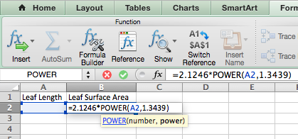
- Next, click in cell B2 and grab the bottom right corner and drag it down. This copies the function just entered into the cells below it. You will need to drag it down to cover enough cells so that you have the function for all of the data you plan to enter. For example if you have 50 leaf lengths you will need to drag the box down to cover 50 cells.
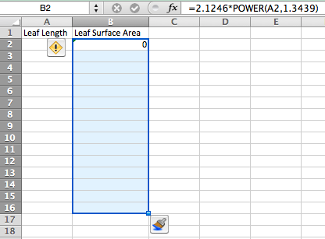
- Now, students can enter the leaf length data into column A.
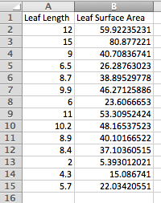
- Next, right click on a random cell, select INSERT FUNCTION. Select the SUM function.
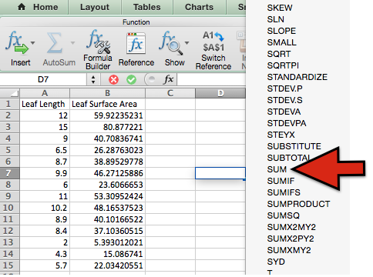
- Now, click on B2 or enter it into the brackets, then click on the last cell in column B that has data in it or enter that cell number into the brackets. See example below.
E.g =SUM(B2+B15)
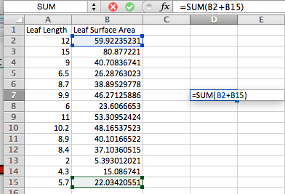
- Hit the ENTER/RETURN key. This adds all of the numbers in the Leaf Surface Area column giving you the TOTAL LEAF SURFACE AREA (TLSA) for the tree branch as long as you entered all of the leaf lengths for your tree branch into column A.

- So our TLSA in this example is 81.9565578.
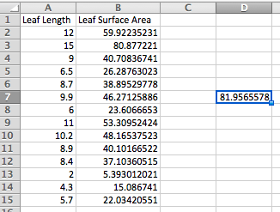

TRANSPIRING TREES EXCEL INSTRUCTIONS

EXPLORE PART 3
Statistical Analysis

Multiple options exist to run statistical analysis on the data. Below are a few easily available options to determine the statistical significance of your data set using p-value.

- Microsoft Excel – In order for this to work you must have the analysis tool pack installed. (Note: this is not available for all versions of excel) Here is a short video tutorial explaining how to find p value using the regression function.
  - https://www.youtube.com/watch?v=vFcxExzLfZI

- Google Spreadsheets – This is a short tutorial explaining how to find p value in Google spreadsheets using the regression function.
  - https://drive.google.com/file/d/0B_pBNbQVSt6fQlc5aWlCaDNuSTQ/view?usp=sharing

- Other available options:
  - Vernier Graphical Analysis- http://www.vernier.com/products/software/ga/
  - Datastudio - http://www.pasco.com/datastudio/

Other options are available through a simple web search.

