TRIANGLE CONGRUENCE POSSIBILITIES

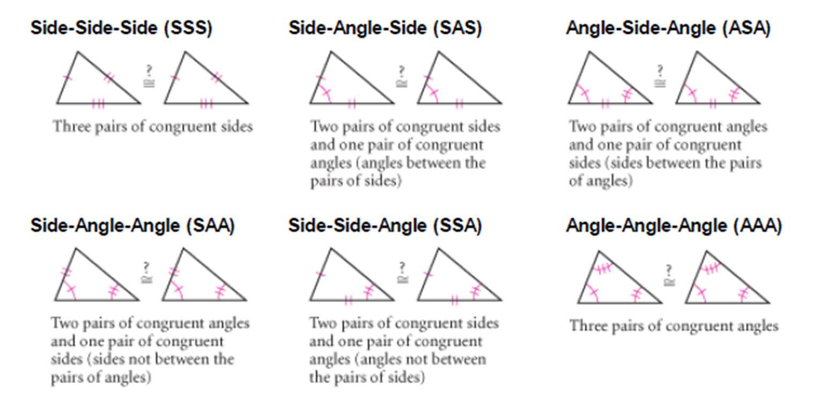

Serra, M. (2003). Discovering geometry: An investigative approach (Vol. 4). Emeryville, CA: Key Curriculum Press.

