Visual Vocabulary

Angle of Elevation (Angle of Incline)
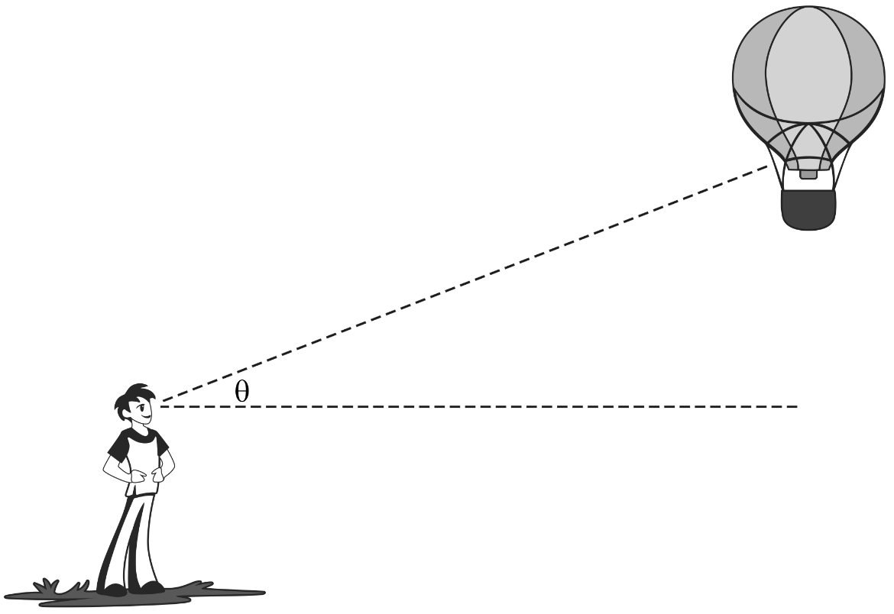

Angle of Depression (Angle of Decline)
