Image Sort
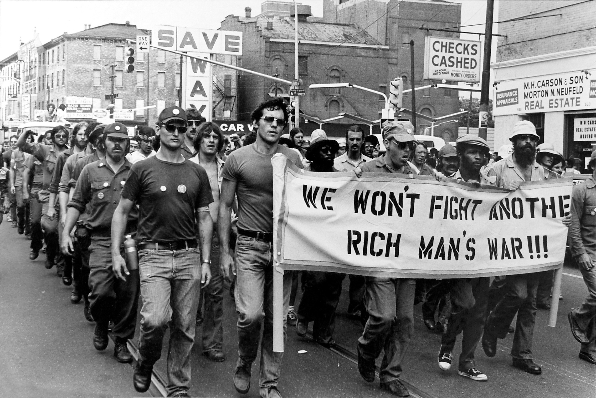
Rich Man’s War. Retrieved from https://blogs.haverford.edu/amongfriends/files/2008/12/we-wont-fight-final.jpg?file=2008/12/we-wont-fight-final.jpg

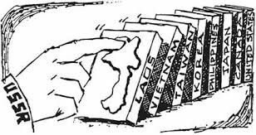
The Domino Theory cartoon: New York Times. Retrieved from https://historycollection.co/today-history-domino-theory-comes-fire-cia-1964/
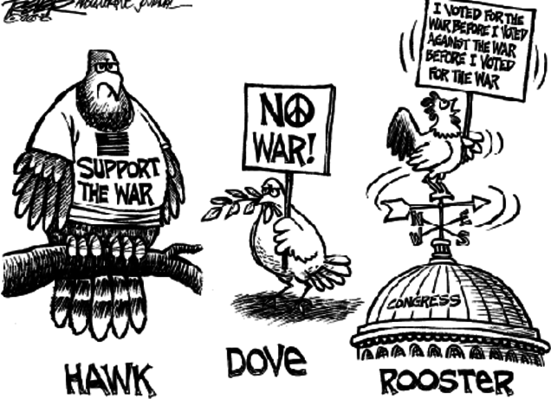
Hawk, dove, and rooster cartoon. Retrieved from http://amnatgov.blogspot.com/2012/04/making-foreign-policy.html

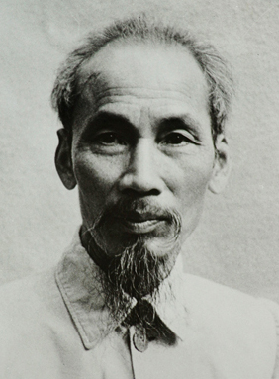
Ho Chi Minh, 1946. Retrieved from https://commons.wikimedia.org/wiki/File:Ho_Chi_Minh_1946.jpg

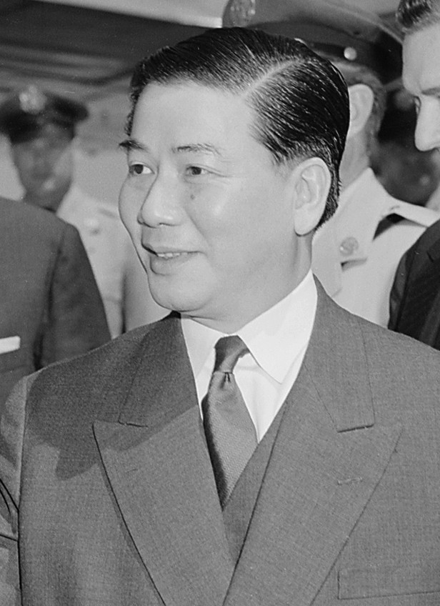
Ngo Dinh Dien. Retrieved from https://commons.wikimedia.org/wiki/File:Ngo_Dinh_Diem_-_Thumbnail_-_ARC_542189.png
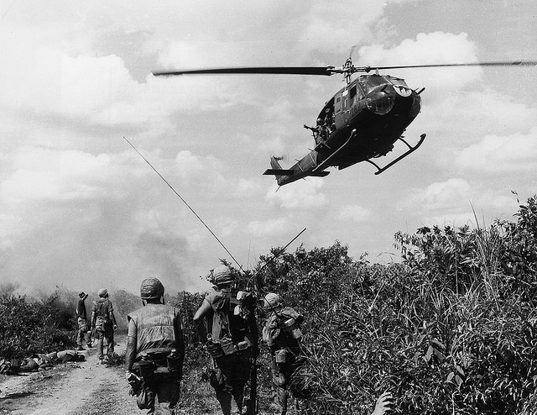
Vietnam War 1967 – US Marines Patrol Demilitarized Zone. Retrieved from https://www.flickr.com/photos/13476480@N07/36574620606
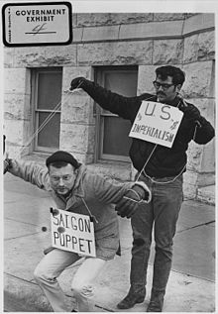
Vietnam War Protesters, 1967. Retrieved from https://commons.wikimedia.org/wiki/File:Vietnam_War_protesters._1967._Wichita,_Kans_-_NARA_-_283627.jpg
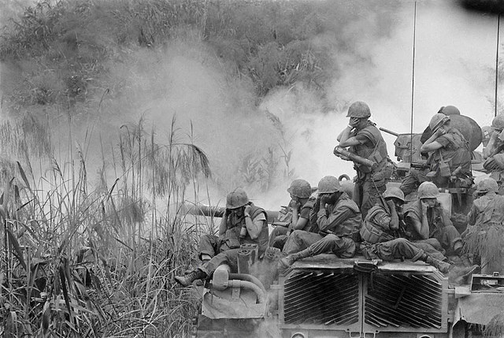Vietnam War – Marines riding atop an M-48 tank. Retrieved from https://www.flickr.com/photos/13476480@N07/37105498596

