Secret Agent Pythagoras

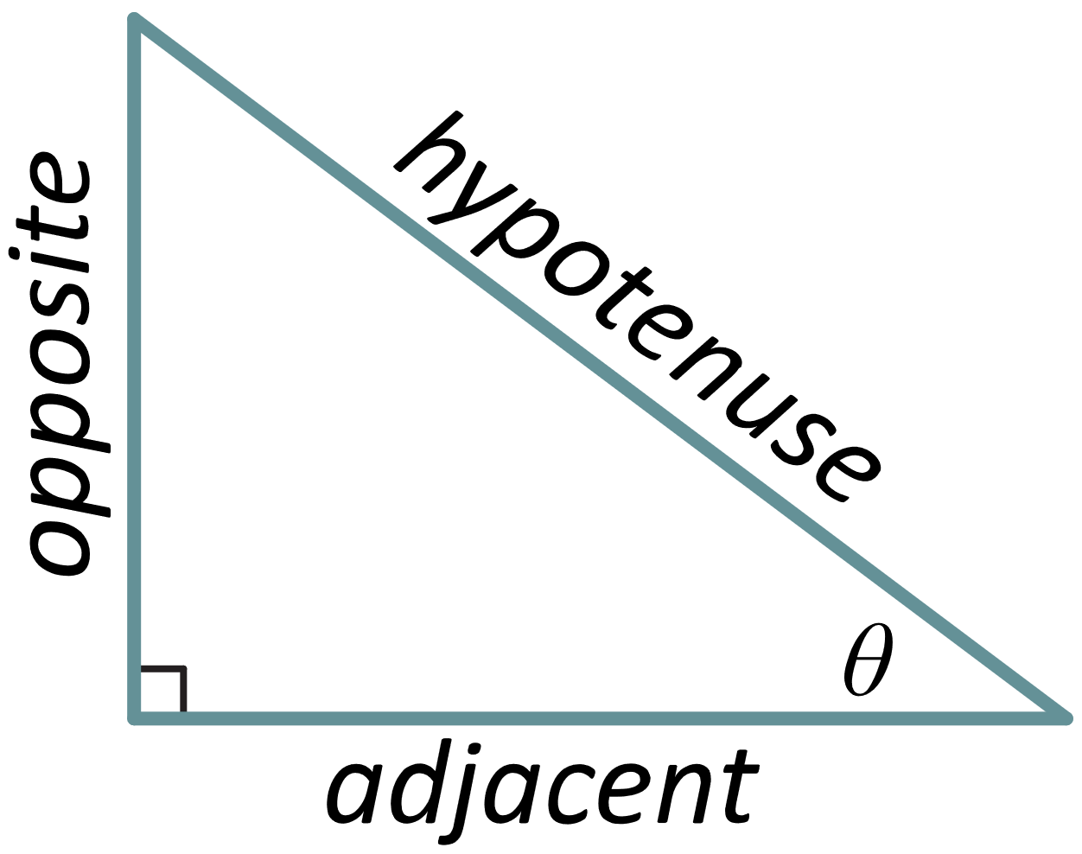

# Step 1

Use the labels from the figure above to write the Pythagorean theorem.

# Step 2

Divide both sides of your equation by and simplify.

# Step 3

Your final result from Step 2 is a Pythagorean identity. Find another Pythagorean identity by dividing your result from Step 2 by .

# Step 4

Find yet another Pythagorean identity by dividing your result from Step 2 by .