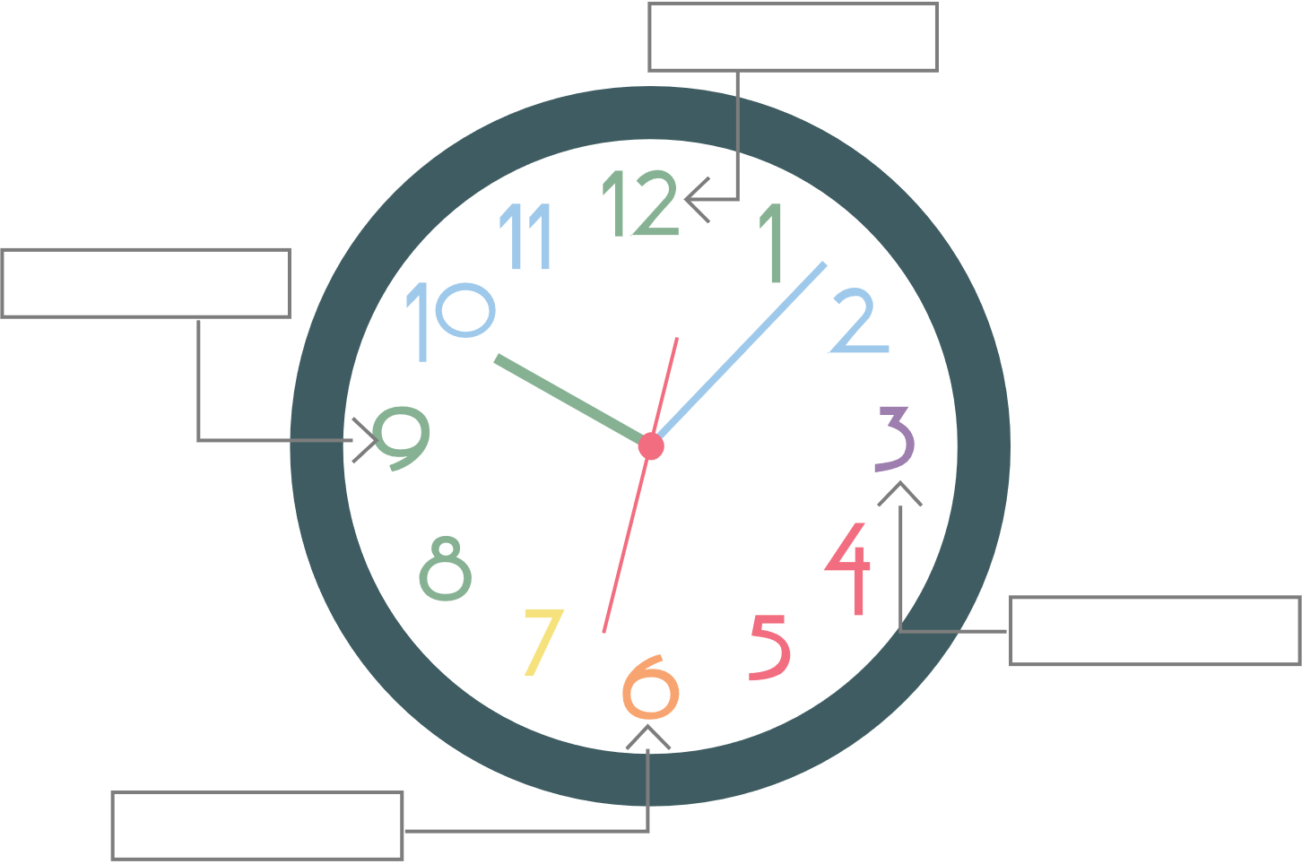Appointment Clocks

# 3:00 Appointment

Solve each of the following equations for .

**1)** 

**2)** 

# 6:00 Appointment

Solve each of the following equations for .

**3)** 

**4)** 

# 9:00 Appointment

Solve each of the following equations for .

**5)** 

**6)** 

# 12:00 Appointment

Discuss what was similar and what was different about the problems you solved.