Bell Ringer

For , graphically represent the following equation and explain the meaning of the solution: .

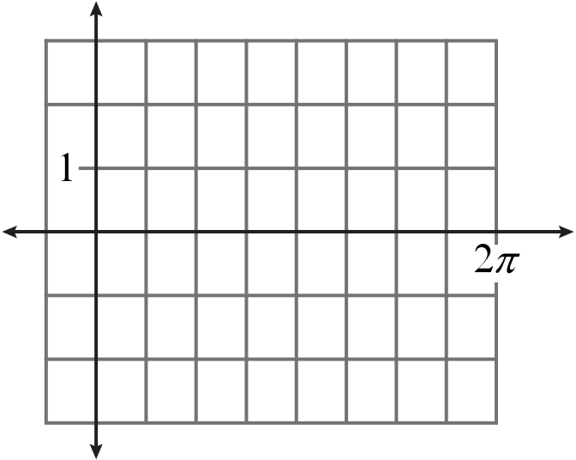



Trig Identities, Part 2

Bell Ringer

For , graphically represent the following equation and explain the meaning of the solution: .

