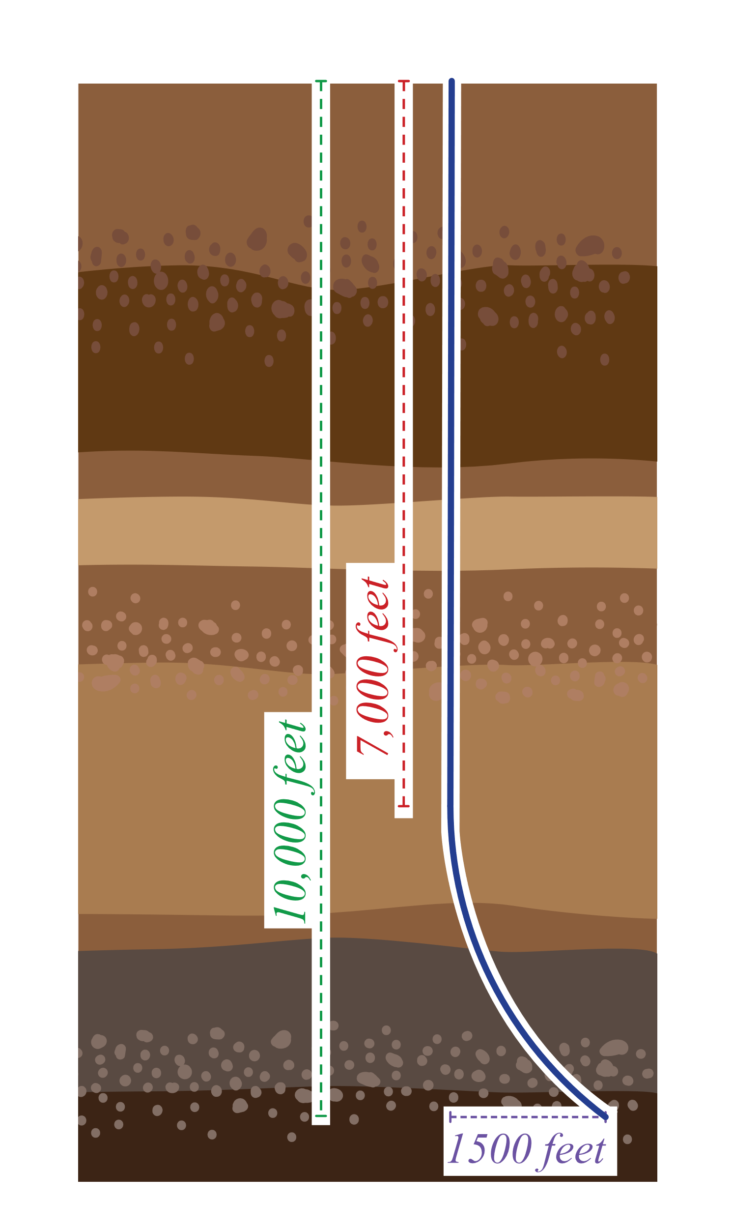Oil Drilling (Sample Responses)

# Real-World Application

A well planner is working with a petroleum engineer to design a well. There will be three sections of drilling: the vertical portion, the curved portion, and the horizontal portion. The point where the drilling transitions from the vertical to curved portion is known as the kickoff point.

The drilling needs to transition from the vertical portion to the curved portion to bypass a salt dome section. Salt domes cause expensive challenges when drilling, so it is best if they are avoided.

The desired horizontal width, *x*, for the curved portion is 1,500 feet. The true vertical depth includes the vertical height of the curved portion, *y*, and vertical length of the vertical portion. This total needs to be 10,000 feet.

**______________________________________________________________________________**

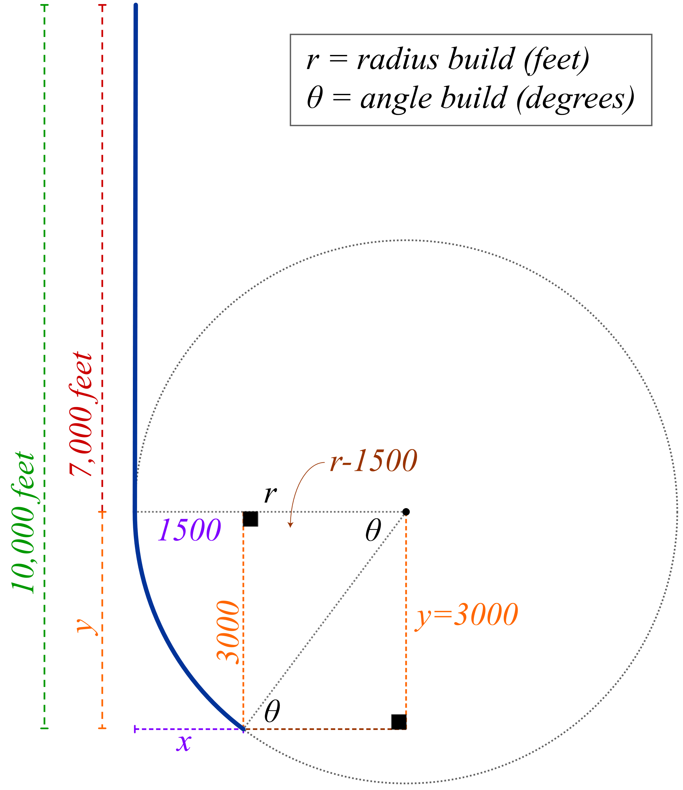**(a)** If the kickoff point is 7,000 feet below the surface, write the ratio of  in terms of *r*, , and .







**(b)** Use your results to find *θ*. Round to the nearest degree.

 

**(c)** Determine the value of *r*.



**(d)** Calculate the total length of the vertical and curved portions. This total length is known as the measured depth, *m*, and is measured in feet. Round to the nearest foot.

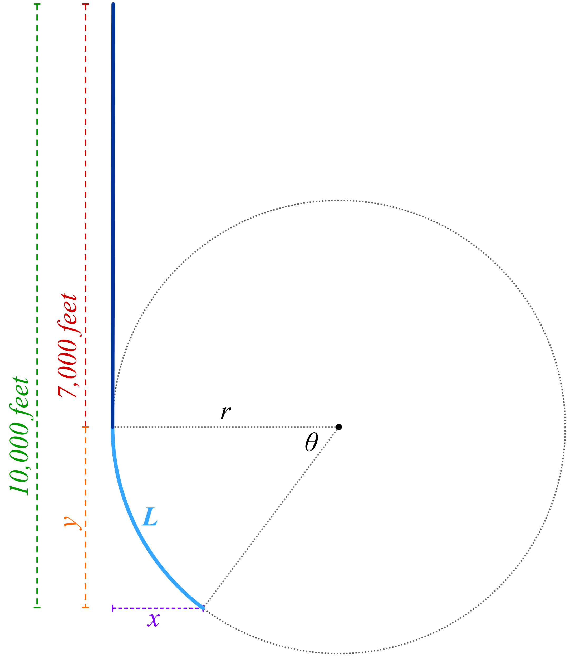



**(e)** Use the formula  to calculate the buildup rate, *q*, measured in degrees per foot. This rate is used to determine the type of drilling tools needed for the job.

