Into the Unknown: Sine (Sample Responses)

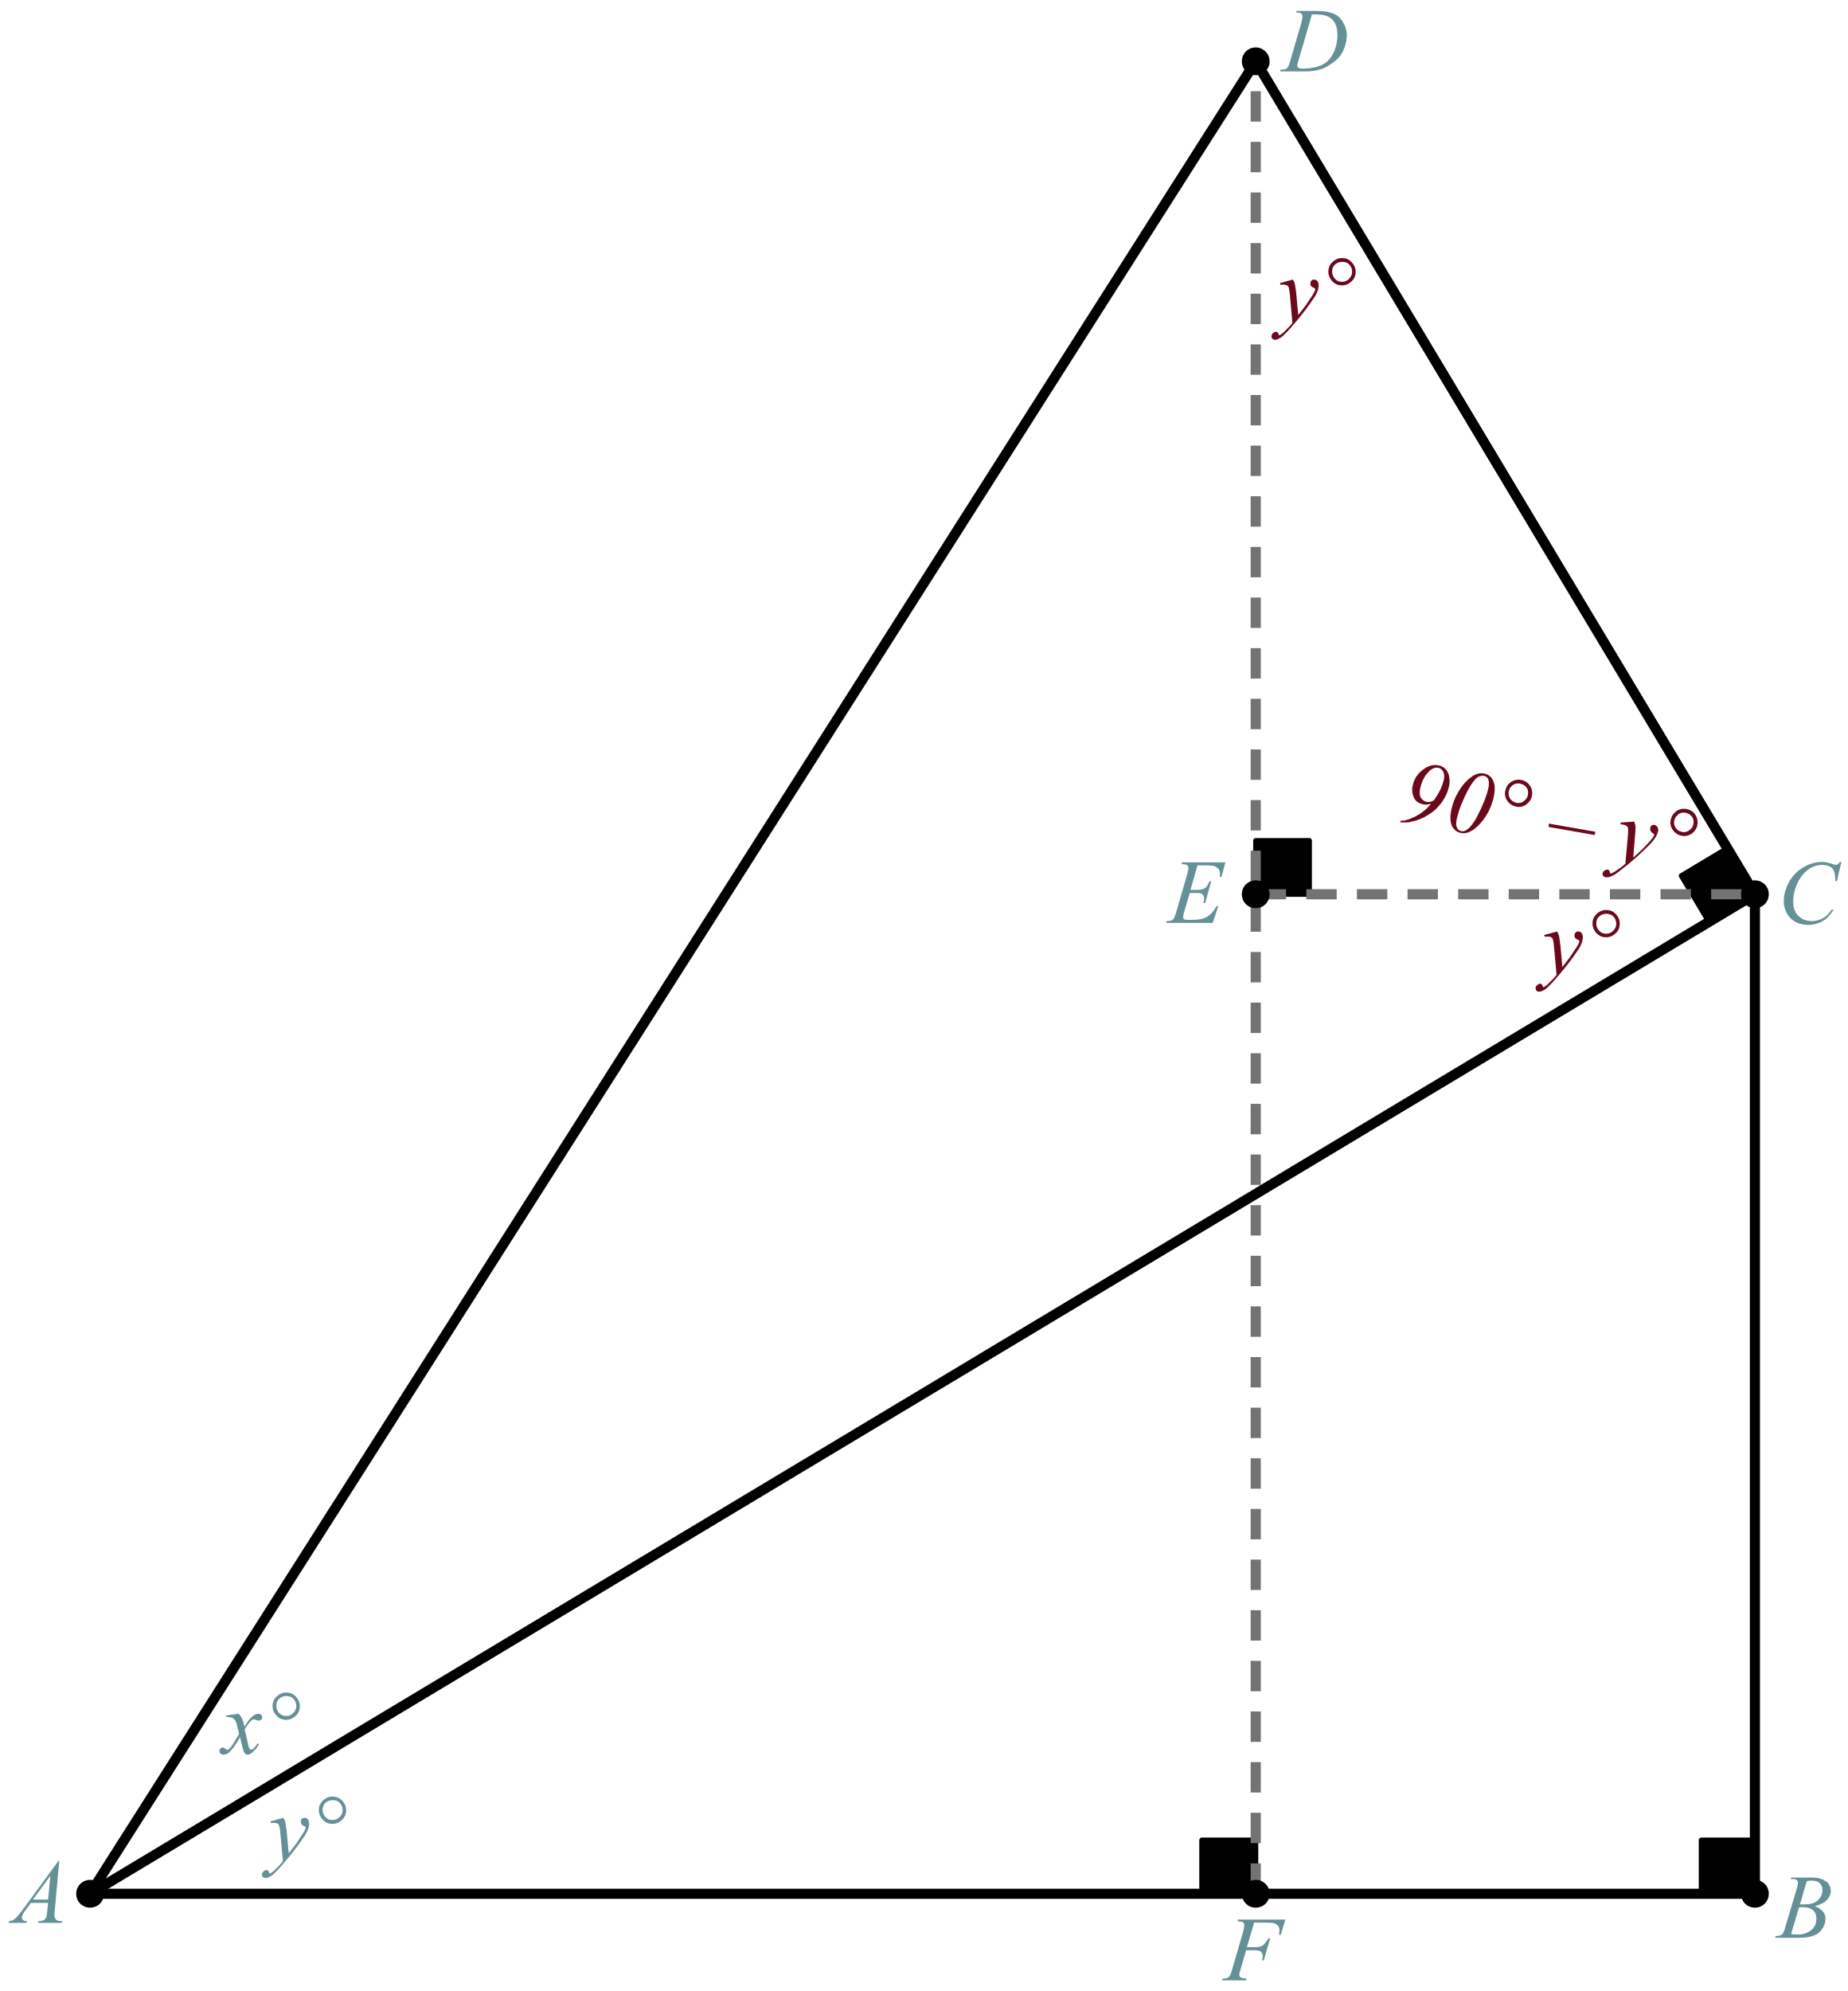

# Step 3: Teamwork

Put your pieces of information together to find the identity. Let .



Into the Unknown: Cosine (Sample Responses)



# Step 4: Teamwork

Find the identity for . Let .

