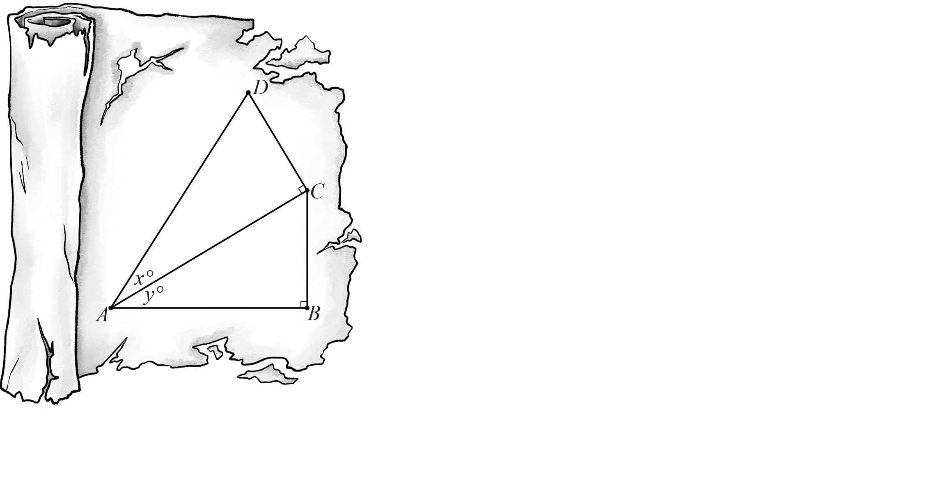The Scrolls – Student A (Sample Responses)

The focus of this task is to uncover the identity for . To ensure your success, you must work together efficiently and communicate effectively.

# Step 1: Independent Work

Use the figure above to write ratios using sine and cosine.









# Step 2: Independent Work

Rewrite and simplify your equations above using .









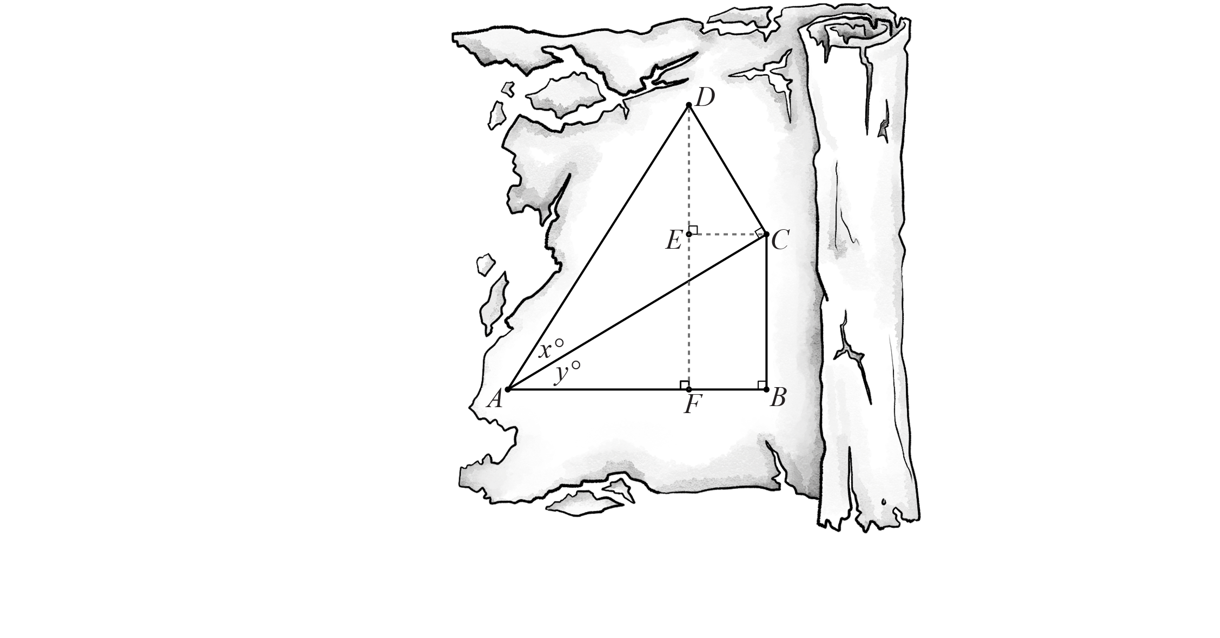The Scrolls – Student B (Sample Responses)

The focus of this task is to uncover the identity for . To ensure your success, you must work together efficiently and communicate effectively.



# Step 1: Independent Work

Find  in terms of *x* and/or *y*. *Hint: Use the alternate interior angles theorem.*



# Step 2: Independent Work

Then use  to write ratios using sine and cosine.







