Image 1
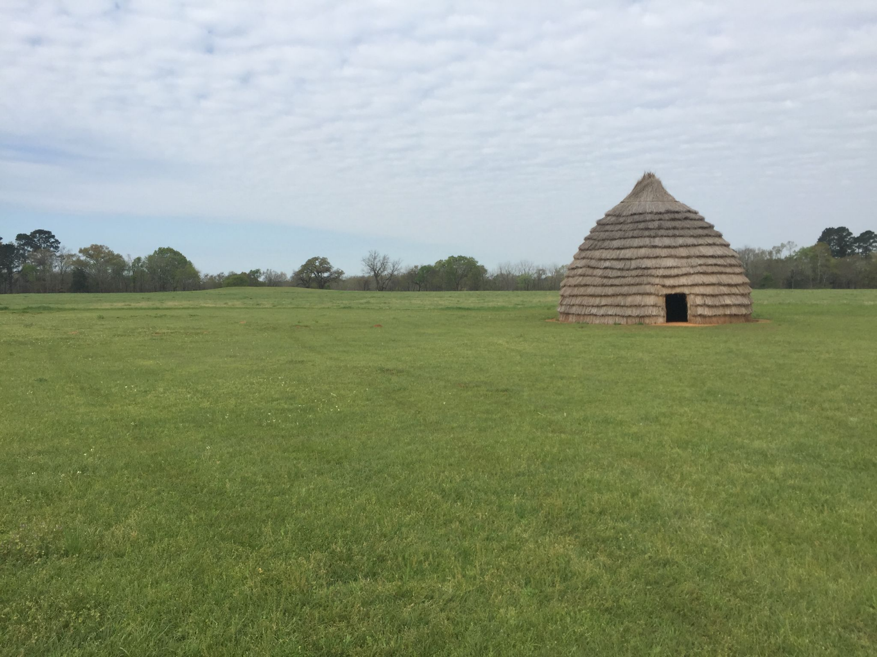
Garcia, O. C. (2017, May 24). Hasinai. Explore Texas. https://exploretexas.blog/tag/hasinai/

Image 2
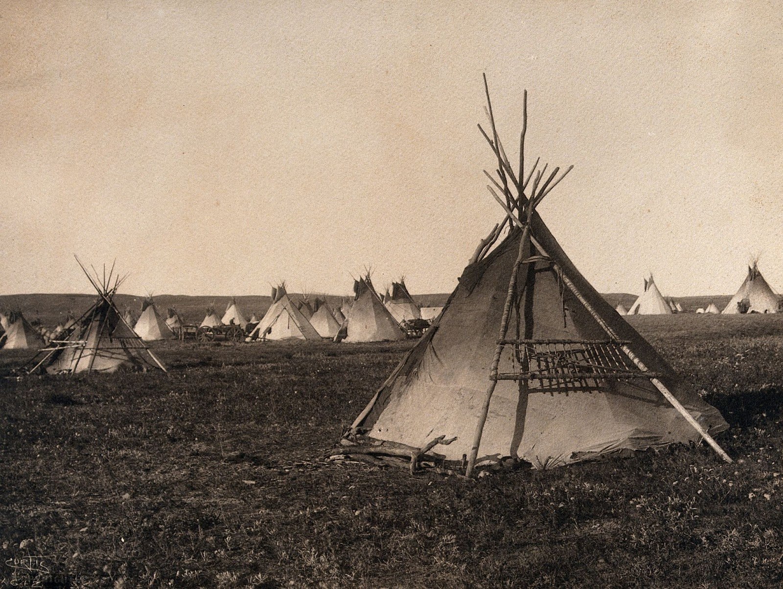
File: Plains Indian tipi, North America. wellcome v0038483.jpg. (n.d.-e). http://commons.wikimedia.org/wiki/File:Plains_Indian_tipi,_North_America._Wellcome_V0038483.jpg

Image 3
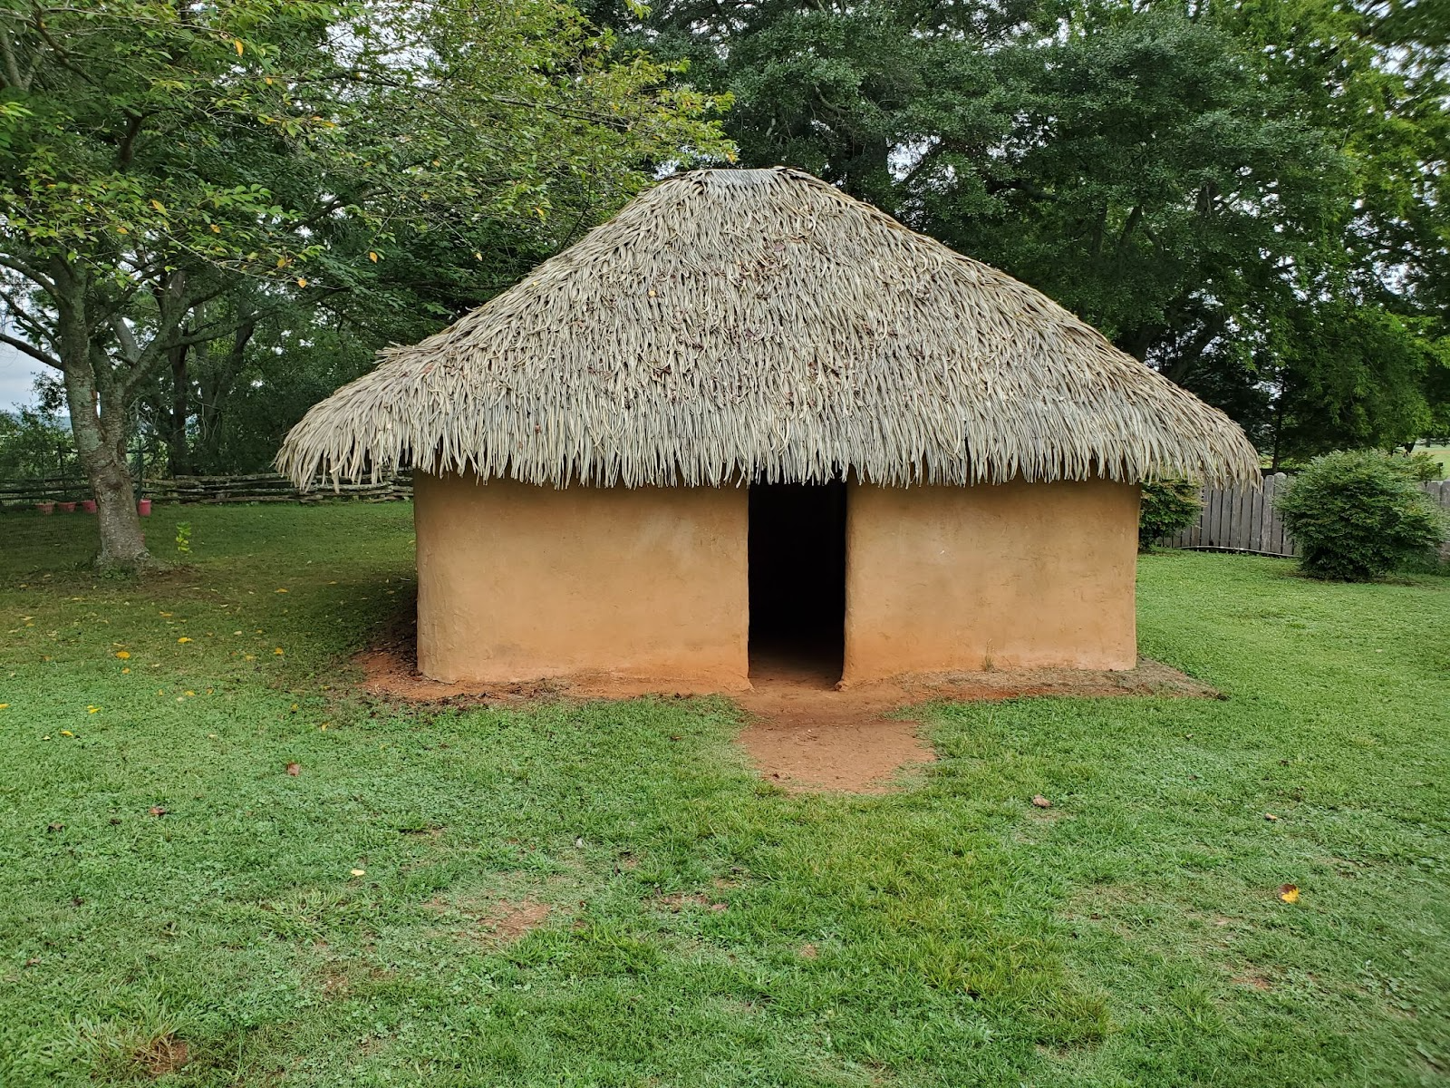
File : Wattle and Daub House, Etowah Indian mounds.jpg. (n.d.-f). https://commons.wikimedia.org/wiki/File:Wattle_and_daub_house,_Etowah_Indian_Mounds.jpg

Image 4
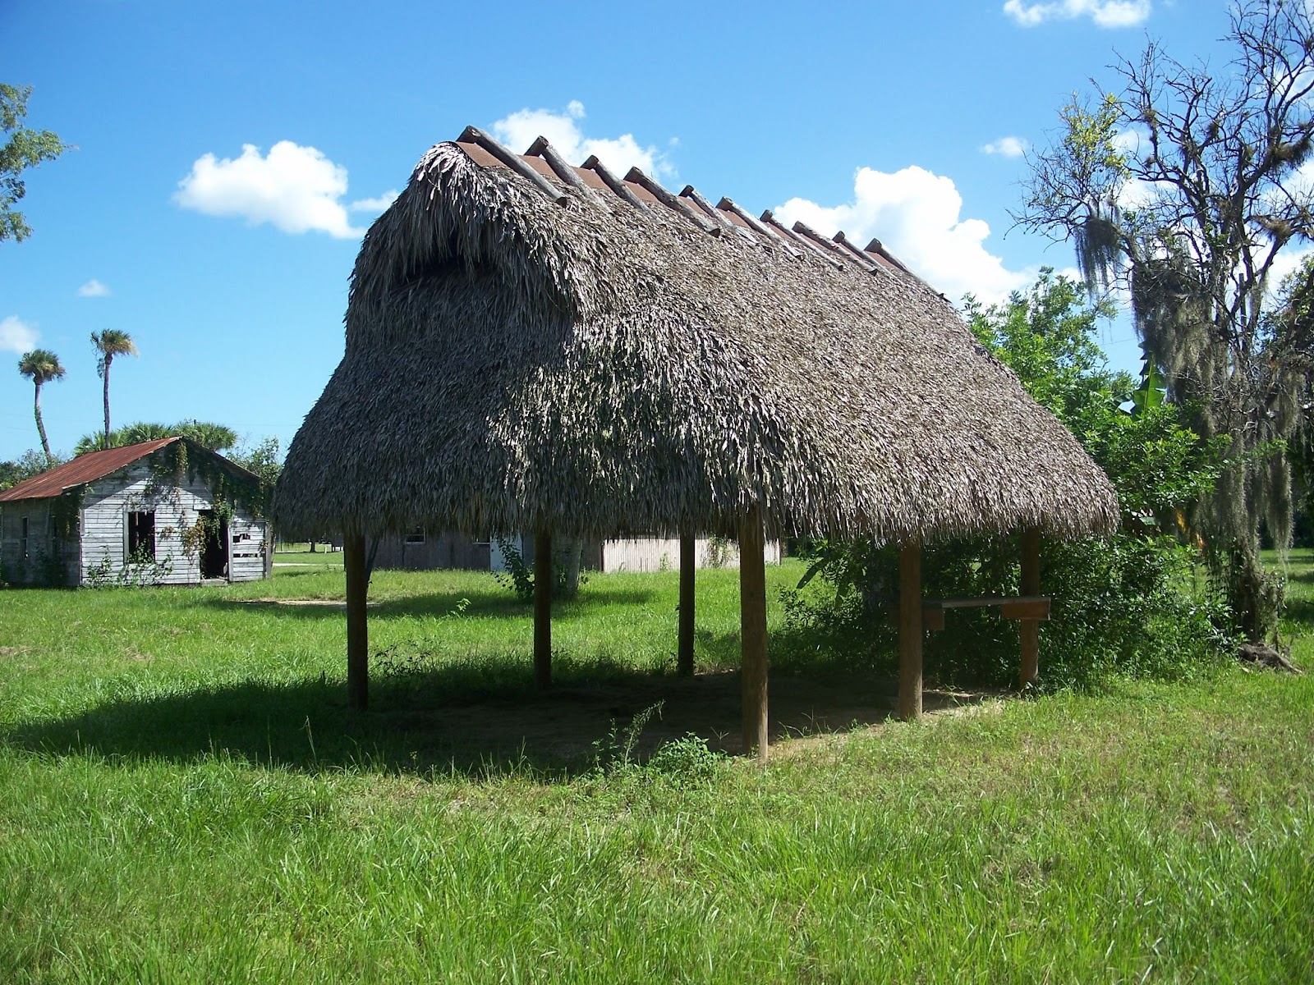
Category: Brighton Seminole Indian Reservation. Wikimedia Commons. (n.d.). https://commons.wikimedia.org/wiki/Category:Brighton_Seminole_Indian_Reservation

Image 5
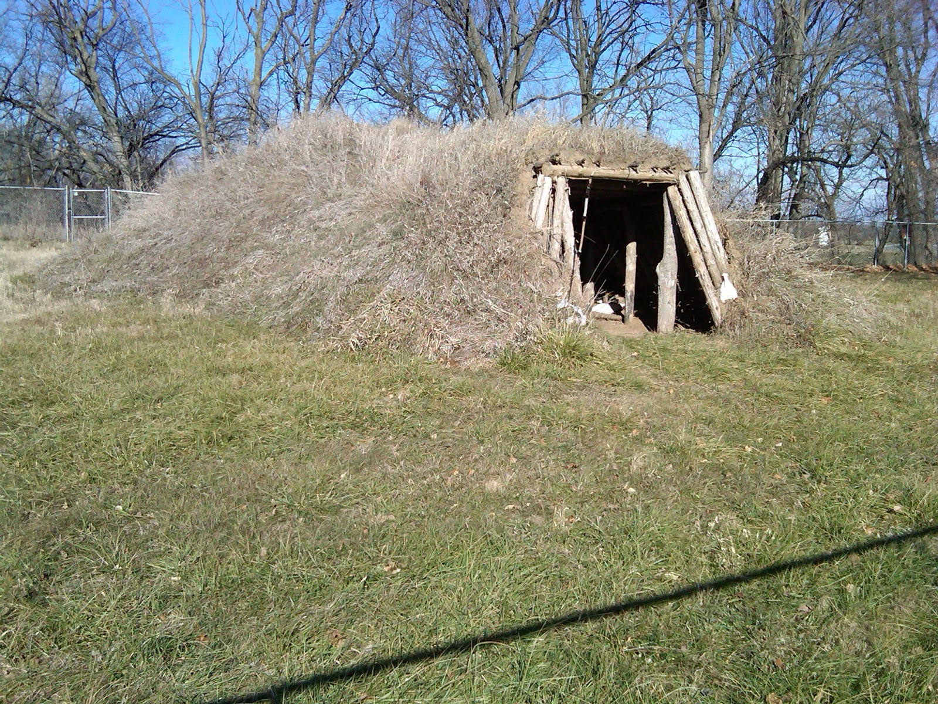
File: Glenwood Earth Lodge.jpg - Wikimedia Commons. (n.d.-e). https://commons.wikimedia.org/wiki/File:Glenwood_Earth_Lodge.jp

Image 6
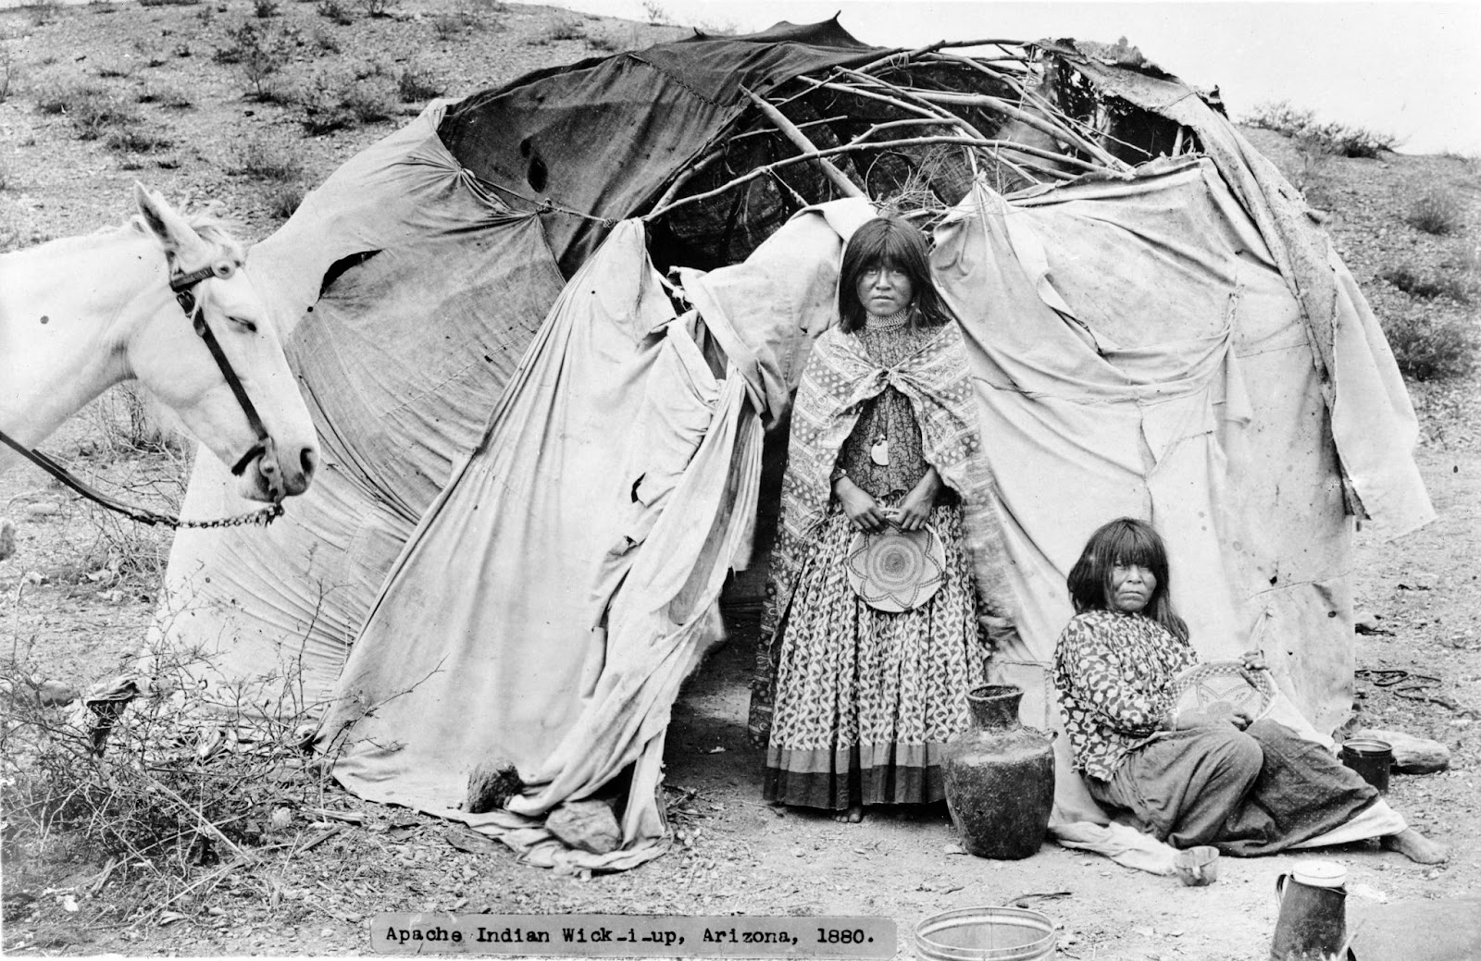
File: Apache wickiup.jpg - Wikimedia commons. (n.d.-h). https://commons.wikimedia.org/wiki/File:Apache_wickiup.jpg

Image 7
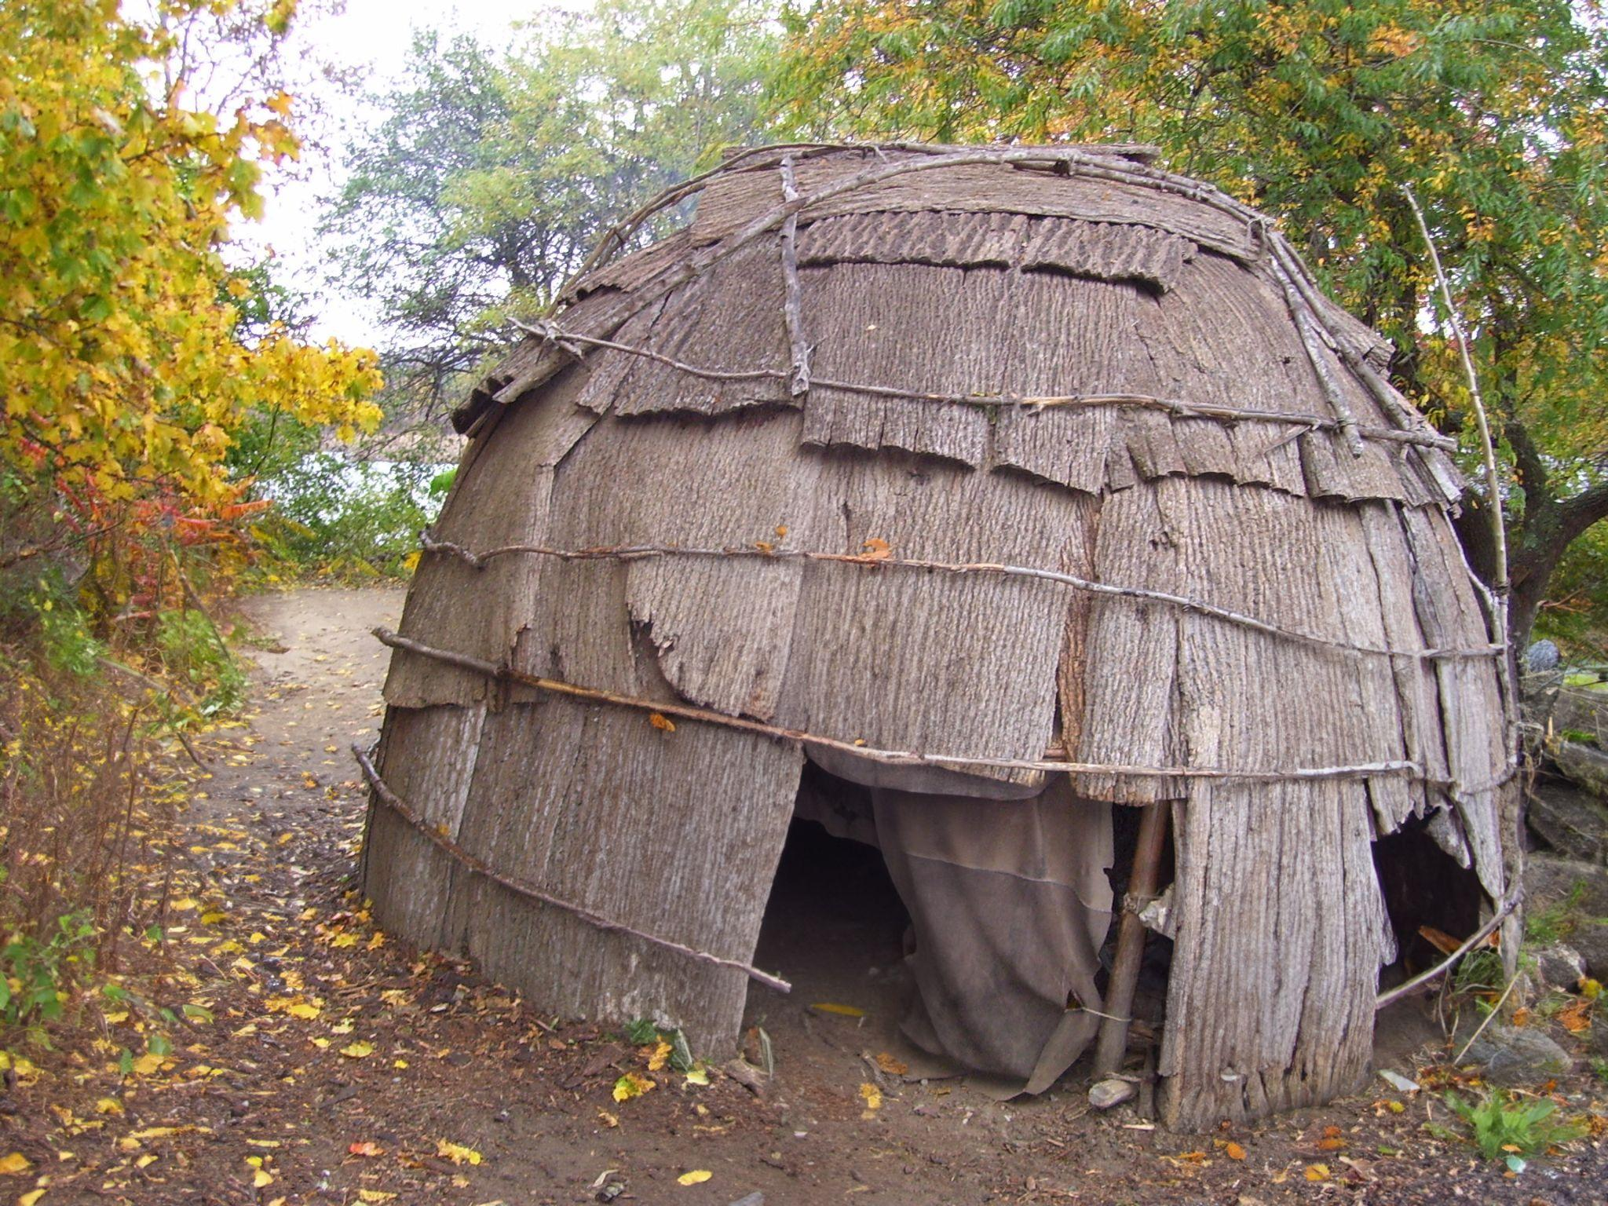
File : Plimoth plantation native American wigwam.jpg. (n.d.-g). https://commons.wikimedia.org/wiki/File:Plimoth_Plantation_Native_American_Wigwam.jpg

Image 8
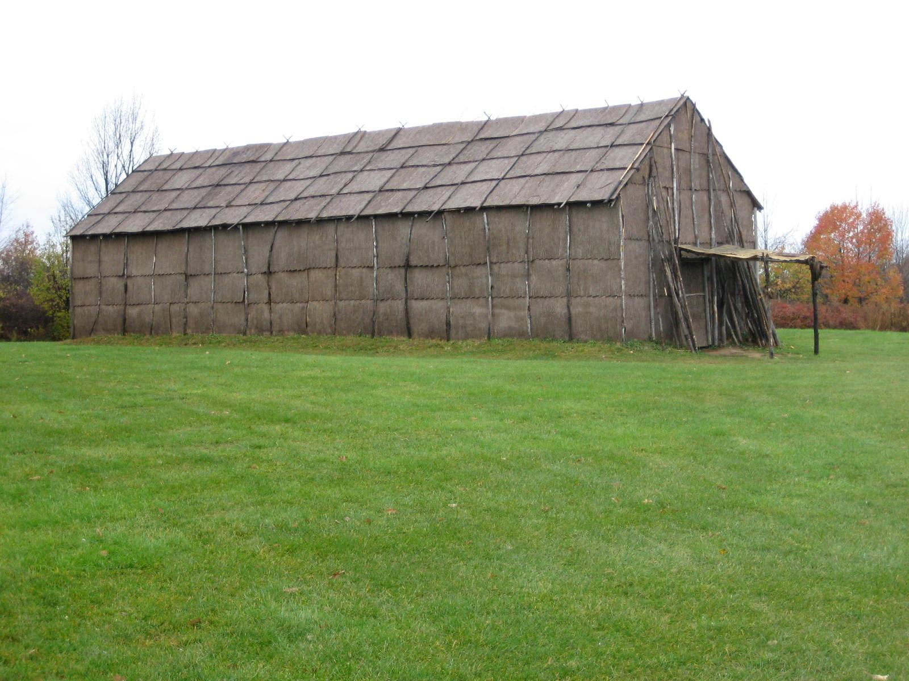
File: ganondagan-house.jpg - Wikimedia commons. (n.d.-j). https://commons.wikimedia.org/wiki/File:Ganondagan-house.jpg

