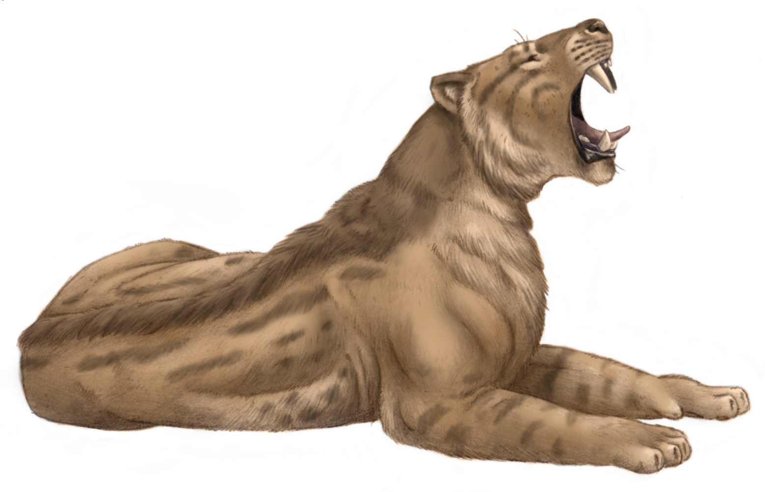

***Machairodus***

Mid-Miocene to Pleistocene

Jesus Gamarra Gonzalez (CC BY-SA 4.0)

<https://en.wikipedia.org/wiki/Machairodus#/media/File:Machairodus_from_Cerro_de_Batallones.png>

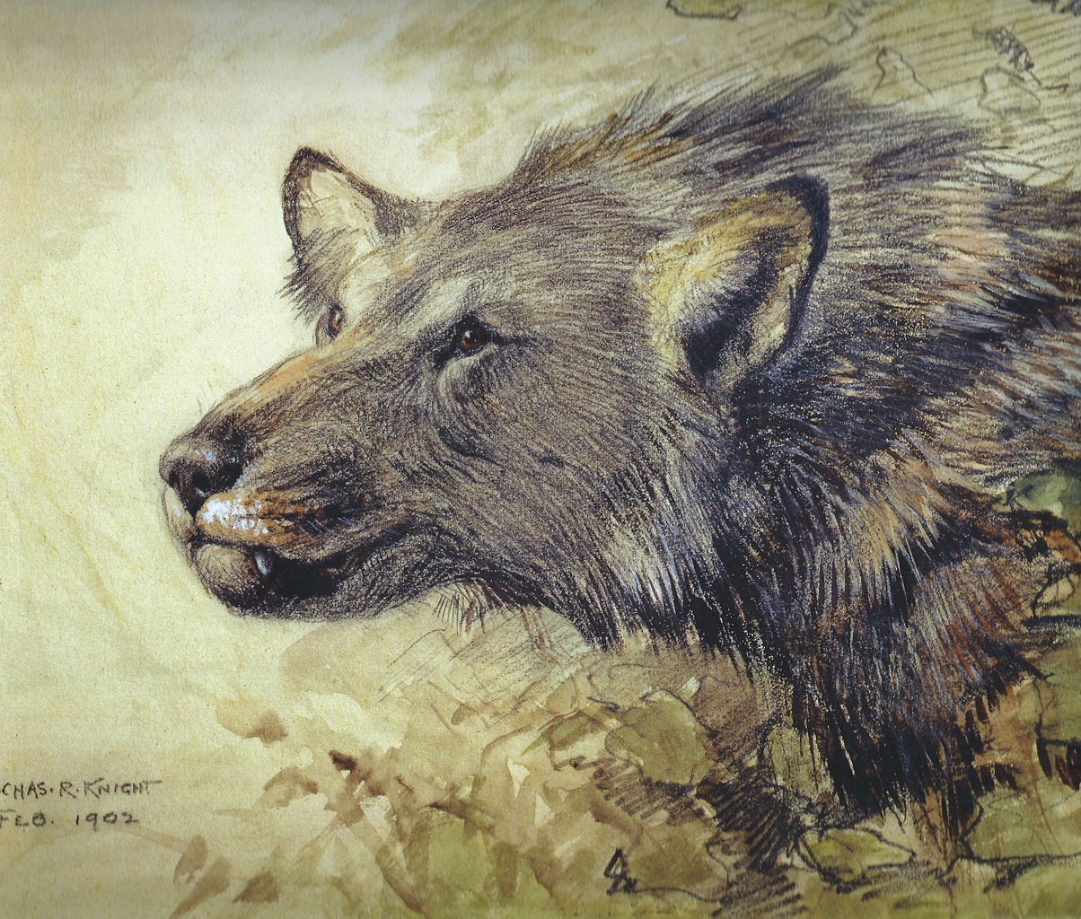

***Borophagus***

Mid-Miocene to Early-Pleistocene

Charles R. Knight (public domain)

<https://en.wikipedia.org/wiki/Borophagus#/media/File:Borophagus_Knight.jpg>

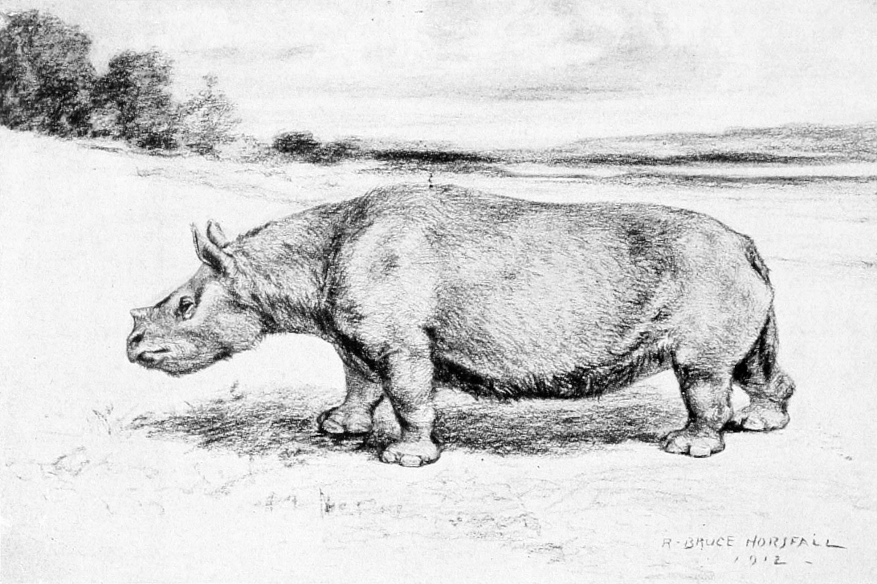

***Teleoceras***

Mid-Miocene to Pliocene

Robert Bruce Horsfall (public domain)

<https://en.wikipedia.org/wiki/Teleoceras#/media/File:Teleoceras_Horsfall.jpg>

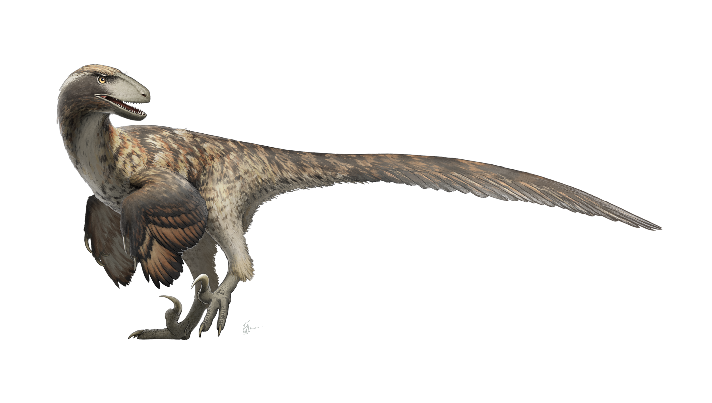

***Deinonychus***

Early Cretaceous

Fred Wierum (CC BY-SA 4.0)

<https://en.wikipedia.org/wiki/Deinonychus#/media/File:Deinonychus_Restoration.png>

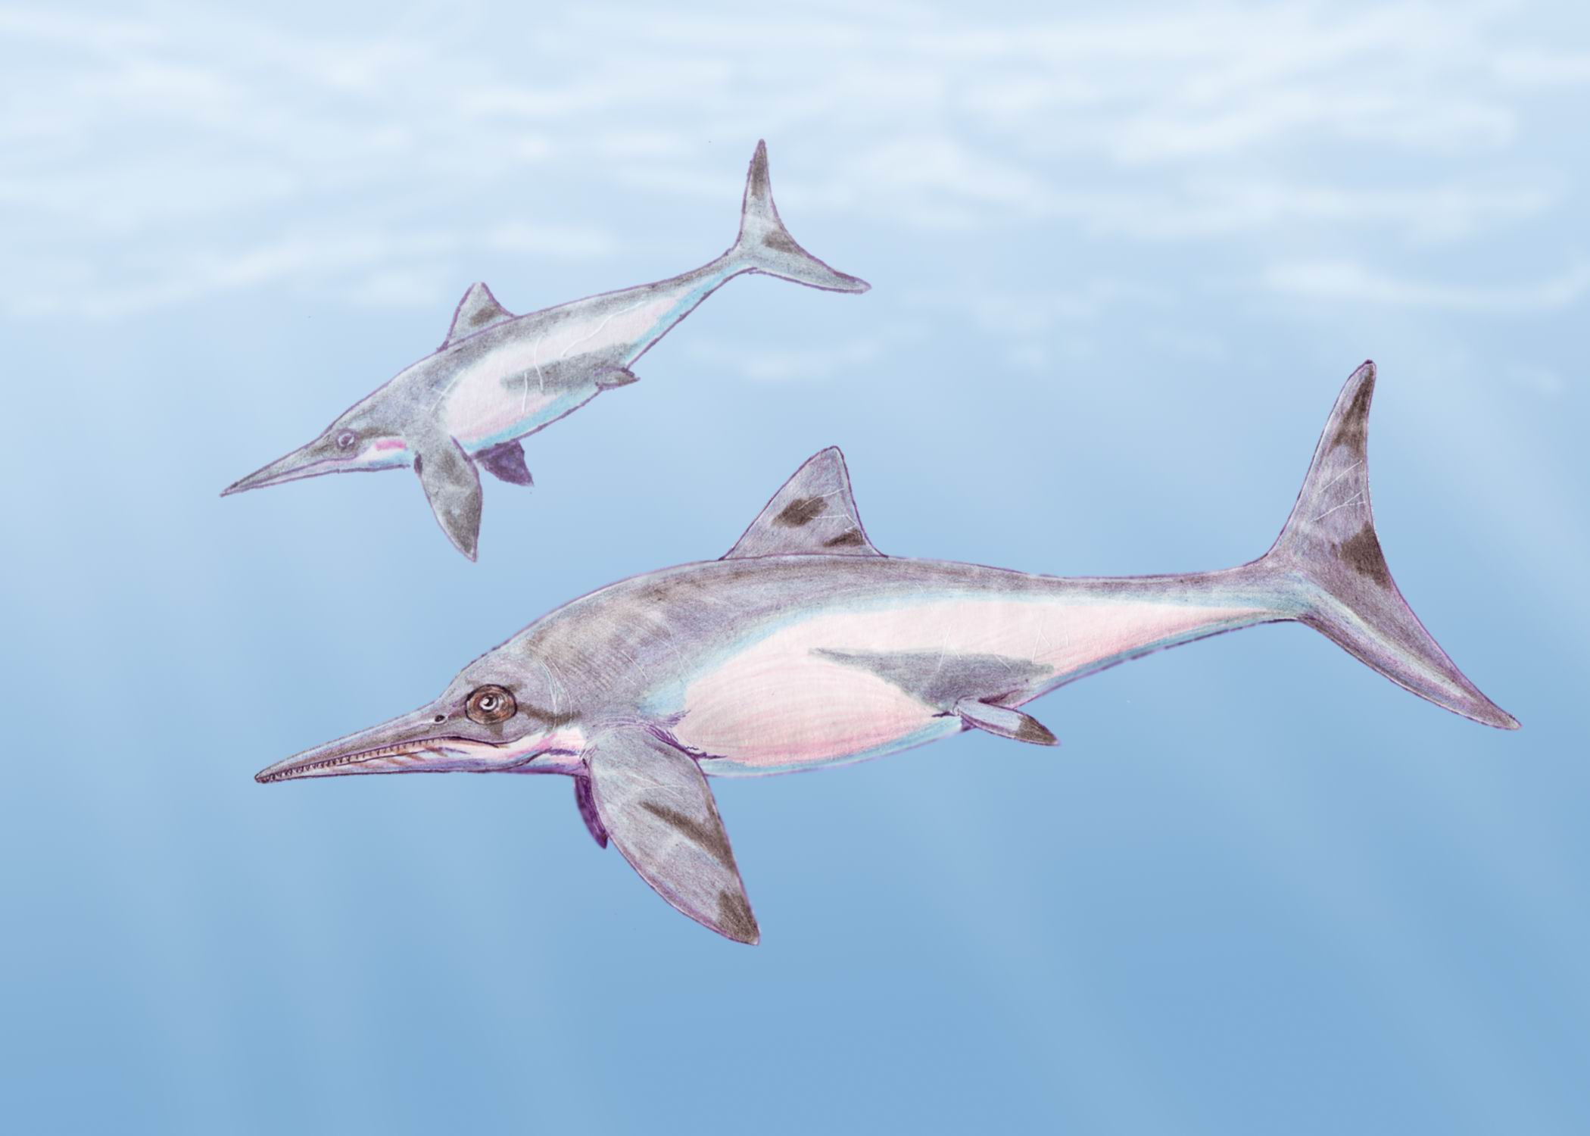***Ichthyosaur***

Early-Triassic to Late Cretaceous

Dmitry Bogdanov (CC BY 3.0)

<https://en.wikipedia.org/wiki/Ichthyosaur#/media/File:Platypterigius_kiprjanov2.jpg>

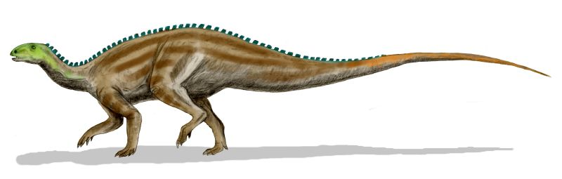

***Tenontosaurus***

Early Cretaceous

Nobu Tamura (CC BY 2.5)

<https://en.wikipedia.org/wiki/Tenontosaurus#/media/File:Tenontosaurus_BW.jpg>

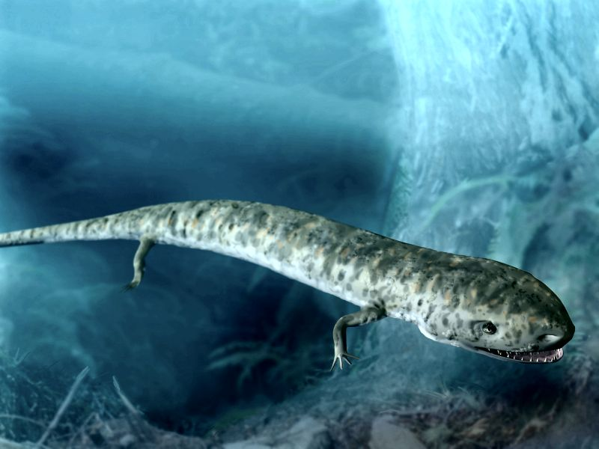

***Cardiocephalus***

Permian

Nobu Tamura (CC BY 3.0)

<https://en.wikipedia.org/wiki/Cardiocephalus#/media/File:Cardiocephalus_peabodyi.jpg>

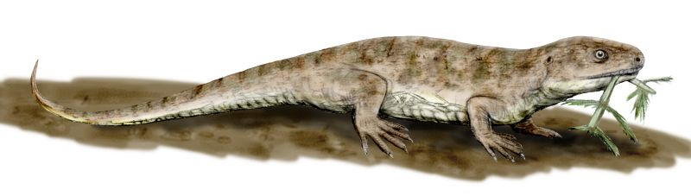

***Captorhinus***

Permian

Nobu Tamura (CC BY 3.0)

<https://en.wikipedia.org/wiki/Captorhinus#/media/File:Captorhinus_BW.jpg>

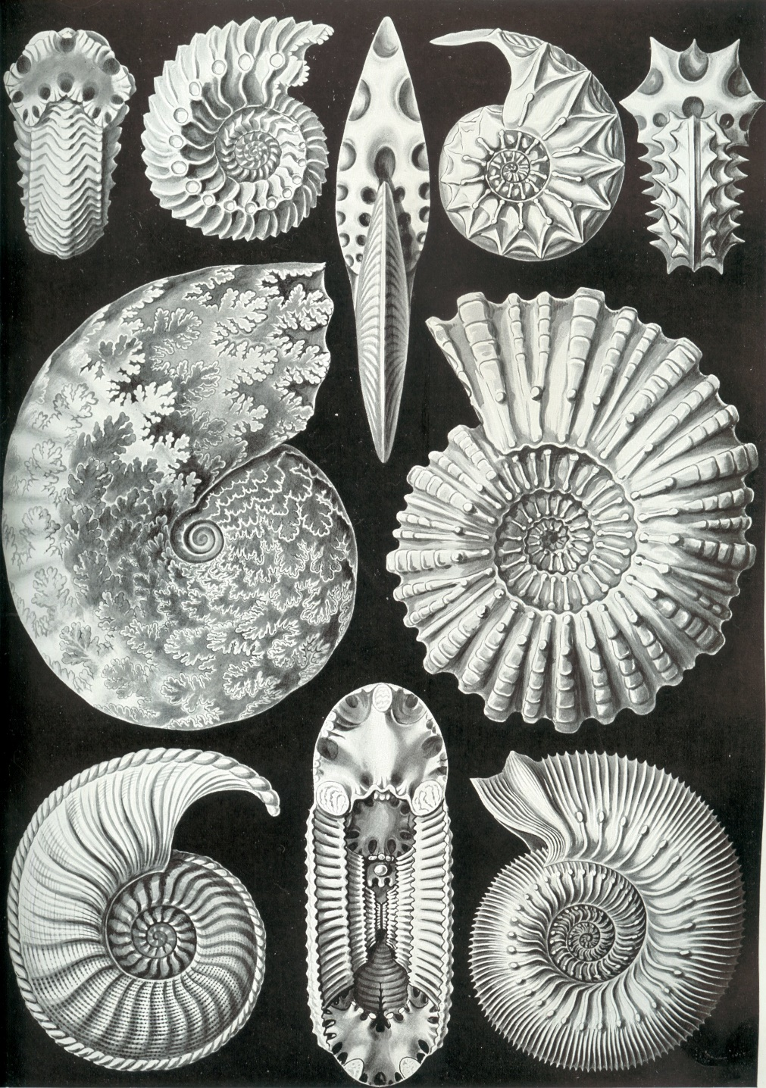

**Ammonites**

Early-Devonian to Late Cretaceous

Ernst Haecke (public domain)

<https://en.wikipedia.org/wiki/Ammonoidea#/media/File:Haeckel_Ammonitida.jpg>

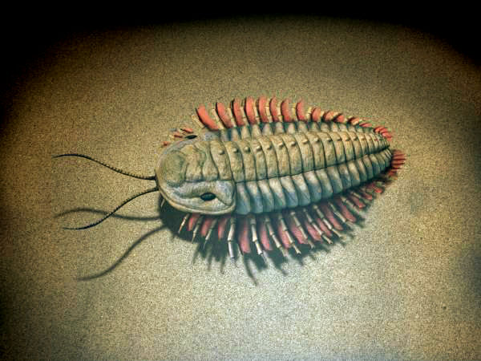

**Trilobites**

Paleozoic Era

Nobu Tamaura (CC BY-SA 4.0)

<https://en.wikipedia.org/wiki/Trilobite#/media/File:Triarthrus_NT_small.jpg>

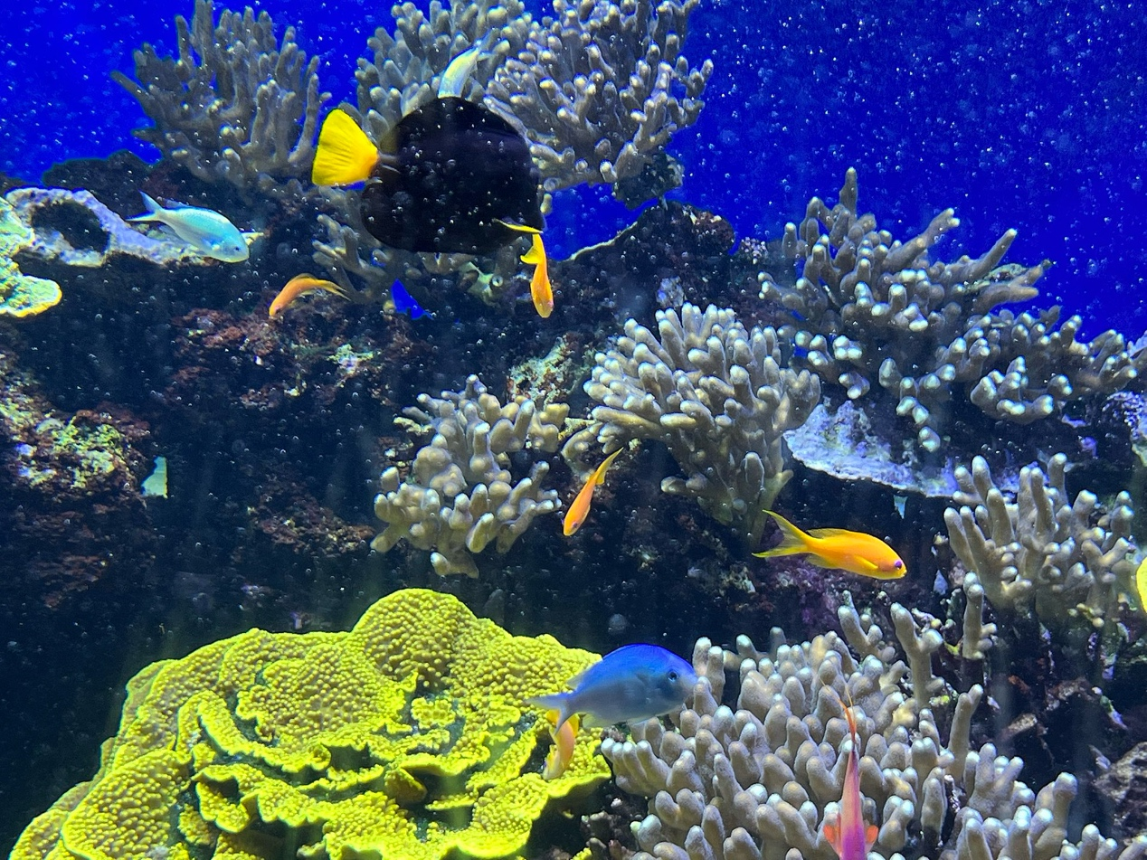

**Corals**

Paleozoic Era to Holocene (present)

Benoît Prieur (public domain)

<https://commons.wikimedia.org/wiki/Category:Corals#/media/File:Aquarium_de_Monaco_en_novembre_2021_(34).jpg>