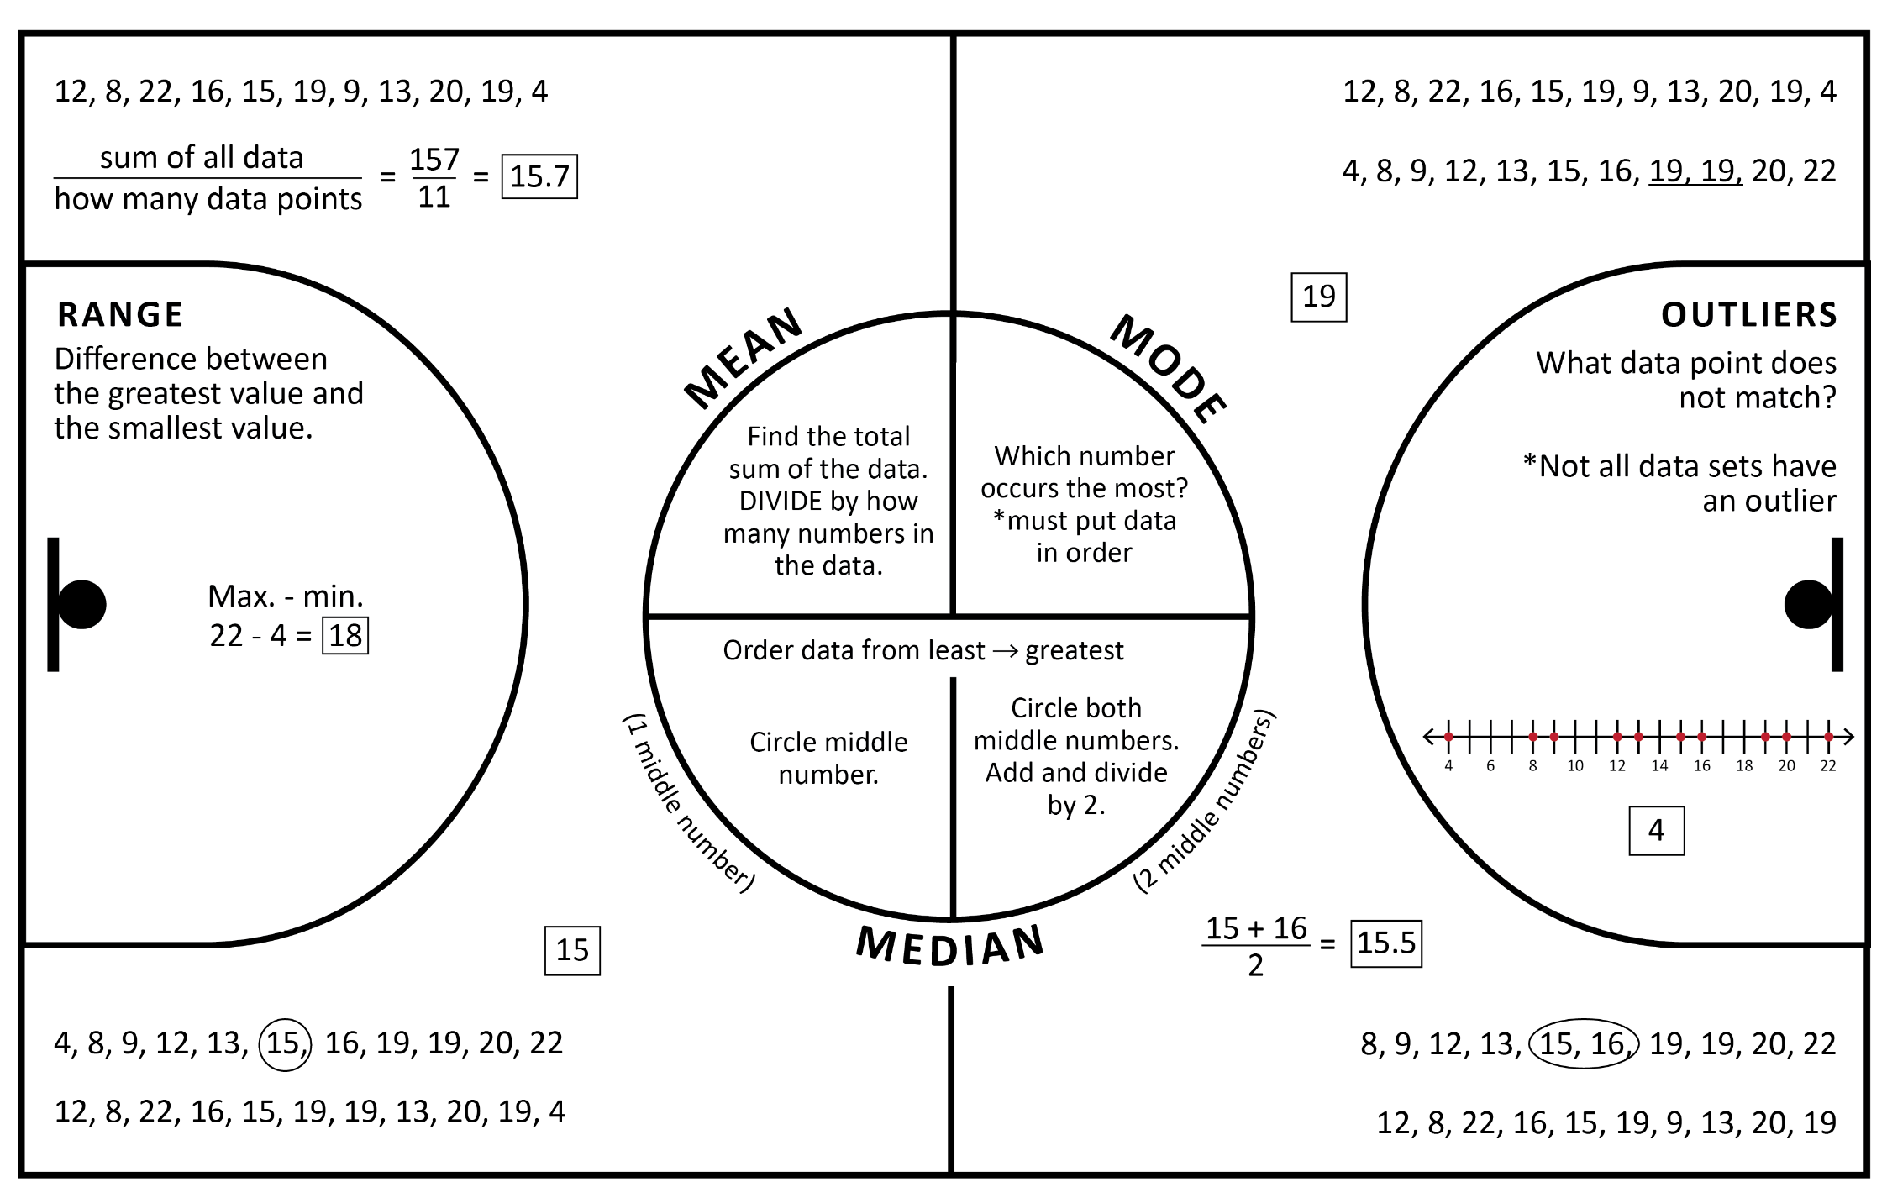
Q1 | Median of lower half of data
Q2 | Median of the data
Q3 | Median of upper half
IQR | Range from Q1 to Q3
*Always include least and greatest data points to create the whiskers.
