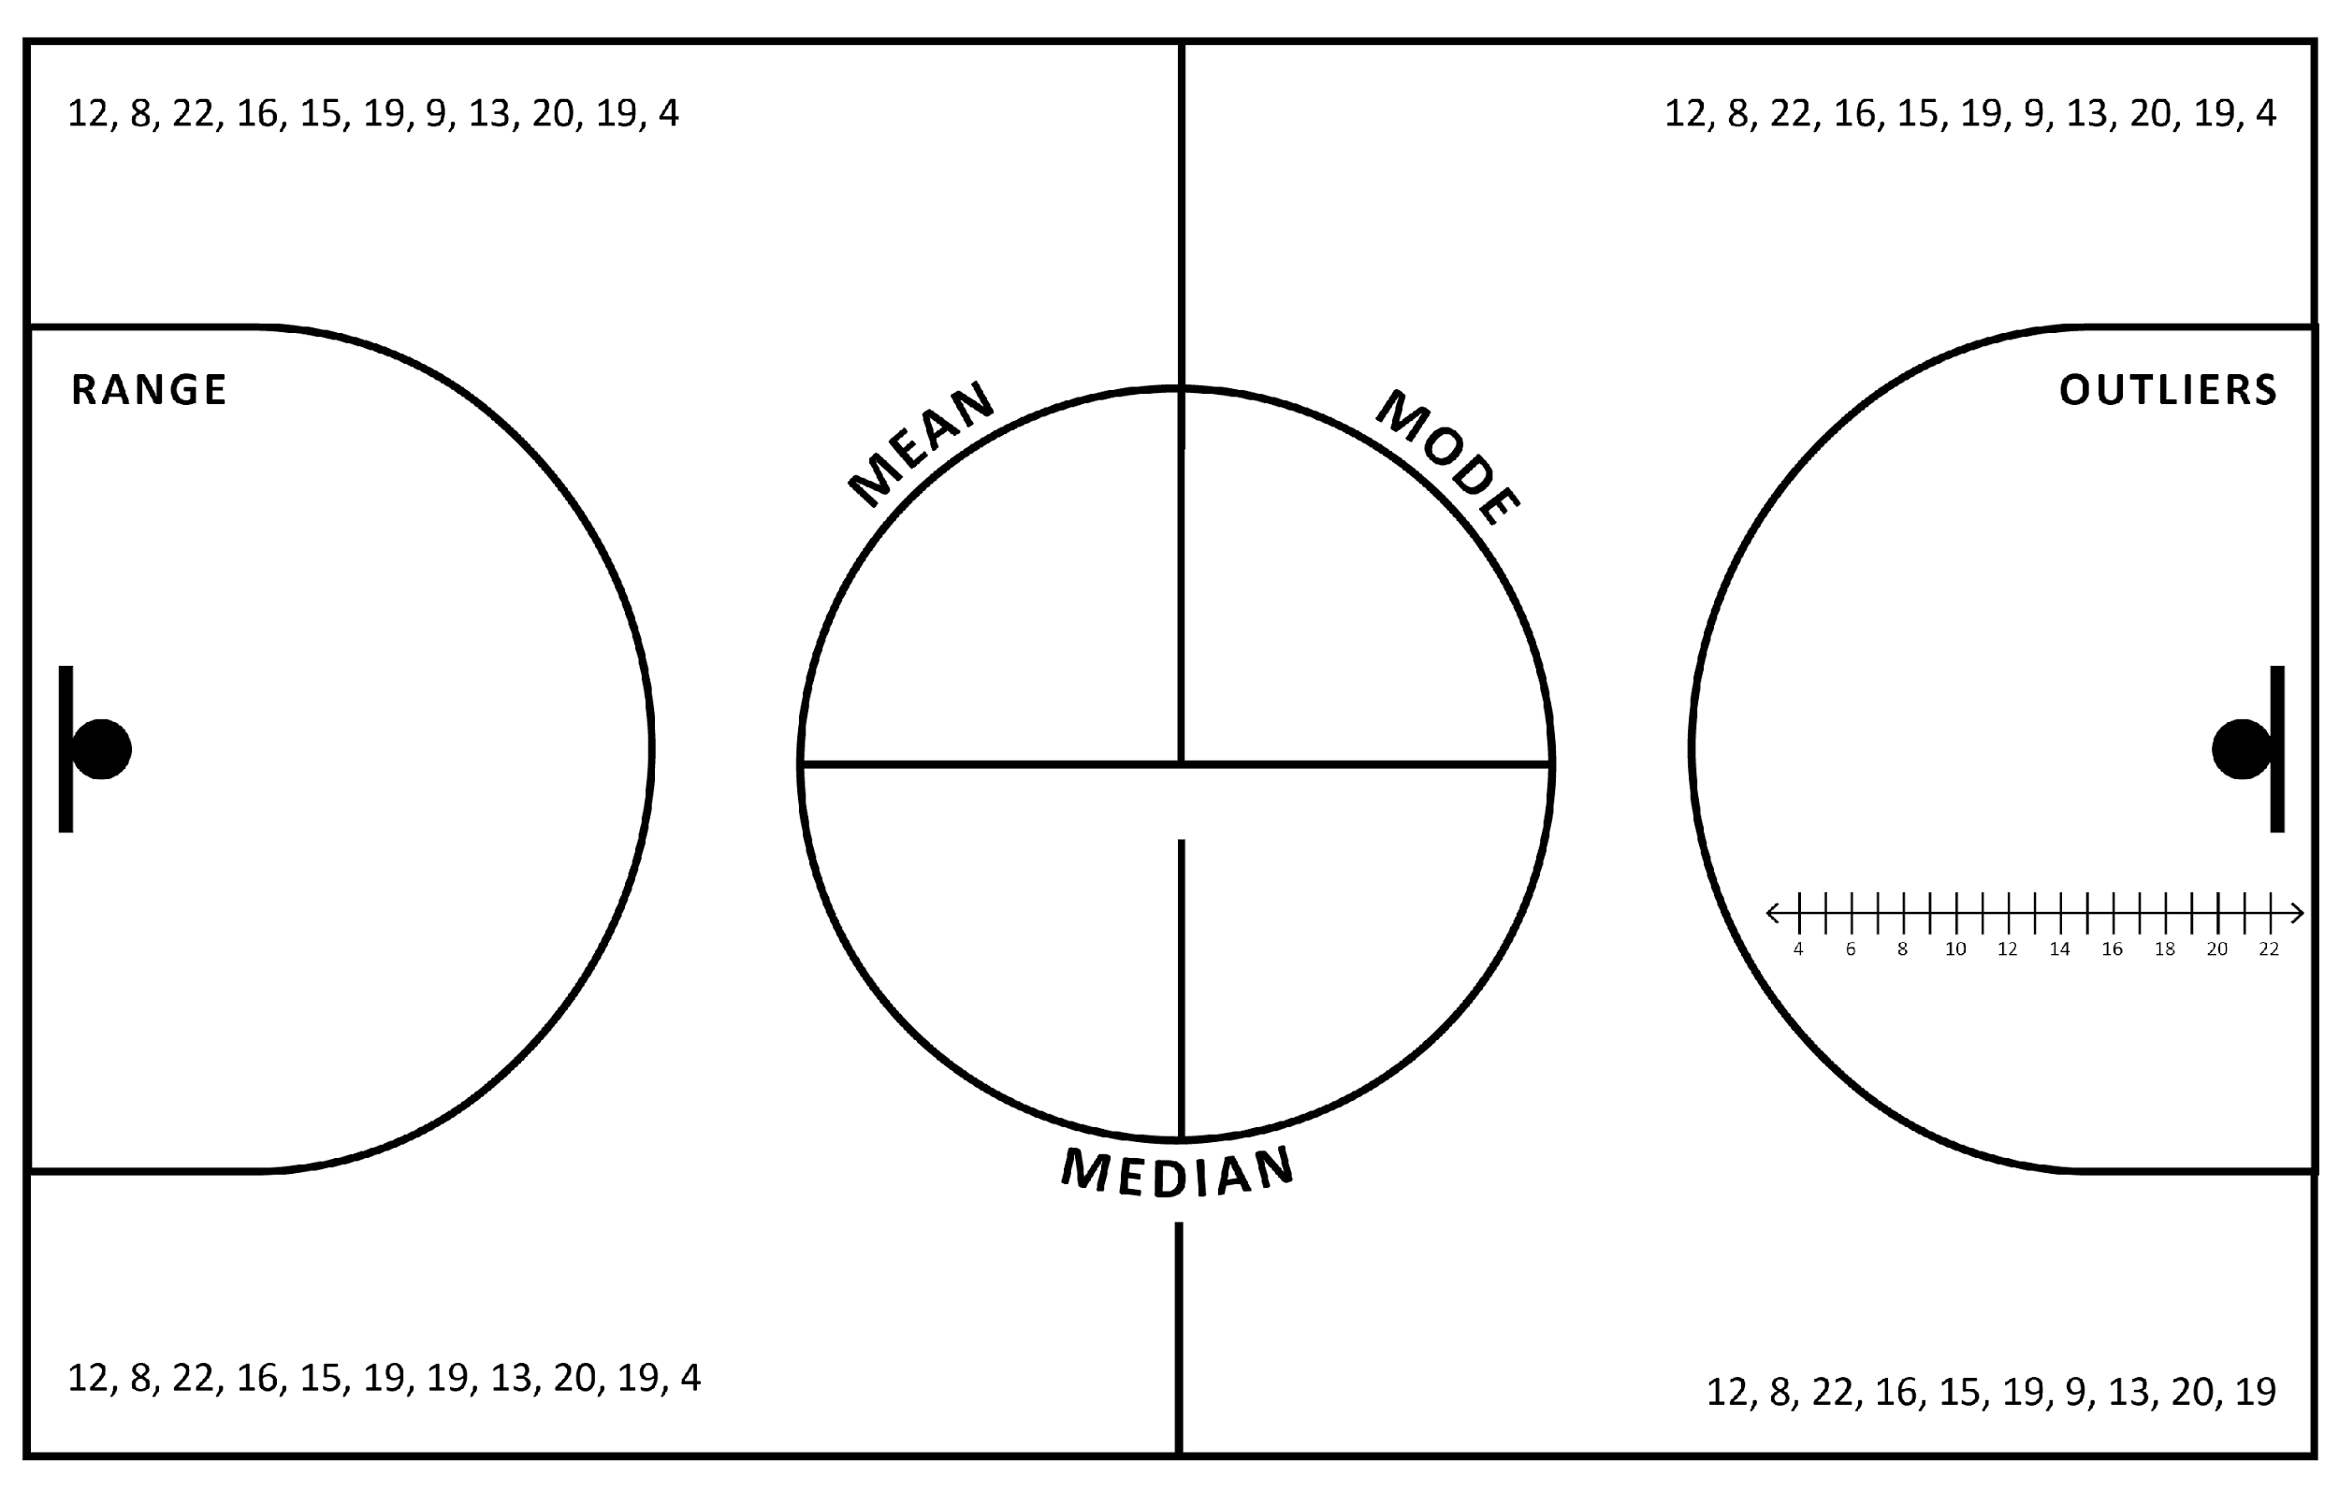

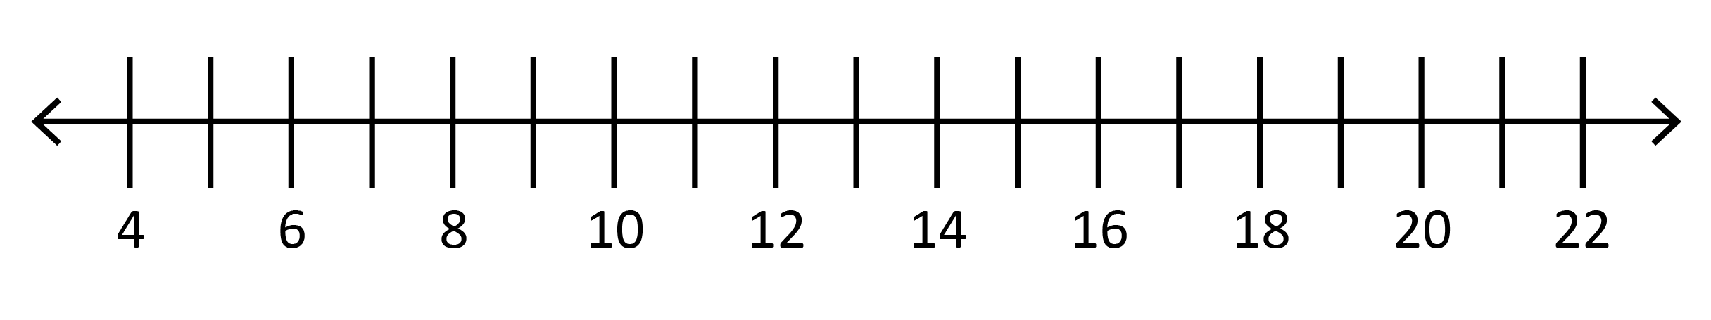

4, 8, 9, 12, 13, 15, 16, 19, 19, 20, 22

Q1
Q2
Q3
IQR

