STATS ON THE SIDELINE PRACTICE, VERSION 2

3, 2, 3, 11, 17, 9, 7, 4, 7, 7, 12, 8, 9, 13, 7, 10, 9, 8, 6, 3, 9, 24

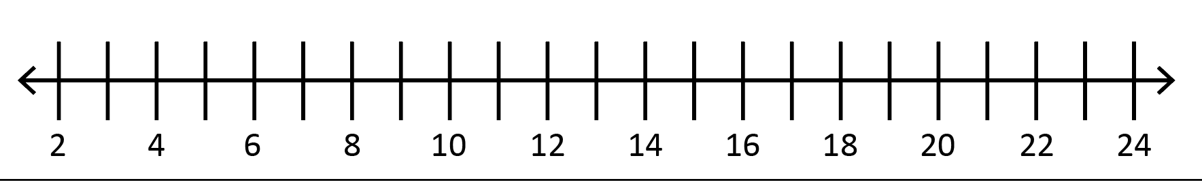

Mean |  | Q1
Median |  | Q3
Mode |  | IQR
Range |  | Outlier

Headline:

