WHAT IS YOUR CLEAT SIZE?

Equipment is a major part of any game, particularly soccer. Cleats must fit correctly for players to perform at their best. It is your job as the equipment manager of a fantasy team to order a new player’s shoes. The new player is not responding to your e-mails, text messages, or phone calls, so you must order his cleats without knowing his shoe size.

Consider the shoe sizes of the fantasy team players in the table below to decide what cleat size you will order for the new player.

Name | Player # | Shoe Size
Neymar da Silva Santos, Jr. | 1 | 8
Cristiano Rinaldo | 2 | 9
Paul Pogba | 3 | 10.5
Thibaut Courtois | 4 | 11
Zlatan Ibrahimovic | 5 | 12
Jack Butland | 6 | 12
Fraser Forster | 7 | 12
Peter Crouch | 8 | 12
Romelu Lukaku | 9 | 13.5
Nwankwo Kanu | 10 | 15

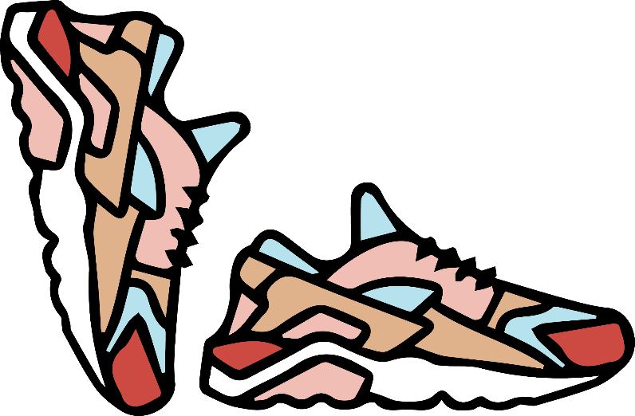
Discussion Questions
Justify your answers by showing your math.

- Based on the data collected for the fantasy team, what do you think is the most common shoe size among professional soccer players?

- What shoe size do you think is right in the middle of the biggest and smallest shoe sizes among professional soccer players?

- Would you order the new player’s shoes based on question number 1, question number 2, or neither? Use the following questions to guide your thinking.
  - Is there a difference between the two answers you got for question number 1 and question number 2? Could there be if you had different data?

  - If you look at the numbers above and below the middle, what do you notice about the top half compared to the bottom half?

  - Is there something else we can do to find a shoe size that would represent all the numbers?

