MATH IN MOTION
Given the following graph, answer the questions with a partner.
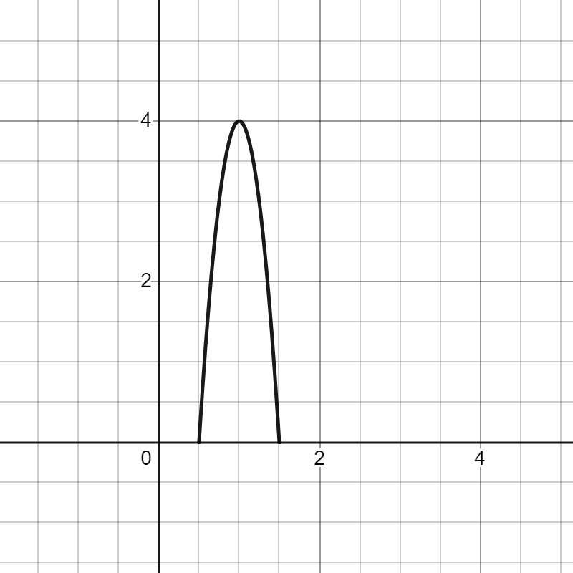

Question | Answer | Vocabulary word
Which way is the u-shape opening? (up or down)
Where is the highest part of the shape? Mark this on the graph with a point.
What are the x-intercepts of the shape?
Where is the line of symmetry on the shape? | Draw the line of symmetry directly on the graph
Does this graph show a linear function?

