MATH IN MOTION - TEACHER EDITION
Given the following graph, answer the questions with a partner.
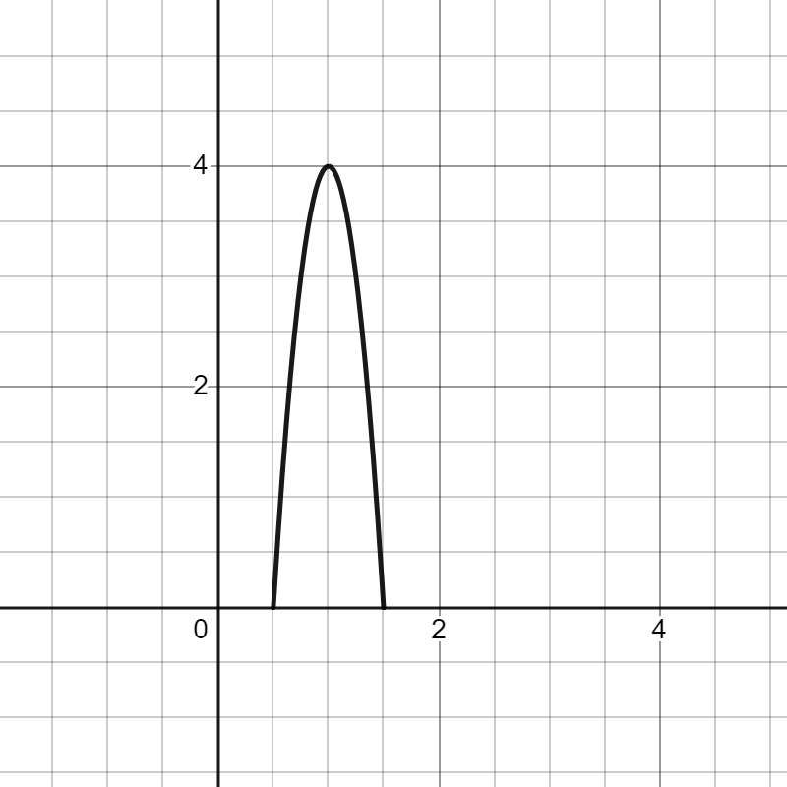

Question | Answer | Vocabulary word
Which way is the u-shape opening? (up or down) | Down | Direction
Where is the highest part of the shape? Mark this on the graph with a point. | (1,4) | Minimum or Maximum
What are the x-intercepts of the shape? | (0.5, 0) (1.5, 0) | Intercepting points
Where is the line of symmetry on the shape? | Draw the line of symmetry directly on the graph | Axis of Symmetry
Does this graph show a linear function? | No | Quadratic  (Parabola)

