Einstein’s Spacetime Reading
The model below constructed of fabric and marbles represents Albert Einstein’s idea of the fabric of spacetime. Einstein came up with the idea that objects exist in 4-dimensional spacetime. To uniquely identify the location of an object, not only do you need to define its position in 3-dimensional space relative to the observer but also the time in the observer’s reference frame. In other words, the “fabric” (spacetime) is a real thing. Spacetime is so real that we will examine how ripples in spacetime (gravitational waves) have actually been detected. Einstein’s view was that spacetime is not a construct that we are putting on top of reality, but that the universe itself is woven together in spacetime.

Accepting this interpretation of the world offers further explanation about why gravity causes masses to attract each other. The fabric represents a cross-section of 2-dimensional space. When an object is placed into that fabric, it creates a distortion that we can think of as a depression. The larger the object the deeper the depression will be in the fabric (spacetime). Masses accelerate toward each other at a distance because they slip into the depression in spacetime. | 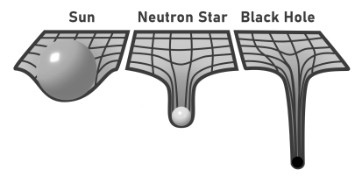  This image shows the sun, a more massive neutron star, and an even more massive black hole, and their effects on the fabric of space.

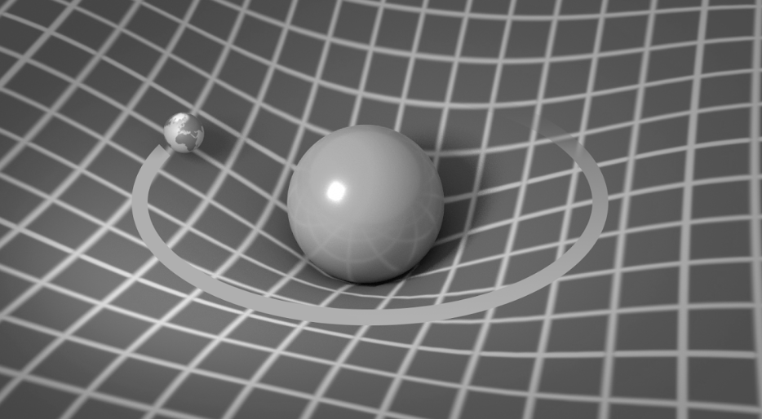 | When other objects or even light move through space, they move along the contour of this fabric and their paths follow the contours created by these massive objects.  For example, a planet orbiting the sun moves around the curvature in the fabric of space created by the sun.
Einstein published his “Theory of General Relativity” in 1915. It passed its first test during the solar eclipse of 1919. Scientists took pictures of the star field behind the sun during the solar eclipse and took pictures of the star field during the months before and after. The conclusion was that the apparent locations of the stars had changed during the eclipse. This phenomenon is what Einstein predicted because the light from the stars that passed close to the sun followed a warped spacetime path, which makes us think that the apparent location of the stars had changed since our minds assume that the light traveled in a straight line. Warping spacetime changes the reality we observe.
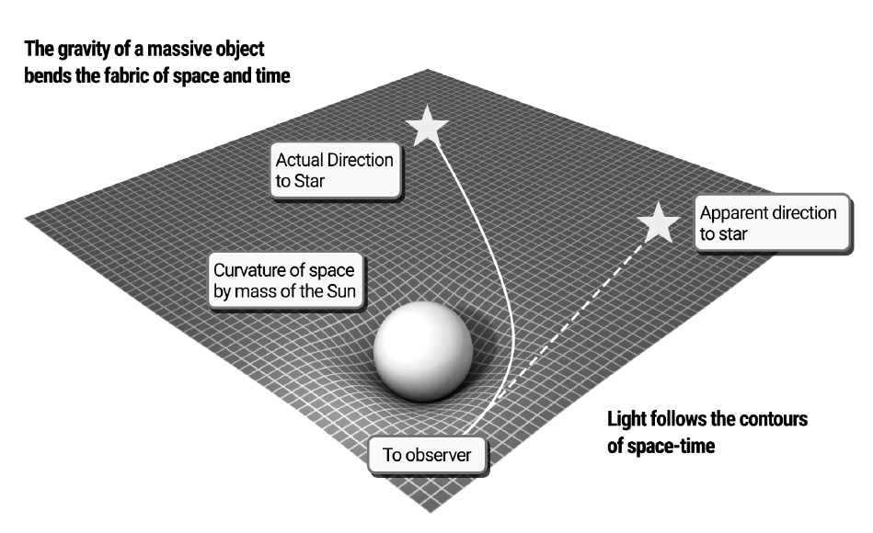
One of the main problems with the fabric of spacetime is that it requires 4 dimensions, which we cannot see in our 3-dimensional world. Adding an additional axis perpendicular to the x, y, and z axes seems impossible, but people have come up with ways, both conceptually and mathematically, to imagine how a 2-dimensional world could view our 3-dimensional world. They have extended these ideas to explain how 4-dimensional objects might look in our 3-dimensional space.
The main point is that a 3-dimensional sun has nowhere in our perceived 3-dimensions of space to depress the fabric. This explains why our model focuses on 2-dimensional space being stretched into the 3rd dimension of space. Visualizing how 4-dimensional spacetime works takes additional math and mental gymnastics, but this is what physicists believe the universe is actually like.
If you are interested in learning more about this, check out the two videos listed below.
A Beginner’s Guide to the 4th Dimension: https://www.youtube.com/watch?v=j-ixGKZlLVc
Understanding Other Dimensions: Flatland: https://www.youtube.com/watch?v=zO1y-Tm8dSI

YouTube. (2007, August 4). Understanding other dimensions - flatland. YouTube. https://www.youtube.com/watch?v=zO1y-Tm8dSI
YouTube. (2016, June 30). A beginner’s guide to the fourth dimension. YouTube. https://www.youtube.com/watch?v=j-ixGKZlLVc

