Fabric of Spacetime Setup Directions
- Build the tables using the instructions below, or using the slightly different design shown on this website. One table is enough for the lesson, but it is preferable to have 2-3 tables with 3 or 4 groups per table so that everyone has a chance to participate.
- Practice the demonstrations until you can perform them successfully.
- Place a 1kg disc in the center of the table fabric.
- Pick up one marble and hold your hand toward the mass. Roll the marble to your left or right toward the edge of the table so that it slowly spirals toward the mass. Relate this to a less massive object orbiting a more massive object.
- Take a handful of marble in each of your hands. Roll the marbles in opposite directions away from you. You want the marbles to collide on the other side of the table. At the point when only a few marbles are still moving, all of the marbles can be moving in the same direction. This will not happen each time, so plan on repeating it several times. Discuss how all the matter in a solar system could have been moving around in all directions at one point in time but eventually settled in one direction.
- Allow students some time to experiment on their own with the table.
Instructions for building fabric table:
List of parts per spacetime table:
4 - Insert Female Tee with ½” barb x ½” barb x ½” FPT
4 - ¾” PEX Pipe 46” long
4 - ½” PVC Tee
1 - ½” PVC Cross
8 - ¾” J-Hook Pipe Hanger
4 -½” PVC Adapter
4 - ½” PVC Pipe 22” long
4 - ½” PVC Pipe 30.5” long
1 spandex fabric 1.75m x 1.75m
1 1kg weight
Approximately 20 marbles

- Screw white ½” PVC adapter onto the gray Female T-connector with ½” barb x ½” barb x ½” FPT (picture a). There are 4 of these.

- Push a 22” long .5” PVC into each of the four white adaptors (pic b).

- Push the .5” PVC T-connector onto the other side of each PVC pipe (pic c).
d) 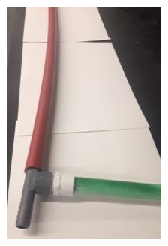e)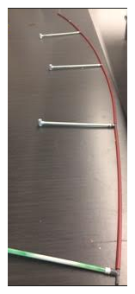f) 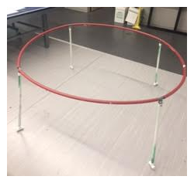

- Connect a red .75” PEX pipe to one side of each gray connector. The .75” red PEX pipes are pushed into the female ½” barbs on the gray Female T-connector with ½” barb x ½” barb x ½” FPT (pic d).

- Connect four of the red .75” PEX pipes together by laying them out on the floor (pic e).

- Connect the free ends together by slowly bending the red pipes, and stand up the table
(pic f). This is much easier with 2-4 people helping.

g) 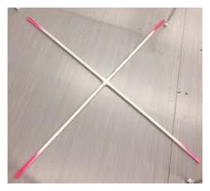h) 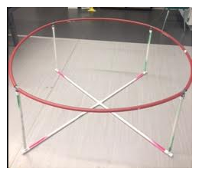

- Connect four 30.5” long .5” PVC pipes to four-way cross .5” PVC connector and lay it on the floor in the middle of the table (pic g).

- Connect the T-connector on the bottom of each leg to the X shaped base piece (pic h).

i) 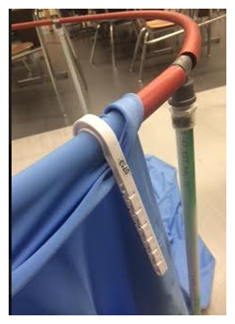j) 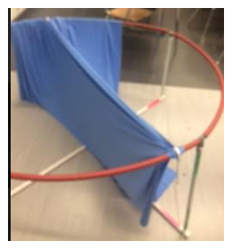

- Drape fabric several inches over red pipe and secure with J-hook (pic i).

- Pull fabric across the table to the opposite side so that the material is tight and not sagging down and secure with another J-hook (pic j).
k) 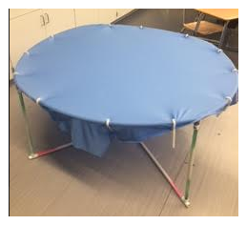l) 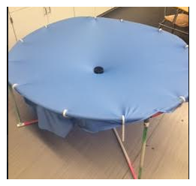

- Attach fabric to the other 2 sides of the table with 2 more J-hooks so that the fabric is not sagging down in the center. Add additional J-hooks until there are 2 hooks per section of red PEX pipe (pic k).

- Place a weighted disc in the center of the fabric to create the curvature (pic l).

