Reader: Models
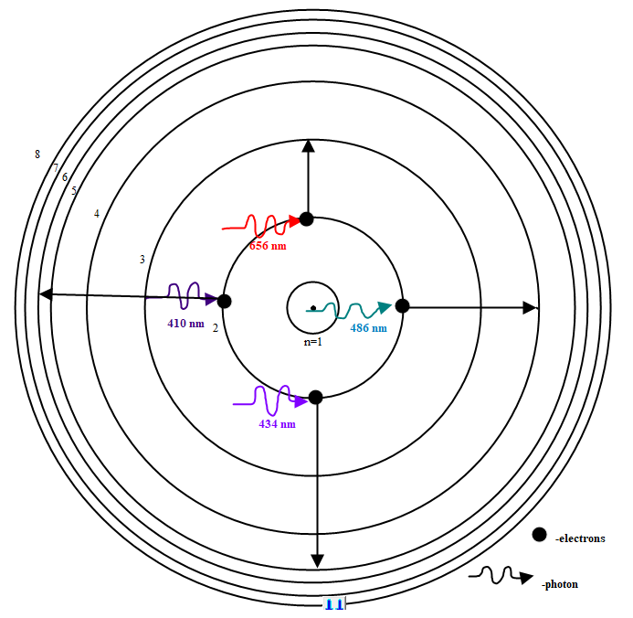
Model 1: In hydrogen atoms, electrons can absorb energy from photons and transition from a lower energy shell (n=2) to higher energy shells (n=3, 4, 5, and 6). The transition from n=2 to n=3 requires a photon with an energy associated with a wavelength of 656 nm.
In the handout “Electrons in Atoms” from Diffraction Lesson 2: Funky Flames, you learned that energized electrons in hydrogen atoms emit four wavelengths of light as they transition from higher energy shells 6, 5, 4, and 3 to the lower energy shell 2, as shown below. The emission lines are shown in Figure 1. These emissions correspond to photons with the wavelengths of 656 nm, 486 nm, 434 nm, and 410 nm.
The wavelength of a photon is inversely related to its energy by the following equation:
E=h∙c/λ, where E is energy in Joules, λ is wavelength in meters, h=6.63x10⁻³⁴ J∙s and c=3x10⁸ m/s
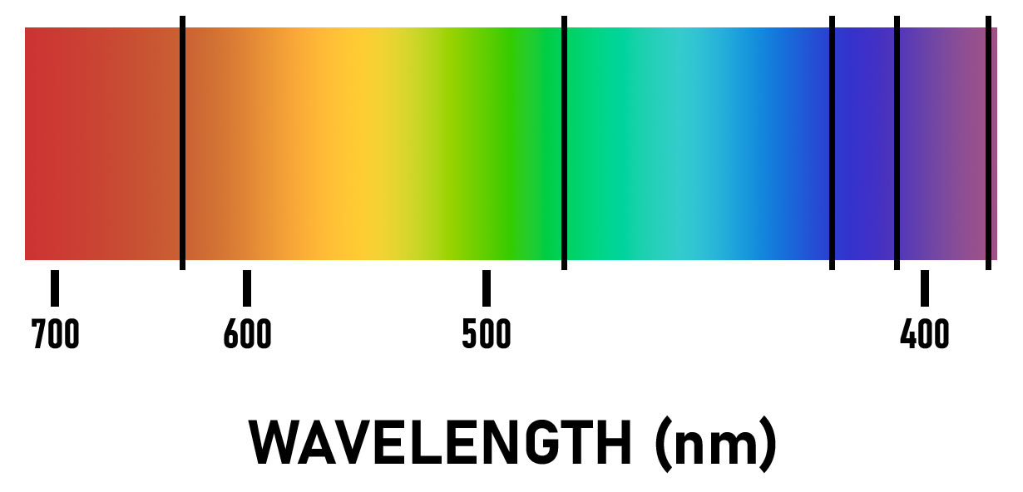
Electrons absorb light when transitioning between energy shells. For instance, in hydrogen atoms, electrons may transition from a lower energy shell (n=2) to higher energy shells (n=3, 4, 5, and 6) as shown above in Model 1. Exact energies are required for electrons to transition to higher energy levels. Energy for electron transitions is obtained when electrons absorb the energy of photons. The energy of the photo must be an exact match for the energy needed for the transition. Some of these photons have energies associated with wavelengths of visible light. When white light passes through gases of elements, some wavelengths of light will be absorbed as electrons transition between shells. When this light is viewed through a diffraction gradient, black lines will appear in the positions normally occupied by the absorbed light. This diffraction pattern is known as an absorption spectrum. The absorption spectrum is related to the emissions spectrum. The emission spectrum is mostly black with a few lines of color. The absorption spectrum is mostly colored with a few lines of black. The colored lines of the emission spectrum are in the same position as the black lines on the absorption spectrum.
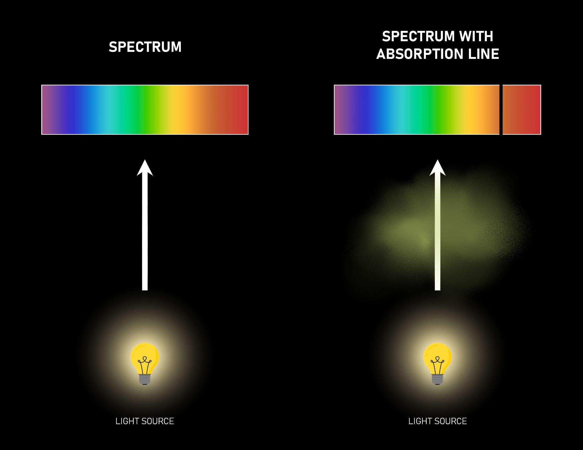
When a hot object, like the sun, emits white light which passes through hydrogen and other gases in its outer layers, the atoms will absorb certain photons of light. Hydrogen makes up about 91.2% of the sun’s composition. As shown above, hydrogen atoms will absorb light with wavelengths of 656 nm, 486 nm, 434 nm, and 410 nm. When the light is viewed through a diffraction gradient these wavelengths will be ‘missing’ or appear as black lines on the spectrum. See Model 2.

The sun’s spectrum would contain all absorbance lines from all elements present in its outer layers. As you can imagine, this image would be complex. However, by locating specific absorbance line wavelength values the elements can be identified.

Recorder: Critical Thinking Questions
- How can electrons transition to higher energy shells?
- What particles transfer energy to electrons?
- What is the wavelength of a photon required to transition an electron from n=2 to n=3?
- What is the wavelength of a photon required to transition an electron from n=2 to n=6?
- Which transition above requires the largest amount of energy?
- How is the color of visible light related to its energy?
Use the words emit, absorb, directly or inversely to answer questions 7-9. Not all four words will be used.
- Electrons transitioning from higher to lower energy shells will__________ photons.
- Electrons transitioning from lower to higher energy shells will __________ photons.
- The wavelength and the energy of a photon are __________ proportional.
- How is an emission spectrum different from an absorption spectrum?
- How is an emission spectrum similar to an absorption spectrum?
- The sun’s atmosphere is also composed of oxygen atoms (1.5%). The photons absorbed by oxygen atoms have wavelengths of 424 nm, 439 nm, 533 nm, 544 nm, 559 nm, 595 nm, 601 nm, 605 nm, 611 nm, 616 nm, 626 nm, 637 nm, 646 nm, 661 nm, and 665 nm. Sketch an absorption spectrum for oxygen.
- The sun’s atmosphere is also composed of carbon atoms (0.043%). The photons absorbed by carbon atoms have wavelengths of 478 nm, 494 nm, 506 nm, 538 nm, 601 nm, and 658 nm. Sketch an absorption spectrum for carbon.
- The sun’s atmosphere is also composed of helium atoms (8.7%). The photons absorbed by helium atoms have wavelengths of 389 nm, 447 nm, 471 nm, 492 nm, 502 nm, 505 nm, 588 nm, 668 nm, 687 nm, 707 nm, 728 nm, and 781 nm. Sketch an absorption spectrum for helium.

