STAR CODES

Reader - Model 1: Barcodes
Barcodes are a series of vertical lines of varying widths that produce unique patterns that computer scanners can read to identify items.
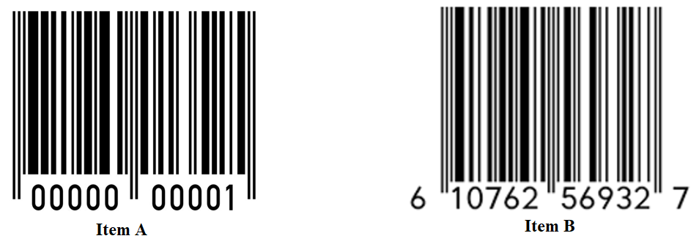
The barcode on the left represents object 1 and the barcode on the left represents object 2.
Simplified spectrum of the sun
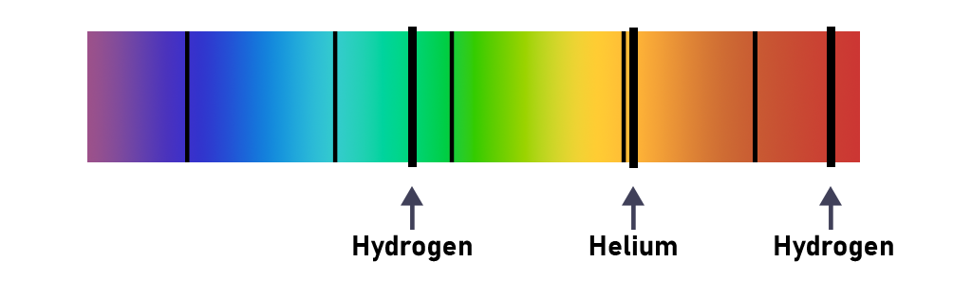
Simplified absorbance spectra of celestial objects in another galaxy
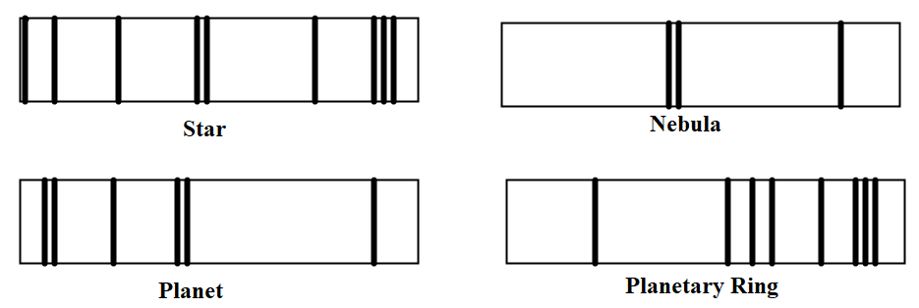

Recorder: Critical Thinking Questions
Answer questions on a sheet of notebook paper.
- When you buy something at the store, how does the clerk know the price of your item?
- Using Model 1, describe a feature of the barcode for item 1 that you could use to distinguish it from the barcode for item 2.
- According to Model 1, which object is represented by the following barcode?
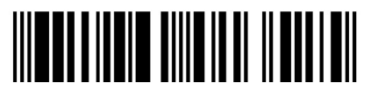
- According to Model 2, which elements appear in the simplified solar spectrum?
- How is an absorbance spectrum like a barcode?
- Identify the following objects using the Models 2 and 3:
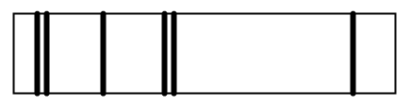
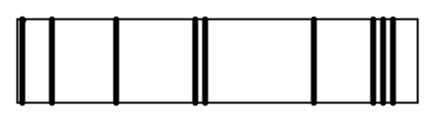
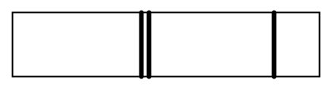

Resources:
Barcode Free Stock Photo - Public Domain Pictures. (n.d.-a). https://www.publicdomainpictures.net/en/view-image.php?image=15705&picture=barcode
Bar code. Bar code | Public domain vectors. (n.d.). https://publicdomainvectors.org/en/free-clipart/Bar-code/78780.html

